Magnetism and electromagnetism

Support activities – Second Year of Secondary Cycle Two
ACTIVITY 23
AST
student BOOK: Chapter 5, pages 163–171
Related Handout: Concept review 23

1. Complete the following sentences, using the words or groups of words in the box below. You may use some words more than once.
• adding  • aligned  • artificial  • attract each other  • attraction  • circular  • cobalt  • coming out of  • conserve  • direction  • distance  • domains  • dynamic  • electrical | • electromagnet(s)  • electromagnetic induction  • electromagnetism  • entering into  • ferromagnetic  • ferromagnetic core  • fingers  • generators  • geographic  North Pole  • increasing  • intensity  • like | • magnet  • magnetic field  • magnetic field  lines  • magnetism  • magnetized  • mechanical  • more powerful  • motion  • moving  • natural  • nickel  • not aligned  • opposite | • ore  • permanent  • powerful  • right-hand rule  • rolled  • sharp blow  • solenoid  • south-seeking  • speed  • steel  • stopping  • temporary  • thumb

a) ________________________ describes all the phenomena caused by magnets. Magnets are objects that can attract other objects containing iron, ________________________ or cobalt. Around 600 bce, the Greeks discovered an ________________________ called magnetite, which is a ________________________ magnet with this property.

b) Certain metals have magnetic properties, which can be explained by their composition: they contain a set of regions called “________________________,” and each of these regions acts like a tiny magnet. The directions of these domains are ________________________ if the metal is not magnetized. If the metal is ________________________, its domains will be well ________________________. The greater the number of aligned domains, the ________________________ the magnet.
c) Each magnet has a north-seeking and a ________________________ pole. By convention, the north pole of a magnet corresponds to the end that naturally turns toward the magnetic pole that is located close to the Earth’s ________________________.
d) Magnets interact with one another through forces of ________________________ and repulsion. In other words, opposite magnetic poles ________________________ and ________________________ magnetic poles repel each other. These forces can act across a ________________________. In a diagram of a magnetic field, they are represented by ________________________. By convention, the lines are drawn ________________________ the north pole and ________________________ the south pole of a magnet.
e) Iron, nickel and ________________________ can be used to make ________________________ magnets. To do so, they are exposed to the ________________________ of another magnet. Substances with the ability to become magnets are described as “________________________.” They can be demagnetized if, for example, they receive a ________________________ or are placed in a magnetic field of opposite polarity.
f) Magnetic remanence is the ability of a material to acquire and ________________________ its magnetic properties. There are two types of magnets: ________________________ magnets, which have low magnetic remanence and readily acquire and lose their magnetic properties (for example, iron containing few impurities), and ________________________ magnets, which have high magnetic remanence and are hard to magnetize and demagnetize (for example, ________________________).
g) Electricity can be used to make magnets. The interaction between magnetism and electricity is called “________________________.” An electric current can generate a magnetic field, and the ________________________ is also true. Only ________________________ electricity can generate a magnetic field because the electrical charges must be in ________________________.
h) Using the ________________________, we can determine the direction of the magnetic field lines of a live wire. The ________________________ points in the direction of the current, from the positive terminal toward the negative terminal. The ________________________ wrapped around the wire show the direction of the magnetic field lines. These lines are ________________________.
i) To increase the intensity of the magnetic field of a live wire, it can be ________________________ into a coil of regularly shaped loops to form a ________________________. This formation will have a ________________________ that resembles that of a bar magnet. However, three characteristics distinguish one from the other: The magnetic field of a ________________________ can be switched on or off simply by ________________________ the current flow. It is possible to change the ________________________ of its magnetic field lines by reversing the current direction. Finally, the intensity of its magnetic field can be increased by ________________________ the number of loops or by increasing current intensity.
j) A solenoid can be transformed into an ________________________ by adding a ________________________ inside the coil. The magnetic field is produced by both the solenoid and the ________________________. The resulting magnet is very ________________________. ________________________ have the same advantages as solenoids, but their magnetism is increased by ________________________ the ferromagnetic core. They are widely used in the field of electricity, notably to transform electrical energy into ________________________ energy.
k) An electric current can be generated from a magnetic field by ________________________. To do this, an electric current is generated in a
conductor by varying a magnetic field around the conductor. The magnetic field must be ________________________ in relation to the conductor. This can be done by ________________________ a conductor inside a magnetic field or by moving a ________________________ around a conductor.
l) Electromagnetic induction is affected by the ________________________ of the magnetic field and the ________________________ at which it moves in relation to the conductor. Electromagnetic induction is widely used to transform mechanical energy into ________________________ energy, for example in the turbines and ________________________ in the dams of hydroelectric plants.

2. The figure below represents the Earth, which is a large magnet. Complete the figure with the following terms.
– geographic North Pole
– North Magnetic Pole
– geographic South Pole
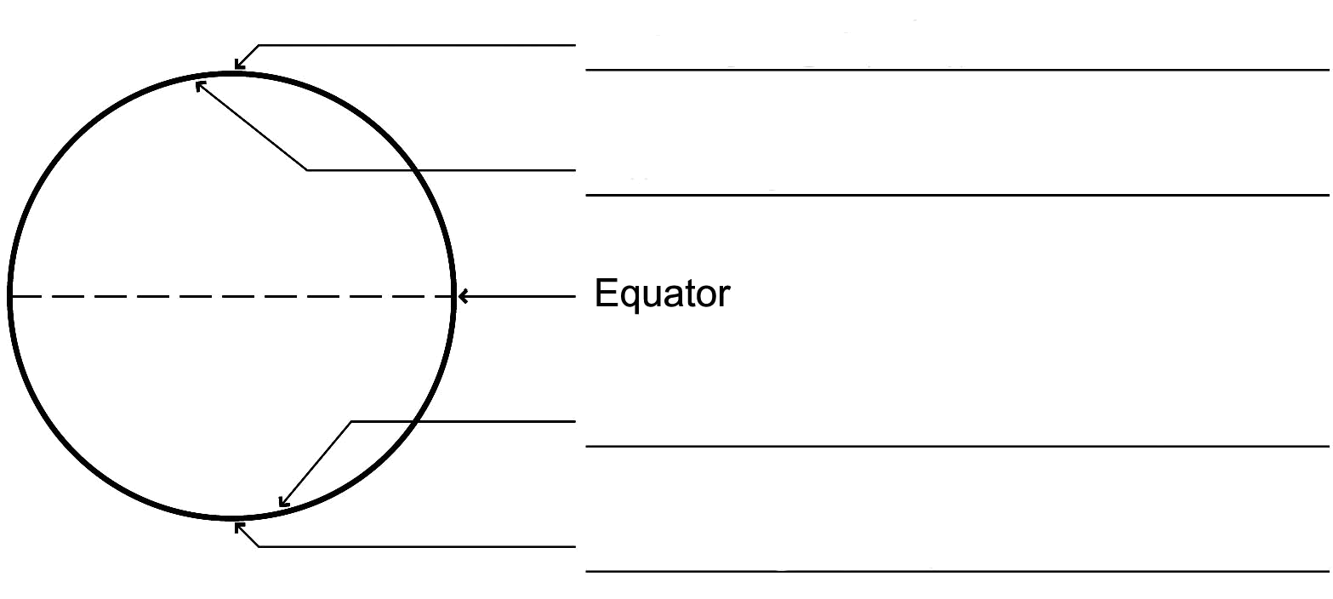
– South Magnetic Pole
3. The circles below represent compasses. In each situation, draw the needles of the compasses, using an arrow to show the direction they point.
b)
a) 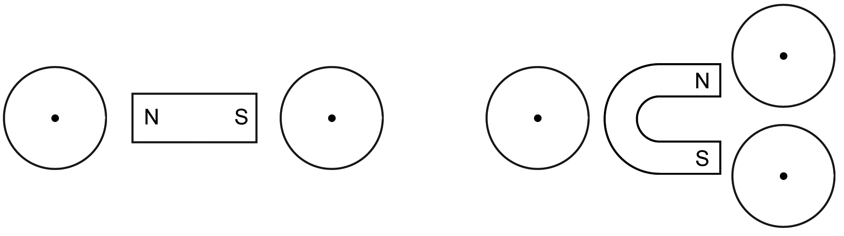
4. Draw the magnetic field of each of the magnets below.
b)
a) 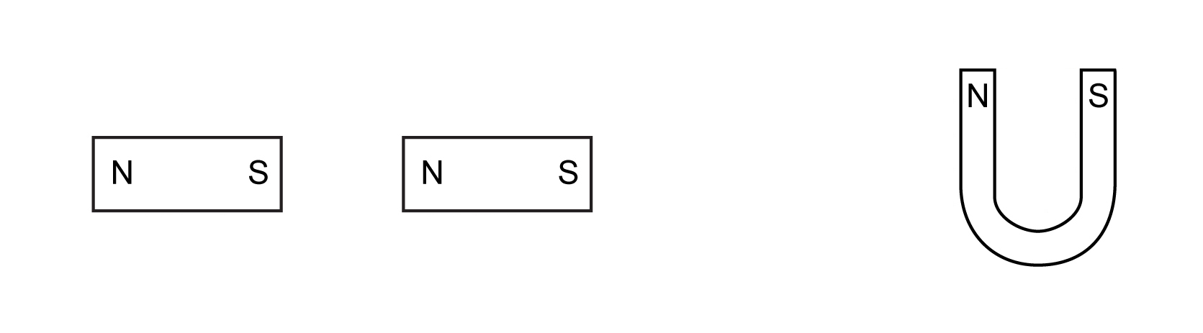
5. Draw the magnetic field lines for each of the solenoids below.
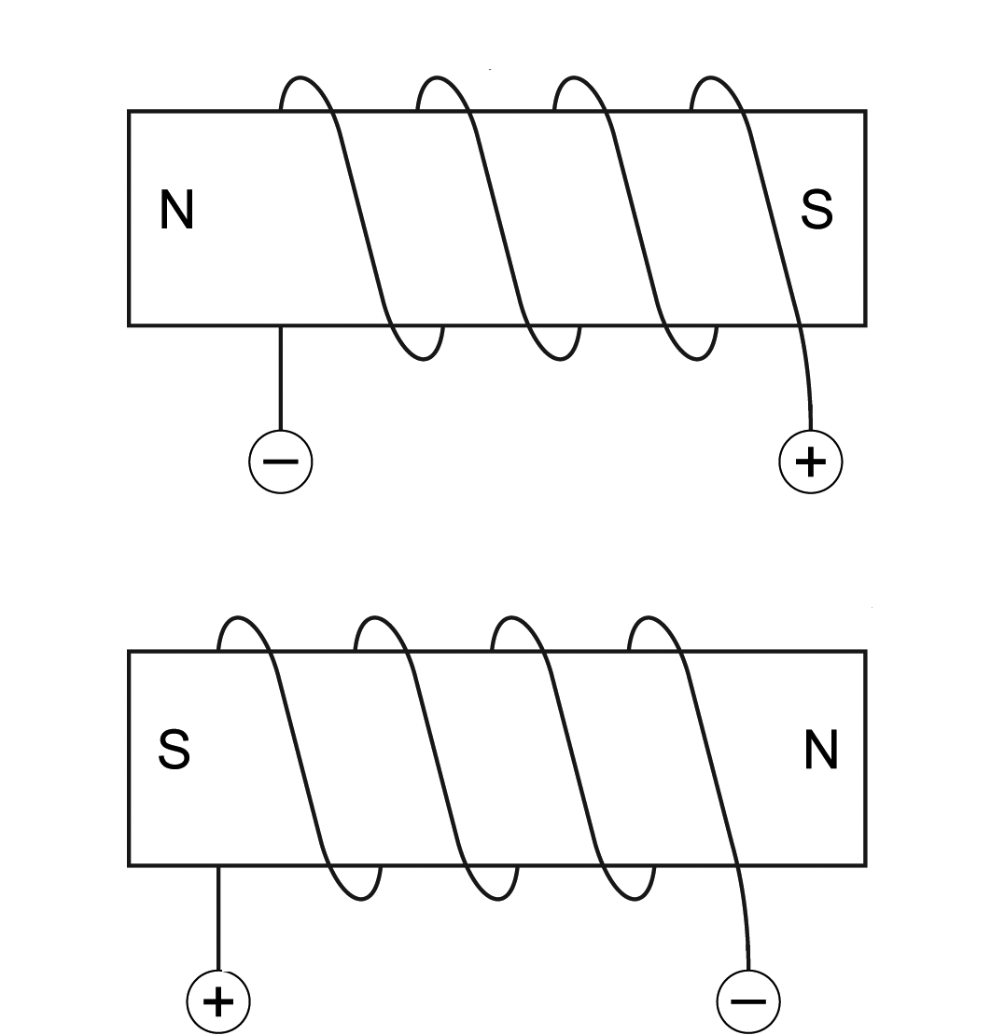
a)
b)

