Electrical circuits

Support activities – Second Year of Secondary Cycle Two
ACTIVITY 22
EST
student BOOK: Chapter 5, pages 156–163
Related Handout: Concept review 22

1. Complete the following sentences, using the words or groups of words in the box below. You may use some words more than once.
• adds up  • branch out  • charges  • circuit  • circuit breakers  • conservation of charge  • conservation of energy  • continues to flow | • conventional  • current  • current intensity  • diagrams  • electrical energy  • equal to  • equivalent resistance  • flow | • motion  • negative  • node  • parallel  • positive  • potential  • power supply  • reduces | • resistors  • series  • shared  • single  • total energy acquired  • total energy transferred  • value  • wires

a) For charges to ________________________, they must be able to move in a loop like a racetrack. A circuit provides them with a loop to flow through, and a power supply keeps them in ________________________. Any ________________________ must contain at least the following three components: a ________________________ to create a potential difference, one or more elements that use _______________________ (for example, a light bulb), and ________________________ that connect the elements and the power supply.
b) Symbols and ________________________ are often used to represent electrical circuits. The current is shown in the ________________________ current direction, in other words, from the _______________________ terminal to the _______________________ terminal.
c) ________________________ circuits and ________________________ circuits are two ways of connecting the components of an electrical circuit.
d) In a ____________________ circuit, the components are connected end to end. The circuit does not ____________________, which means that all the charges follow the same path.
If one of the circuit components is defective, the ______________________ ceases to flow. The energy used by each of the resistors ______________________. Adding resistors _____________________ the energy available for each one. Fuses and ____________________ are examples of elements connected in ____________________.
e) A________________________ circuit branches out in at least one place. The ________________________ can therefore take different paths. The point at which a circuit separates into two paths is called a “________________________.” If an element of the circuit is defective, the current ________________________ through the elements in the other branches. Adding resistors ________________________ the total resistance. The current intensity is ________________________ among the various resistors.
f) Two important laws in electricity are based on the law of _______________________ and the law of ________________________. Kirchhoff’s first law states that the ________________________ flowing into an element or a node of an electrical circuit is always ________________________ the current intensity flowing out of it. Kirchhoff’s second law is about potential difference. It states that the ________________________ by the charges from the power supply is always equal to the ________________________ by these charges, whatever pathway they may take in the circuit.
EST
g) Kirchhoff’s two laws can be summarized as follows: In a _______________________ circuit, the total current intensity is equal to the current that flows through each of the ________________________, and the total potential difference is equal to the sum of the potential differences of all the resistors in the circuit. In a ________________________ circuit, the total intensity is equal to the sum of the currents flowing through each of the resistors in the circuit, and the total ________________________ difference is the same everywhere, for each element in the circuit.
EST
h) The following equations represent Kirchhoff’s two laws:
EST
For a ________________________ circuit: I_{total} = I₁ = I₂ = I₃ = I₄ = …
V_{total} = V₁ + V₂ + V₃ + V₄ + …
For a ________________________ circuit: I_{total} = I₁ + I₂ + I₃ + I₄ + …
V_{total} = V₁ = V₂ = V₃ = V₄ = …
i) The ________________________, symbolized by the letters R_{eq}, is equal
to the resistance value needed to replace all the resistors in a circuit with a ________________________ resistor. By applying Ohm’s law and Kirchhoff’s laws, this ________________________ can be calculated with the following equations:
EST
For a ________________________ circuit: R_{eq} = R₁ + R₂ + R₃ + R₄ + …
For a ________________________ circuit: R_{eq} =
1
+ + + …
1
R₁
1
R₂
1
R₃
2. Draw a series circuit and a parallel circuit that each include a power supply, two light bulbs and two resistors.
a) series circuit b) parallel circuit

3. Calculate the resistance value in the circuit below.

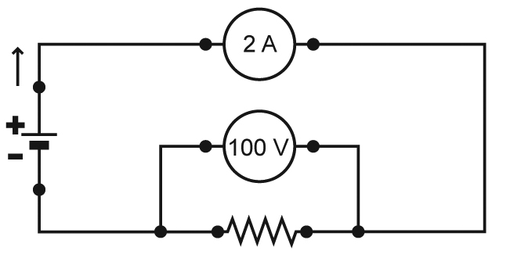
EST

4. Calculate the current intensity flowing through the R₁ resistor in the circuit below.
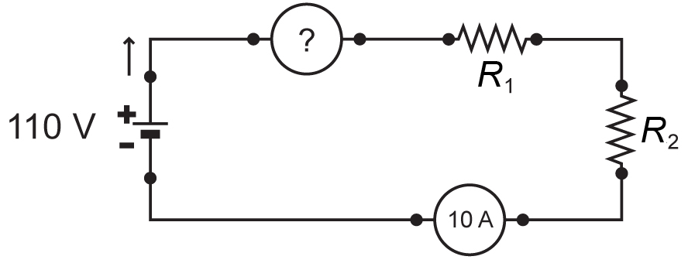
5. In the circuit below, what is the potential difference at the terminals of the power supply?
EST
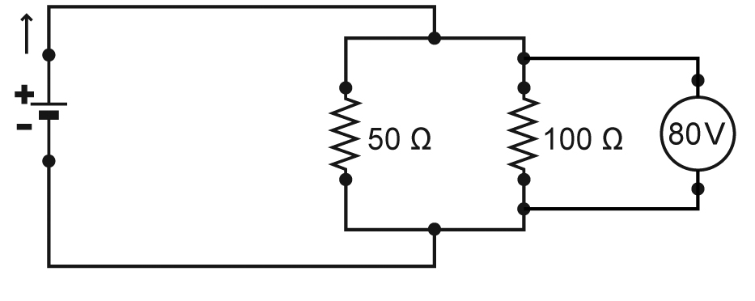
6. In the table below, write the equations that express the application of Ohm’s law and
Kirchhoff’s laws to series and parallel circuits.
EST
Characteristic | Series circuit | Parallel circuit
Current intensity
Potential difference
Equivalent resistance
7. Calculate the equivalent resistance in each of the following three circuits.
EST
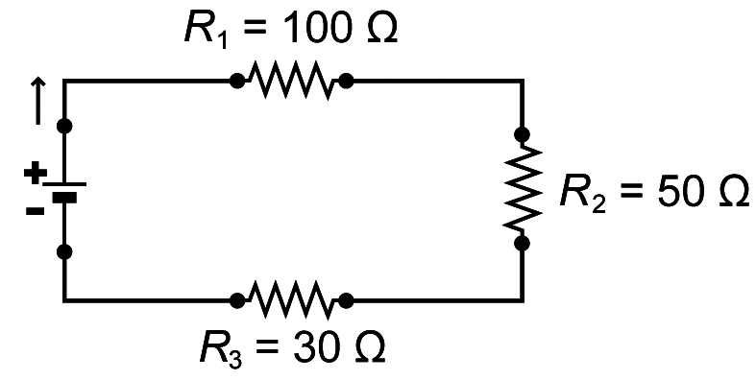
a)

b) 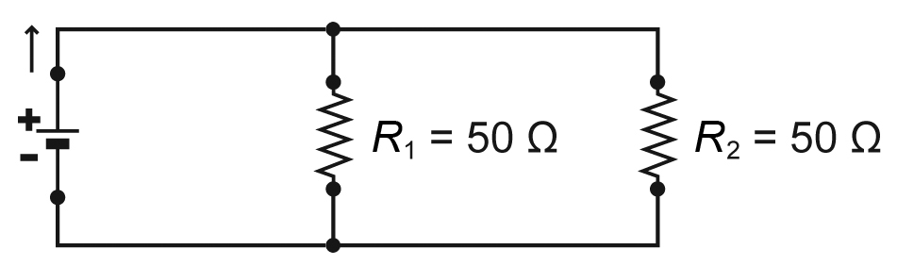
c) 