Representing atoms

Support activities – Second Year of Secondary Cycle Two

ACTIVITY 3
EST
student BOOK: Chapter 1, pages 26–29
RELATED HANDOUT: Concept review 3

1. Complete the following sentences, using the words or groups of words in the box below. You may use some words more than once.
• 18 electrons  • arcs  • around  • atomic number  • ball-and-stick  • balls  • bonds  • chemical reactivity | • dots  • fourth shell  • group  • group number  • innermost shell  • Lewis notation  • nearest  • neutrons | • one  • period  • points of a compass  • protons  • relative atomic mass  • round off  • Rutherford-Bohr  • second shell | • simplified  • size  • subtract  • three  • three facts  • two  • valence

a) To explain ___________________________, researchers have represented the atom with different models: ___________________________, the ___________________________ atomic model, the ___________________________ atomic model and the “___________________________” atomic model.

b) As a rule, electrons try to fill the electron shells ___________________________ the nucleus before occupying a farther shell. For the first 20 elements of the periodic table, the _________________________ can contain a maximum of _________________________ electrons. The ___________________________ can contain a maximum of eight electrons. The third shell can contain a maximum of ___________________________. However, after eight electrons, the next electrons begin to fill the ___________________________, before returning to the third. In this way, the number of valence electrons always corresponds to the ___________________________ of the element.

c) Lewis notation is a representation of the atom in which the valence electrons are illustrated by ___________________________ placed around the chemical symbol of the element.
The electrons are placed one by one around the symbol, like the four ___________________________. Next, the electrons are doubled to form pairs of dots ___________________________ the element (for example, neon is represented by eight
valence electrons).

d) To represent the atom according to the Rutherford-Bohr model, we must know ___________________________, drawn from the periodic table. The ___________________________ indicates the number of electron shells in the atom.
The _________________________ indicates the number of _________________________ electrons. The ___________________________ indicates the total number of protons
(and of electrons) in the atom.
e) Sodium, for example, presents the following three facts: It has _______________________
electron shells because it is in the third period. It has ___________________________ valence electron because it belongs to Group IA. Its ___________________________ is 11, which tells us it has 11 protons and 11 electrons. A sodium atom according to the Rutherford-Bohr model appears as follows:
f) The simplified atomic model of the atom resembles the Rutherford-Bohr model except that the number of ___________________________ is shown and the electron shells are drawn as ___________________________. To find the number of neutrons, we round
off the ___________________________ to the nearest whole number and ___________________________ the total number of protons from this number.
EST

g) To represent a sodium atom with the simplified atomic model, we must know its ___________________________, which is 22.99. Next, we must ___________________________ the mass to the nearest whole number, which is 23.
The number of ___________________________ is 11. To find the number of
___________________________, we must subtract the second number from the first:
23 – 11 = 12. A sodium atom according to the simplified model appears as follows:
EST

h) In the “_________________________” atomic model, the atoms appear as _________________________, whose _________________________ varies depending
on the number of electron shells. The chemical _________________________ are shown with sticks.

2. Draw a Lewis structure for each of the following elements.
a) boron d) sulphur
b) sodium e) phosphorus
c) oxygen f) fluorine
3. For each of the following elements, write its group number and the number of valence electrons in its outermost electron shell.
a) lithium
b) chlorine
c) argon
d) calcium
4. Draw each of the following elements according to the Rutherford-Bohr atomic model.
a) aluminum d) chlorine
b) boron e) beryllium

c) nitrogen f) sulphur

5. Draw each of the following elements according to the simplified atomic model.
a) magnesium d) oxygen
EST
b) silicon e) helium

c) carbon f) fluorine

6. Match each of the following compounds to the corresponding “ball-and-stick”
atomic model.
EST
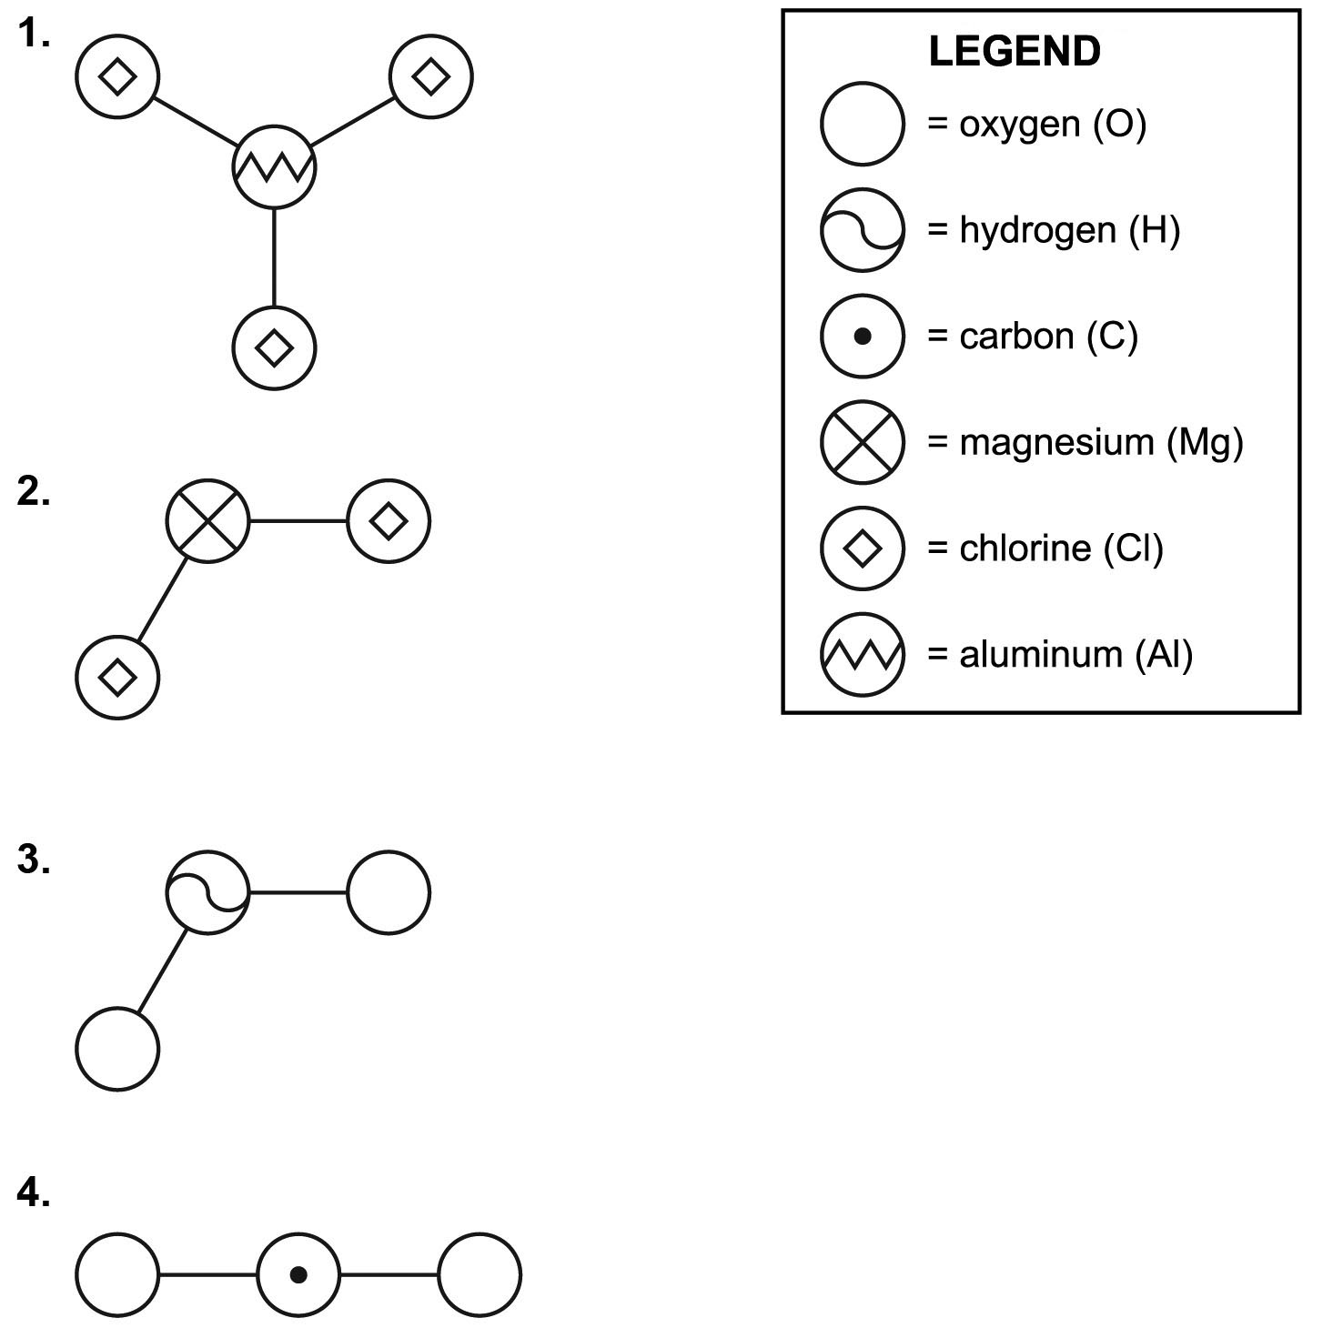
a) H₂O b) MgCl₂ c) CO₂ d) AlCl₃

