The toxicity threshold

Science labs
PROGRAMS: EST, SE
LAB TYPE: Observation
CONCEPT: Ecotoxicology (contaminants)
student BOOK: Chapter 10, page 334
TOOLBOX: Pages 23–24

GOAL
LAB 69
Observe the effect of an alcohol solution on daphnia.
observation CRITERIA
1. What is a contaminant?
2. What is the necessary condition for considering a contaminant toxic to an organism?
3. What is the toxicity threshold?
4. When you observe a daphnia under the microscope, you can see its heart beating. What visual clue could help you determine whether a substance affects the daphnia’s health?
MatEriAlS
• plastic pipette
• 3 daphnia
• 3 cavity slides
• 3 microscopes
• dropper bottle of distilled water
• dropper bottle of 10% alcohol solution
• dropper bottle of 50% alcohol solution
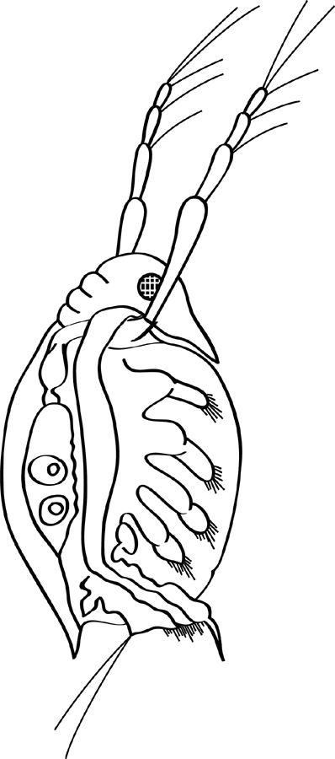
Antenna
Eye
Legs
Digestive tube
Heart
pROCEDURE | 
1. With the pipette, pick up one daphnia. Choose one of the largest individuals.
2. Place the daphnia in the cavity of a slide.
3. Remove as much water as you can from around the daphnia.
4. Add a drop of distilled water to the cavity.
5. Install the slide on the stage of the first microscope and adjust the focus.
6. Lower the light intensity to keep the daphnia from overheating.
- Observe the daphnia. Locate the eye, antennae, digestive tube, legs and heart.

8. Carefully observe the daphnia’s heart rate. Count the beats for 10 seconds. Record the result.
9. Repeat steps 1 to 6 with another daphnia placed in another slide, but this time add a
drop of 10% alcohol solution instead of distilled water.
10. Install the slide on the stage of the second microscope.
11. Count the heartbeats of the daphnia for 10 seconds. Compare the heart rate of this
daphnia with the heart rate of the daphnia in distilled water. Record the result.
12. Repeat steps 1 to 6 with another daphnia placed in another slide, but this time add a
drop of 50% alcohol solution.
13. Install the slide on the stage of the third microscope.
14. Count the heartbeats of the daphnia for 10 seconds. Compare the heart rate of this
daphnia with the heart rate of the daphnia in distilled water. Record the result.
15. Wait about five minutes, and then check to see if the daphnia’s hearts are still beating. Record the result.
16. Clean up and put away the materials.

observations
Record your observations in the table below. Give your table a title.
Title:

Liquid medium | Effect on heart rate immediately after  adding water/solution | Effect on heart rate  5 minutes after  adding water/solution
Distilled water
10% alcohol solution
50% alcohol solution
ReFLECTING ON YOUR OBSERVATIONS
1. What effect does a high concentration of alcohol have on the heart rate of a daphnia?
2. What is the concentration range of the toxicity threshold for alcohol in daphnia? Explain your answer, referring to your observations.
3. What other elements could you consider to determine whether the alcohol is toxic to the daphnia?
4. What does this lab suggest about the effect alcohol may have on human heart rates?
5. Have your observations helped you understand how to determine the toxicity threshold of a contaminant in a living organism? Explain your answer.
6. How could you improve the protocol for this lab?

