Ecological factors

Science labs
PROGRAMS: ST, EST
LAB TYPE: Observation
CONCEPT: Study of populations (density, biological cycles)
student BOOK: Chapter 9, page 299

GOAL
LAB 66
Observe certain factors that can affect earthworms.
OBSERVATION CRITERIA
1. What is an ecological factor?
2. a) What are the two types of ecological factors?
b) Briefly describe each type of factor.
3. If earthworms are placed between two environments offering different living conditions, toward which environment will the worms tend to migrate?
MatEriAlS
• cardboard box or opaque, rectangular • 4 earthworms
plastic container • sandpaper
• black soil • dry sand
• piece of cardboard • spray bottle of water
• light source

pROCEDURE | 
Part A: Observing how earthworms react to light
1. Cover the bottom of the box with a thin layer of soil.
2. Cover half of the box with the piece of cardboard.
3. Turn on the light source and direct it toward the open half of the box.
4. Place the worms at the edge of the lit part of the box.
5. Observe the worms for about 5 minutes. Note which side of the box they move toward. Record your observation.
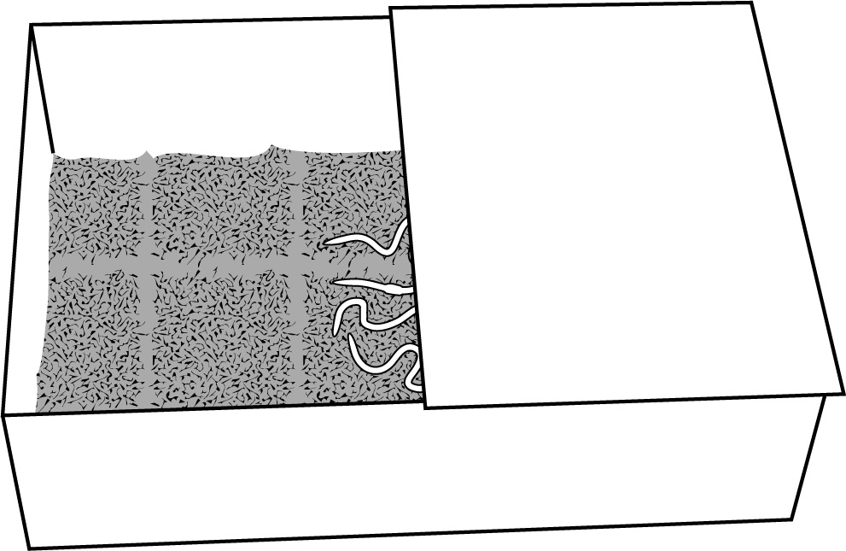
Part B: Observing how earthworms react to a rough surface
1. Remove the soil and worms from the bottom of the box.
2. Fold a piece of sandpaper in half and use it to line one half of the bottom of the box.
3. Place the worms at the edge of the sandpaper.
4. Observe the worms for about 5 minutes. Note which side of the box they move toward. Record your observation.
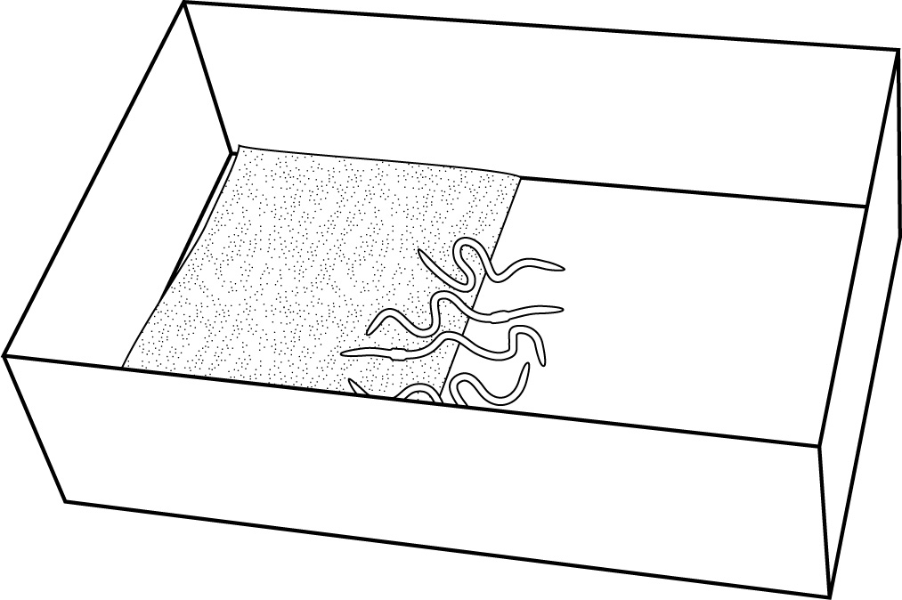

Part C: Observing how earthworms react to humidity
1. Remove the worms and sandpaper from the box.
2. Line the bottom of the box with a thin layer of dry sand.
3. Use the spray bottle to moisten half the sand in the bottom of the box.
4. Place the worms at the edge of the wet sand.
5. Observe the worms for about 5 minutes. Note which side of the box they move toward. Record your observation.
6. Clean up and put away the materials.
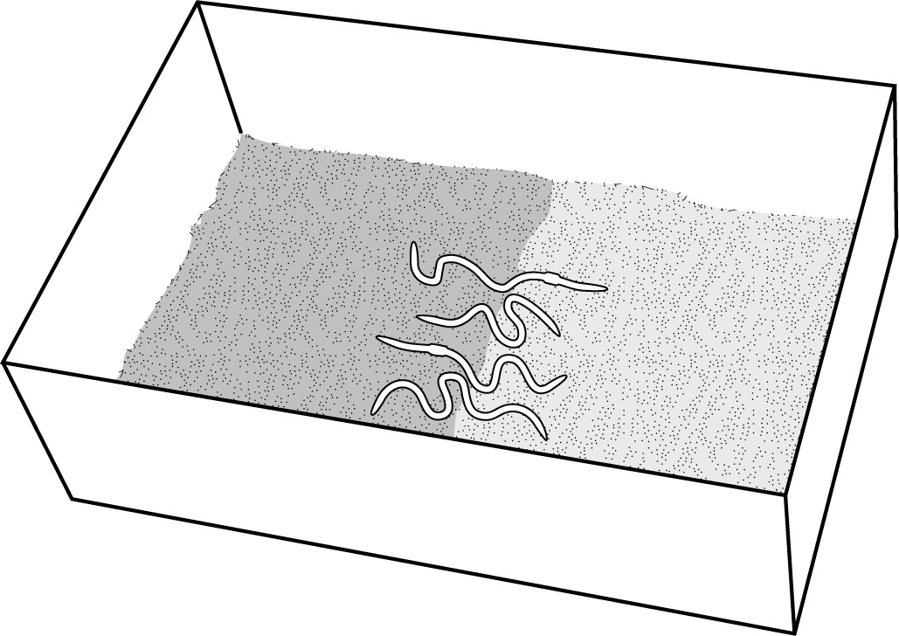
observations
Record your observations in the table below. Give your table a title.
Title:

Observation | Environment 1 | Environment 2 | Environment chosen by earthworms

A
B
C
REFLECTING ON YOUR OBSERVATIONS
1. This lab involved three ecological factors.
a) List the three ecological factors.
b) Based on your observations, explain how you know that these are ecological factors.
c) Were these factors abiotic or biotic? Explain your answer.
2. Answer the following questions, referring to your observations.
a) Do earthworms prefer light or shade? What do you think is the reason for this preference?
b) Do earthworms prefer rough or smooth ground? What do you think is the reason for this preference?
c) Do earthworms prefer a damp or dry environment? What do you think is the reason for this preference?
3. Have your observations helped you understand ecological factors? Explain your answer.
4. How could you improve the protocol for this lab?

