An artificial aquatic biome

Science labs
LAB 63
PROGRAMS: ST, EST
LAB TYPE: Technique
CONCEPT: Aquatic biome
student BOOK: Chapter 8, page 272
TOOLBOX: Pages 19–20

GOAL
Apply a method for creating an artificial aquatic biome.
MatEriAlS
• large plastic container • functional aquarium
• 250-mL graduated cylinder • 2 or 3 pond snails (Lymnaeidae)
• liquid antibacterial soap • thermometer
• brush • universal indicator paper
• strainer • pH scale
• sand or gravel • goldfish
• aquatic plants • Siamese fighting fish
• decorative items for an aquarium (optional) • guppies
• long wooden spoon • fish net
• dropper
pRoCEDURE | 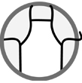
1. Note the volume indicated on the plastic container or determine its volume, using the graduated cylinder and water. Record the volume.
2. Scrub the container with liquid antibacterial soap and water.
3. Rinse the container several times with water to remove all traces of soap.
4. Place enough sand or gravel in the strainer to completely cover the bottom of the container with a 5-cm layer. Rinse the sand or gravel and pour it into the container.
5. Add just enough water to cover the sand or gravel.
6. Plant the aquatic plants (and the decorative items) in the sand or gravel.
7. Carefully pour in water to the desired level.
8. With the wooden spoon, take a small amount of sand or gravel from the aquarium.
9. Add the sand or gravel to the container.
10. With the dropper, take a few millilitres of water from the aquarium.
- Add the water to the container.
- Let your artificial biome sit for at least two days to let chlorine in the water evaporate and give bacteria from the aquarium a chance to spread.
13. Add 2 or 3 snails to your artificial biome.
14. Take the water temperature reading in your artificial biome with the thermometer. Record
the temperature.

15. Measure the pH of the water in your artificial biome with the universal indicator paper.
Record the pH value.
Fish species | Ideal temperature  (ºC) | Ideal pH | Behaviour
Goldfish | Between 18°C and 25°C | From 7.0 to 8.0 | Tolerates other fish well.
Siamese fighting fish | Between 21°C and 29°C | Ideally 7.0 | Does not tolerate other fish.
Guppy | Between 22°C and 27°C | From 7.2 to 7.6 | Tolerates other fish.

16. Based on the data in the table below, choose the appropriate species and numbers of fish
for your artificial biome. Usually a minimum of 2 L of water is required for each cm in length
of fish (not counting tail fins).
17. Use a fish net to place the fish you have chosen in your artificial biome.
18. Clean up and put away the materials.
EXPERIMENTAL SETUP
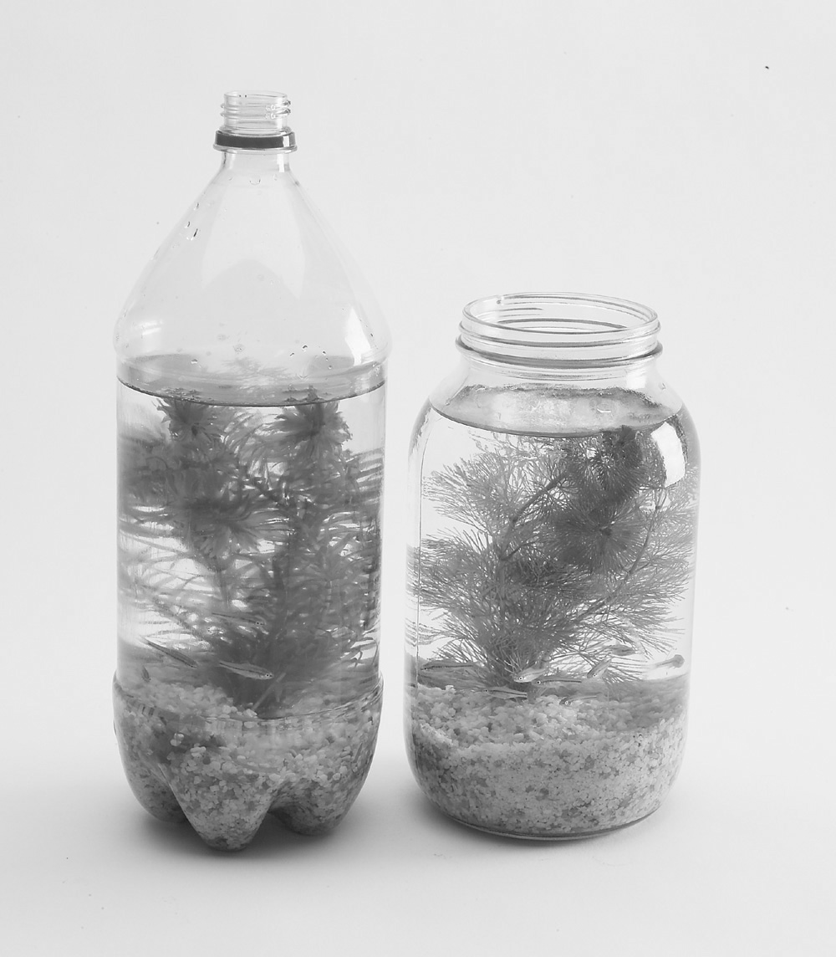
REsults
1. Volume of the container:
2. Temperature of the artificial biome:
3. pH of the water in the artificial biome:
4. Species and number of fish selected:
REFLECTING ON the lab technique
1. Why was it important for your container to be clean and free of soap?
2. Explain what makes the biome you built an aquatic biome.
3. Explain what makes the biome you built a freshwater biome.
4. Name at least two characteristics that your artificial biome has in common with a typical lake in Québec.
5. Name at least two characteristics of your artificial biome that are different from those of a typical lake in Québec.

6. Which elements of your biome act as filters to eliminate the fish’s waste? Name one living element and one non-living element.
7. What are you going to do to keep the contents of your biome alive?
8. What are the possible sources of error in this lab?
9. How could you improve the protocol for this lab?

