Terrestrial biomes

Science labs
PROGRAMS: ST, EST
LAB TYPE: Observation
CONCEPT: Terrestrial biomes
student BOOK: Chapter 8, page 263

GOAL
LAB 62
Observe terrestrial biomes that can support the growth of grass, impatiens and beans.
OBSERVATION CRITERIA
1. What are biomes?
2. Name the seven main types of terrestrial biomes.
3. What observations could lead you to conclude that a plant is well adapted to a particular biome?
Materials
• 2-L milk carton • 30 grass seeds
• stapler • watering can
• scissors • tap water
• 30-cm ruler • plastic wrap
• black soil • elastic bands
• dry sand • lamp
• 10 impatiens seeds • switch with an automatic timer
• 5 bean seeds • spray bottle of tap water

pROCEDURE | 
1. Make sure the milk carton is empty and clean.
2. Close the spout on the carton and staple it closed.
3. With the scissors, cut out and remove one of the four sides of the carton.
4. On the side opposite the one you removed, punch 4 holes, each about 15 mm in diameter. Place the carton with this side down on the work surface.
5. Choose one set of growing conditions from the table below.
Setup | Soil type | Light exposure  per day | Watering instructions
1 | Sand | 8 hours of direct light | Let the sand dry out completely; then, spray to dampen the surface.
2 | Black soil | 1 hour of direct light,  7 hours of indirect light | When the surface of the soil is dry, add water until the entire surface is wet again.
3 | Black soil | 8 hours of direct light | When the surface of the soil is dry, add water until the entire surface is wet again.
4 | Black soil | 8 hours of indirect light | Keep the soil damp.

Growing conditions for plants
6. Fill the milk carton to 3 cm below the brim with the type of soil for your setup.
7. Divide the soil surface into three sections.
8. In the section closest to the spout, plant the impatiens seeds.
9. Plant the bean seeds in the middle section.
10. In the third section, scatter the grass seeds.
11. Water the seeds thoroughly.
12. Cover the opening with plastic wrap, securing it with elastic bands if necessary.
13. Leave the carton in a warm place for about 10 days to give the seeds time to germinate.
14. When most of the seeds have germinated, program the timer. Place the lamp so that it will provide the amount of light described in the selected setup.
15. Water the plants according to the instructions. Leave the plastic wrap in place at all times except during watering.
16. After two weeks, observe the plants to see how they have grown under the conditions provided. Record the results.
17. Clean up and put away the materials.

EXPERIMENTAL SETUP
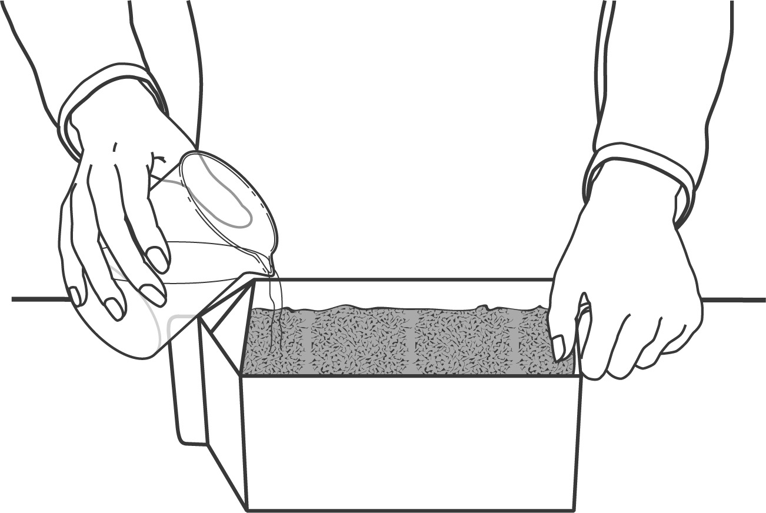
observations
Record your observations in the table below. Give your table a title.
Title:

 
Setup | Plant | Were the conditions favourable? | Observations
 | Impatiens
 | Beans
 | Grass

Setup | Plant | Were the conditions  favourable? | Observations
 | Impatiens
 | Beans
 | Grass

Setup | Plant | Were the conditions favourable? | Observations
 | Impatiens
 | Beans
 | Grass
REFLECTING ON YOUR OBSERVATIONS
1. Which factors determining terrestrial biome distribution did this lab demonstrate?
2. Which type of biome did each setup in this lab represent?
Setup | Biome
1
2
3
4
3. Have your observations helped you understand how plants survive in biomes with growing conditions like those you created in this lab? Explain your answer.
4. How could you improve the protocol for this lab?

