Air pollution

Science labs
PROGRAMS: EST, SE
LAB TYPE: Observation
CONCEPT: Contamination (atmosphere)
student BOOK: Chapter 7, page 235

TOOLBOX: Page 20

GOAL
LAB 60
Observe the effect of sulphur dioxide on water pH.
observation criteria
1. Below which level on the pH scale is rain considered acid rain?
2. How can we determine the pH of a solution?
3. What are the main atmospheric contaminants that cause acid rain? Where do they come from?
4. How does the combustion of certain substances make water acidic?
Materials
• stibnite (Sb₂S₃) or another • dropper of litmus solution
metallic sulphide (FeS₂, ZnS, PbS, etc.) • 2 strips of universal indicator paper
• test tube (25 mm × 150 mm) • 60-cm flexible tubing
• retort stand • 15-cm flexible tubing
• universal clamp • syringe
• two-hole stopper (No. 4) fitted with • adhesive tape
2 glass elbow tubes • Bunsen burner
• wash bottle of distilled water • lighter
• 250-mL beaker

procedure | 
1. Pour about 1 g of stibnite (Sb₂S₃) into the test tube.
- Attach the test tube to the retort stand with the universal clamp.
- Stopper the test tube with the two-hole stopper.
- Pour about 150 mL of distilled water into the beaker. Add 6 drops of litmus solution to
obtain a dark colour. Record the colour of the liquid.
- Take the pH reading of the water with a strip of indicator paper. Record the result.
6. Fit one end of the 60-cm tubing onto one of the glass elbow tubes and insert the other end into the water in the beaker.
7. Fill the syringe to the 140-mL mark with air and connect it to the other glass elbow tube
with the 15-cm tubing. Attach the syringe to the retort stand with adhesive tape.
- Light the Bunsen burner and place it so that the flame heats the bottom of the test tube.
- After heating the stibnite for 2 minutes, press down slowly on the syringe plunger to push
the gas in the test tube into the water in the beaker. You should achieve a rate of 2 to 3 bubbles per second.
10. Remove the flexible tubing from the water. Turn off the burner once you have pushed the plunger all the way into the syringe.
11. Record the colour of the water.
12. Take the final pH reading of the water with the other strip of indicator paper.
13. Clean up and put away the materials.
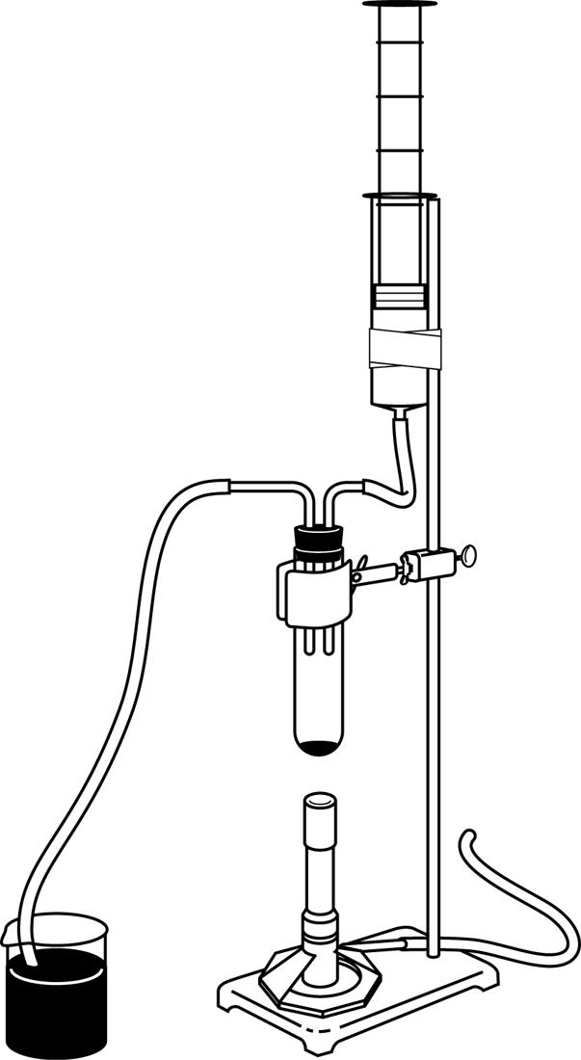
experimental setup

observations
Record your observations in the table below. Give your table a title.
Title:

Observation of water mixed with litmus solution | Initial reading  (before reaction) | Final reading  (after reaction)
Colour
pH
REFLECTING ON YOUR OBSERVATIONS
1. How was the pH altered in this lab? What conclusion can you draw?
2. Name the three main atmospheric contaminants that cause acid rain. For each contaminant, name the acid it forms on contact with the oxygen and humidity in the air.
•
•
•
3. What are the principal sources of sulphur dioxide (SO₂) and nitrogen oxides (NO_{x})?
4. Have your observations helped you understand how air pollution causes acid rain?
5. How could you improve the protocol for this lab?

