The greenhouse effect

Science labs
PROGRAMS: ST, EST, SE
LAB TYPE: Experiment
CONCEPT: Greenhouse effect
student BOOK: Chapter 7, page 233

TOOLBOX: Page 19

GOAL
LAB 59
Compare the temperature variation shown on a thermometer in the open air with the temperature variation shown on a thermometer inside a bottle when both thermometers are exposed to a bright light.
1. What is the independent variable in this lab?
2. What is the dependent variable in this lab?
HypothEsiS
I think that
because
MatEriAlS
• 2 thermometer clamps
• retort stand
• 2 thermometers
• 710-mL green plastic bottle with its cap, perforated
• 250-W infrared lamp
• stopwatch
pROCEDURE | 
1. Attach both thermometer clamps to the ring stand, one right above the other.
2. Insert one thermometer into the hole in the bottle cap (still on the bottle). Attach the thermometer securely to the retort stand with one clamp.
3. Attach the second thermometer to the second clamp, positioning the thermometer at
the same height as the first and about 10 cm away from the bottle.
4. Place the infrared lamp about 30 cm from the experimental setup so that it throws light
on both thermometers (spaced about 10 cm apart).
5. Record the temperature readings on both thermometers.
6. Turn on the infrared lamp and immediately start the stopwatch.
7. For the next 5 minutes, record the temperature readings on both thermometers every
30 seconds.
8. Put away the materials.
EXPERIMENTAL SETUP
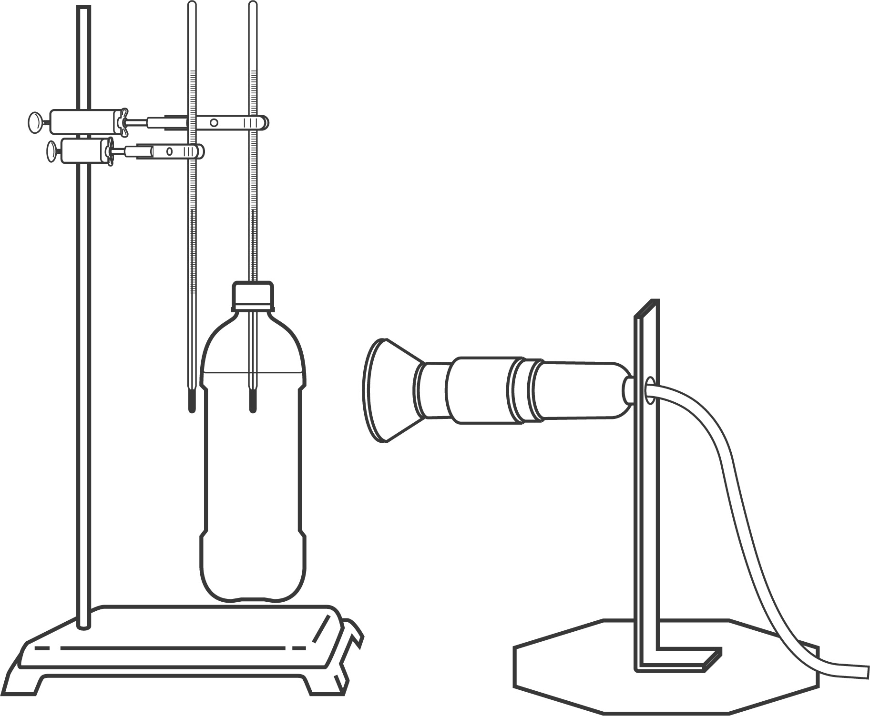
REsults
Record your results in the table below. Give your table a title.
Title:

Time  (s) | Temperature on  thermometer in the open air  (ºC) | Temperature on  thermometer in the bottle  (ºC)
0
30
60
90
120
150
180
210
240
270
300
ANALYSIS OF THE RESULTS
1. How do you know that the light bulb emitted heat?
2. What was the temperature variation recorded by the thermometer in the open air? Show your calculations.
3. What was the temperature variation recorded by the thermometer in the bottle? Show your calculations.
4. Which thermometer showed the greater variation in temperature? Why?
5. Would it be correct to say that the bottle helped retain the heat from the light bulb? Explain your answer.
6. What is the process by which heat from a thermal energy source is retained?
7. If the bottle had been filled with carbon dioxide (CO₂) or methane (CH₄), how would this have affected the temperature variation? Explain your answer.
8. What are the possible sources of error in this lab?
9. How could you improve the protocol for this lab?
Conclusion
1. What do you conclude from this lab?
2. Was your hypothesis confirmed or not? Explain your answer.
APPLICATION
Explain why, in summer, the temperature rises more quickly inside a car than outside it.

