Relative humidity

Science labs
PROGRAMS: ST, EST, AST
LAB TYPE: Technique
CONCEPT: Air mass
student BOOK: Chapter 7, page 229

TOOLBOX: Pages 49–50

GOAL
LAB 58
Practise a method for measuring relative humidity.
MatEriAlS
• 2 thermometer clamps • piece of gauze
• retort stand • wash bottle of water
• 2 thermometers • thin elastic band
pROCEDURE |  | 
1. Attach the thermometer clamps to the retort stand.
2. Attach the thermometers to the clamps so that they touch neither the work surface nor the base of the retort stand.
3. Wet the gauze with water.
4. Completely cover the bulb of one thermometer with wet gauze.
5. Use the elastic band to hold the wet gauze on the bulb. This thermometer will be the
wet-bulb thermometer.
6. Wait about 4 minutes.
7. Record the temperature reading on the dry-bulb thermometer.
8. Record the temperature reading on the wet-bulb thermometer.
9. Subtract the temperature of the wet-bulb thermometer from the temperature of the dry-bulb thermometer and record the result.
10. Find the relative humidity value in the chart below, at the intersection of the two values obtained experimentally: the wet-bulb thermometer temperature (first column of the chart) and the result of the subtraction in step 9 (second row of the chart). Record the relative humidity value in the “Calculations” section.
Wet-bulb thermometer temperature (°C) | Dry-bulb thermometer temperature – wet-bulb thermometer temperature
Wet-bulb thermometer temperature (°C) | 0 |  | 0.5 |  | 1 | 1.5 | 2 | 2.5 | 3 | 3.5 | 4 | 4.5 | 5 | 5.5 | 6
0 | 100 |  | 90 |  | 81 | 72 | 64 | 56 | 50 | 42 | 36 | 30 | 25 | 20 | 16
1 | 100 |  | 91 |  | 82 | 74 | 66 | 58 | 52 | 45 | 39 | 34 | 28 | 23 | 18
2 | 100 |  | 91 |  | 83 | 75 | 67 | 60 | 54 | 48 | 42 | 36 | 31 | 26 | 22
3 | 100 |  | 92 |  | 84 | 76 | 69 | 62 | 56 | 50 | 44 | 39 | 34 | 29 | 25
4 | 100 |  | 92 |  | 84 | 77 | 70 | 64 | 57 | 52 | 47 | 41 | 36 | 32 | 28
5 | 100 |  | 93 |  | 85 | 78 | 71 | 65 | 59 | 54 | 48 | 43 | 39 | 34 | 30

6 | 100 | 93 | 85 | 79 | 72 | 66 | 61 | 55 | 50 | 45 | 41 | 36 | 33
7 | 100 | 93 | 86 | 79 | 73 | 67 | 62 | 57 | 52 | 47 | 43 | 39 | 35
8 | 100 | 93 | 87 | 80 | 74 | 69 | 63 | 58 | 54 | 49 | 45 | 41 | 37
9 | 100 | 94 | 87 | 81 | 75 | 70 | 65 | 60 | 55 | 51 | 47 | 43 | 39
10 | 100 | 94 | 87 | 82 | 76 | 71 | 66 | 61 | 57 | 53 | 49 | 45 | 41
11 | 100 | 95 | 89 | 83 | 77 | 72 | 67 | 62 | 58 | 54 | 50 | 47 | 43
12 | 100 | 94 | 89 | 83 | 78 | 73 | 68 | 63 | 59 | 56 | 52 | 48 | 44
13 | 100 | 95 | 90 | 84 | 78 | 74 | 69 | 65 | 61 | 57 | 53 | 50 | 46
14 | 100 | 95 | 89 | 84 | 79 | 74 | 70 | 66 | 62 | 58 | 54 | 51 | 47
15 | 100 | 94 | 89 | 84 | 80 | 75 | 71 | 67 | 63 | 59 | 55 | 52 | 49
16 | 100 | 95 | 90 | 85 | 80 | 76 | 72 | 68 | 64 | 60 | 57 | 54 | 50
17 | 100 | 95 | 90 | 85 | 81 | 77 | 72 | 69 | 65 | 62 | 58 | 55 | 52
18 | 100 | 95 | 90 | 86 | 81 | 77 | 74 | 70 | 66 | 63 | 59 | 56 | 53
19 | 100 | 95 | 91 | 86 | 82 | 78 | 74 | 70 | 66 | 63 | 60 | 57 | 54
20 | 100 | 96 | 91 | 87 | 82 | 78 | 74 | 71 | 67 | 64 | 51 | 58 | 55
21 | 100 | 96 | 91 | 87 | 83 | 79 | 75 | 72 | 68 | 65 | 52 | 59 | 56
22 | 100 | 96 | 91 | 87 | 83 | 80 | 76 | 72 | 69 | 66 | 63 | 60 | 57
23 | 100 | 96 | 91 | 87 | 84 | 80 | 76 | 73 | 69 | 67 | 63 | 61 | 58
EXPERIMENTAL SETUP
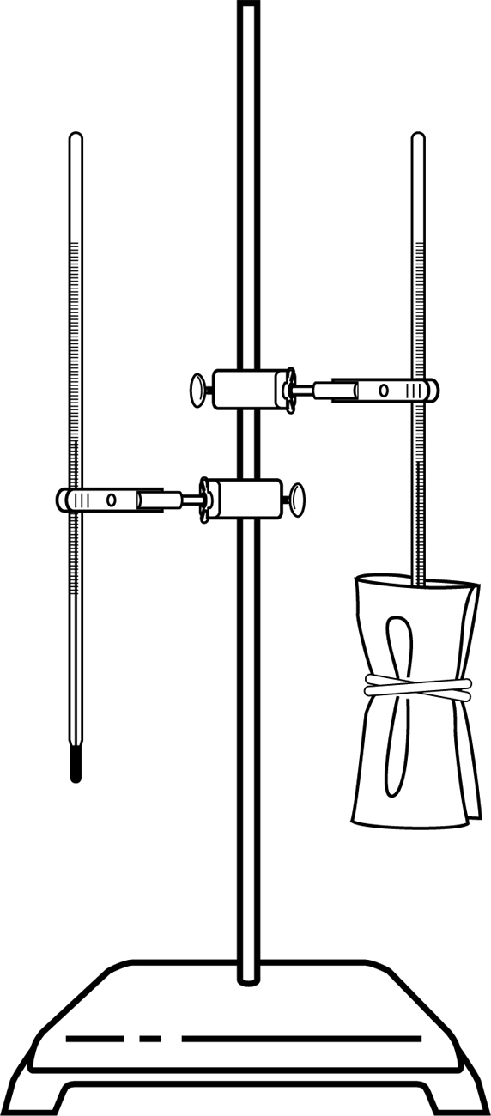
rEsultS
Record your results in the table below. Give your table a title.
Title:

Thermometer | Temperature (ºC)

Dry-bulb thermometer
Wet-bulb thermometer
Difference (dry-bulb minus wet-bulb)
CalculATIONS
Dry-bulb thermometer temperature – wet-bulb thermometer temperature

Relative humidity in the classroom:
ReFLECTING ON THE laB technique
1. Check the statement below that best describes relative humidity.
□ Relative humidity is the amount of water in the air, expressed as a percentage.
□ Relative humidity is the proportion of air that is made up of water, expressed as a percentage.
□ Relative humidity is the ratio (expressed as a percentage) of the amount of water vapour in the air to the maximum amount of water vapour that air can hold.
2. In which zones of air masses does relative humidity tend to change rapidly?
3. | What instrument is used to measure relative humidity?
4. What are the possible sources of error in this lab?

5. How could you improve the protocol for this lab?
6. Compare your result with the results obtained by other teams. Are they similar? If not, what could account for the differences?
Challenge questions
7. Explain why the wet-bulb thermometer reading is different from the dry-bulb thermometer reading when relative humidity is not 100%.
8. If you had used a substance with a different specific heat capacity from that of water to wet the gauze, would the wet-bulb thermometer temperature have been the same? Explain your answer.

