Atmospheric circulation

Science labs
PROGRAMS: ST, EST, AST, SE
LAB TYPE: Observation
CONCEPTS: Atmospheric circulation, air mass
student BOOK: Chapter 7, page 226

GOAL
LAB 57
Observe how air circulates in the atmosphere.
observation CRITERIA
1. What is atmospheric circulation?
2. What is an air mass?
3. Explain why smoke can be used to observe air movement.
4. Are the following air masses associated with areas of high or low pressure?
a) warm air mass:
b) cold air mass:
MatEriAlS
• modified shoebox • small candle • lighter or matches
• 2 cardboard cylinders • sheet of acrylic • ashtray
• ice • adhesive tape
• 250-mL beaker • 2 incense sticks
pROCEDURE | 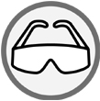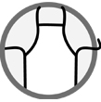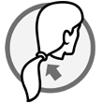
1. Place the modified shoebox on the work surface so that the two holes are on the top and
the opening faces you.
2. Place the cardboard cylinders on the holes in the box.
3. Place the ice in the beaker.
4. Place the beaker in the box under the hole to the left.
5. Light the candle and place it in the box under the hole to the right.

6. Cover the opening of the box with the sheet of acrylic.
7. Tape the acrylic sheet to the box.
8. Light an incense stick.
9. When the incense stick begins to smoke, hold it above the cardboard cylinder over the beaker of ice.
10. Observe how the smoke moves for about 5 minutes. Draw the movement in the first observation figure below.
11. If the incense stick burns down, light the second incense stick and wait until it begins to smoke.
12. Hold the incense stick above the other cardboard cylinder.
13. Once again, observe the movement of the smoke for about 5 minutes. Draw the movement in the second observation figure below.
14. Clean up and put away the materials.
observations
Illustrate your observations in the figures below. Give each figure a title.
Title:
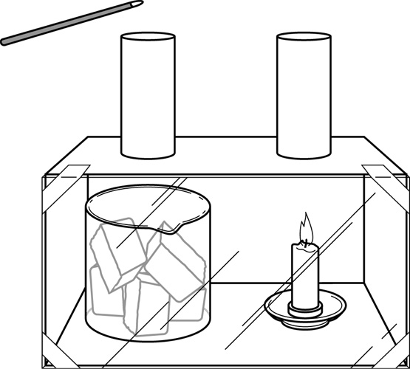
Title:

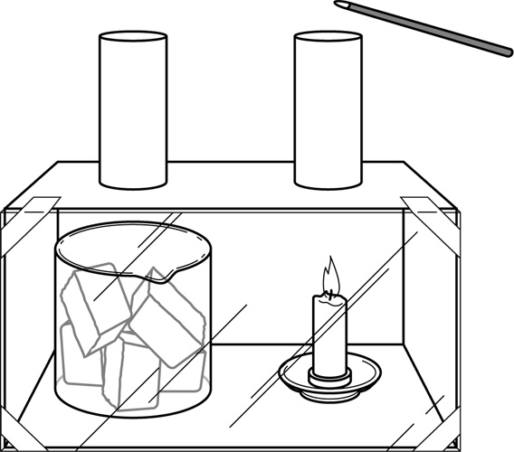
REFLECTING ON YOUR OBSERVATIONS
1. Was the air around the beaker of ice an area of high or low pressure?
2. Was the air around the candle an area of high or low pressure?
3. Based on your observations, how does air move in each of the following cases:
a) in an area of low pressure?
b) in an area of high pressure?
4. Based on your observations, in what direction does air move between an area of low pressure and an area of high pressure at ground level?
5. Have your observations helped you understand the concept of atmospheric circulation? Explain your answer.
6. How could you improve the protocol for this lab?

