Ocean circulation

Science labs
PROGRAMS: ST, EST
LAB TYPE: Observation
CONCEPT: Ocean circulation
student BOOK: Chapter 6, page 205

GOAL
LAB 55
Observe how water salinity affects water flow.
observation criteria
1. What is salinity?
2. Is tap water considered salty? Explain your answer.
3. What is an ocean current?
Materials
• small plastic tub
• tap water
• polystyrene foam cup with 2 holes punched in the bottom
• 25-cm length of adhesive tape
• 10-cm length of adhesive tape
• about 250 mL of a saltwater solution with food colouring added
procedure | 
1. Fill the plastic tub three-quarters full with tap water.
2. Use the 25-cm length of adhesive tape to cover both holes on the inside of the bottom of the cup. Make sure one end of the tape extends beyond the rim of the cup.
3. Use the 10-cm length of tape to attach the cup to one corner of the tub, well above the bottom.
4. Immerse the bottom of the cup in the water to a depth of 5 mm.
5. Fill the cup with the coloured saltwater solution.

6. Remove the adhesive tape covering the bottom of the cup by pulling gently on the free end above the rim.
7. Observe the flow of the colored salt water for 1 minute. Record the result.
8. Clean up and put away the materials.
experimental setup

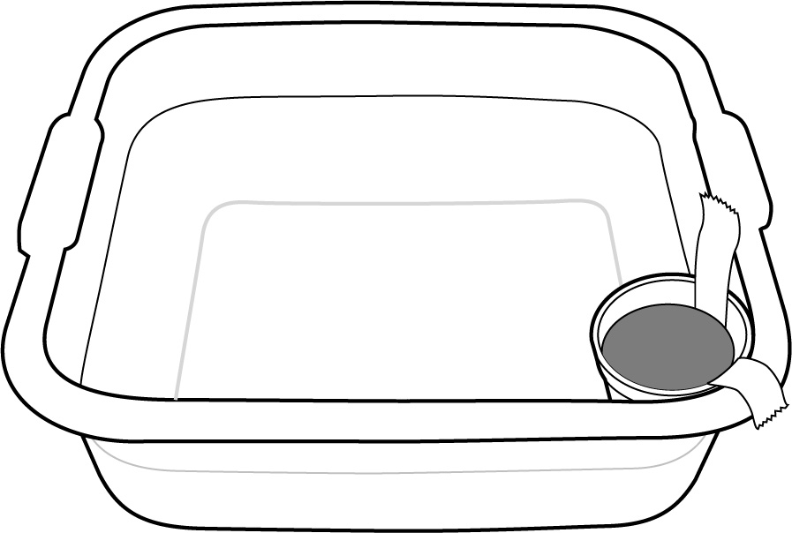
observationS
Flow of the coloured salt water:
Reflecting on your observations
1. Which has the higher density, fresh water or salt water? Explain your answer.
2. Based on your observations, what can you predict about ocean currents?
3. Have your observations helped you understand the effect of salinity on ocean currents? Explain your answer.
4. How could you improve the protocol for this lab?

