A watershed

Science labs
PROGRAMS: ST, EST, AST
LAB TYPE: Observation
CONCEPT: Watershed
student BOOK: Chapter 6, page 202

GOAL
LAB 54
Observe the flow of fertilizer in a model watershed.
observation CRITERIA
1. What is a watershed?
2. Name five factors that can affect how water flows within a watershed.
MateriAlS
• spot plate
• dropper bottle of liquid fertilizer
• dropper bottle of bromothymol blue
• glass stirring rod
• wet sand
• 2 rectangular plastic containers
• ruler
• metal spatula
• wash bottle of distilled water
• glass dropper
• 10-mL graduated cylinder
• wooden stick, about 254 mm long and 15 mm high
• marker
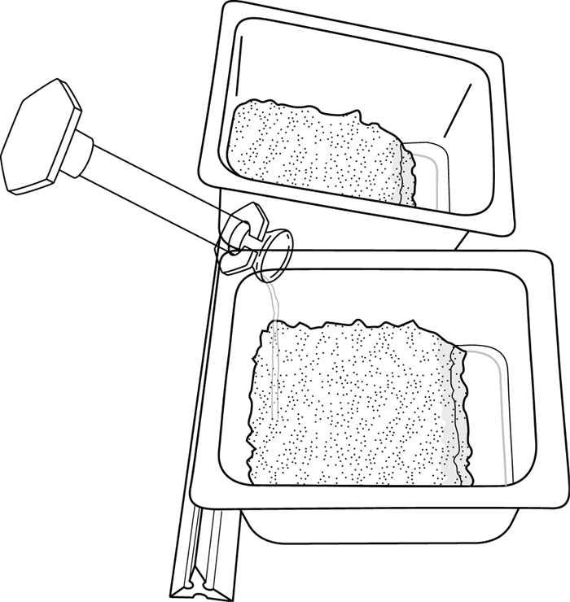
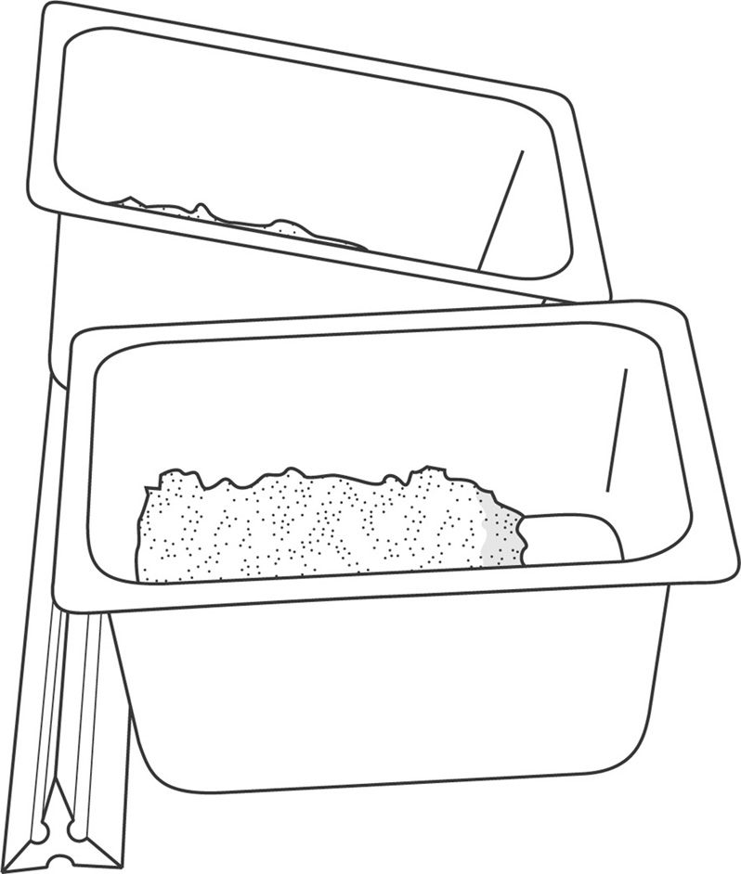
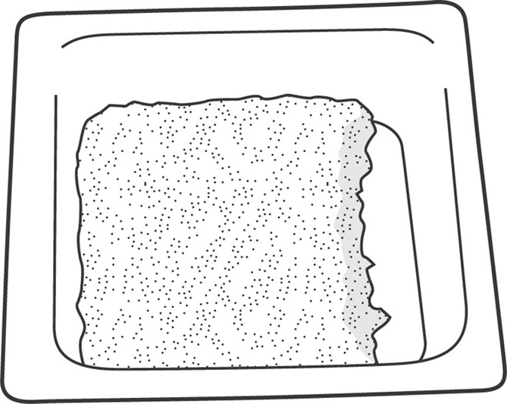
pROCEDURE | 
Part A: Observing the fertilizer pH
1. Place 10 drops of liquid fertilizer in one well of the spot plate.
2. Add 2 drops of bromothymol blue.
3. Stir with the glass rod.
4. Observe and record the colour of the resulting solution.
Part B: Creating waterways
5. Place a layer of wet sand about 2 cm deep in the bottom of each
plastic container. Smooth the top of the sand with the metal spatula.
6. Along one short side of each container, dig a trench about
2 cm wide.
Part C: Observing the pH in waterways after normal rainfall
7. Pour 10 mL of distilled water into one plastic container, along the
length of the side opposite the trench. If the sand
absorbs all the water, keep pouring a little at a time until
some water reaches the trench.
8. With the glass dropper, take up a small amount of water from the
trench and place 10 drops of it in a well of the spot plate.
9. Add 2 drops of bromothymol blue to the well.
10. Stir with the glass rod.
11. Observe and record the colour of the resulting solution.
12. Repeat steps 7 to 11 with the second plastic container, but this
time place the wooden stick under the container to tilt it toward
the trench before adding the distilled water.
Part D: Observing the pH after fertilizer application
13. Pour 5 mL of liquid fertilizer into the container lying flat on the table,
along the length of the side opposite the trench.
14. With the glass dropper, take up a small amount of liquid
from the trench. Place 10 drops of the liquid in a well
of the spot plate.
15. Add 2 drops of bromothymol blue to the well.
16. Stir with the glass rod.
17. Observe and record the colour of the resulting solution.
18. Repeat steps 13 to 17 with the tilted container.
19. Clean up and put away the materials.

OBSERVATIONS
Record your observations in the table below. Give your table a title.
Title:

Test substance | Fertilizer | Water in trench before fertilizer application |  | Water in trench after fertilizer application
Test substance | Fertilizer | Flat  container | Tilted container | Flat  container | Tilted container
Colour of bromothymol blue
ReFLECTING ON YOUR ObservationS
1. Given that bromothymol blue turns yellow when the pH is low (acid), green when the pH is neutral, and blue when the pH is high (base), determine whether the test substances are acidic, basic or neutral.
Test substance | Fertilizer | Water in trench before fertilizer application |  | Water in trench after fertilizer application
Test substance | Fertilizer | Flat  container | Tilted container | Flat  container | Tilted container
pH of solution
2. In which container did the application of fertilizer affect the pH of the water in the trench? Explain your answer.
3. In what way is the tilted container similar to a miniature watershed?
4. How does fertilizer application pose a threat to rivers and streams in watersheds?

5. Have your observations helped you understand how water flows within a watershed?
6. How could you improve the protocol for this lab?

