Sanitary landfills

Science labs
PROGRAMS: EST, SE
LAB TYPE: Observation
CONCEPT: Contamination (lithosphere)
student BOOK: Chapter 6, page 199

GOAL
LAB 53
Determine how to build a sanitary landfill so that it does not contaminate the surrounding area.
observation CRITERIA
1. What is contamination?
2. Give at least three examples of contaminants that can affect soil and the environment.
3. If a contaminant is red in colour, what observation would alert you to its presence in soil or groundwater?
4. Where does most household waste in Québec end up?
MatErIALS
• scissors • piece of cheesecloth (200 mm × 200 mm)
• sturdy plastic bag • 5 wide elastic bands
• 30-cm ruler • 250-mL beaker
• 3 600-mL beakers • graduated cylinder
• clear tap water • dropper bottle of red food colouring
• gravel • 12 pieces of sponge (25 mm × 25 mm × 25 mm)
• black soil
• marker
• forceps

pROCEDURE | 
Part A: Preparing the systems
- With the scissors, cut the plastic bag into four 200 mm × 200 mm pieces.
2. Pour 100 mL of water into each 600-mL beaker.
- Place about the same amount of gravel in each beaker, keeping it below the water level.
- Add about 1 cm of black soil on top of the gravel in the first beaker.
5. Label this beaker “Site 1.”
6. In the second beaker, drape cheesecloth over the mouth of the beaker (about 5 cm above the surface of the water). Hold the cheesecloth in place on the beaker with an elastic band. Label this beaker “Site 2.”
7. Carefully place a handful of gravel on the cheesecloth.
8. In the third beaker, drape a piece of plastic over the mouth of the beaker (about 5 cm above the surface of the water). Hold the plastic in place on the beaker with an elastic band. Label this beaker “Site 3.”
9. Carefully place a handful of gravel on the plastic.
Part B: Adding the contaminant
1. Pour 100 mL of water into the 250-mL beaker.
2. Add 20 drops of red food colouring.
3. Dip the 12 pieces of sponge in the red water.
4. With the forceps, place four pieces of sponge in each of the three systems.
5. Pour 75 mL of water onto each system.
6. Cover each system with a piece of plastic, attaching it to the beaker with an elastic band.
7. Let the systems sit overnight.
8. The next day, compare the intensity of the colour of the water in the bottom of each system. Record the results.
9. Clean up and put away the materials.
Experimental setup
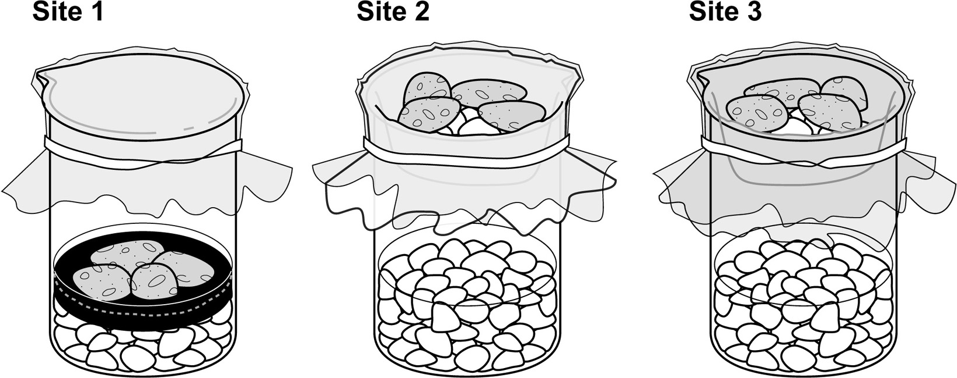
OBSERVATIONS
Record your observations in the table below. Give your table a title.

Site | Colour intensity
REFLECTING ON YOUR OBSERVATIONS
1. In which of the three systems would contaminants spread the most? Explain your answer.
2. In which of the three systems would contaminants spread the least? Explain your answer.
3. Of the systems you built, which site corresponds to each of the following sites?
a) a landfill with a waterproof membrane
b) a landfill with a torn or worn waterproof membrane
c) an open-air dump
4. What is the risk to soil and groundwater quality in open-air dumps and in landfills with damaged membranes?
5. Based on your observations in this lab, what is the essential condition for building a sanitary landfill that protects the soil and groundwater?
6. Have your observations helped you understand how contaminants spread in and around a landfill?
7. How could you improve the protocol for this lab?

