Soil depletion

Science labs
PROGRAM: EST
LAB TYPE: Experiment
CONCEPT: Soil depletion
student BOOK: Chapter 6, page 199

GOAL
LAB 52
Determine the effect of soil depletion on plant growth.
1. What is the independent variable in this lab?
- What is the dependent variable in this lab?
HypothEsiS
I think that
because
MatEriAlS
• 2 small empty plastic bottles
• permanent marker
• 2 funnels
• fine sand
• liquid fertilizer (Knop’s solution)
• distilled water
• 2 bean seeds that have been soaked in water for a day
• 2 cork stoppers, damp and perforated
pROCEDURE | 
1. Label the plastic bottles 1 and 2.
2. Use the funnels to fill the bottles two-thirds full with sand.
3. Pour liquid fertilizer into bottle 1 up to about 1 cm from the bottle neck.
4. Pour distilled water into bottle 2 up to about 1 cm from the bottle neck.
5. Place one bean at the bottom of the hole in each cork stopper.
6. Insert the stoppers into the mouths of the bottles. Be careful to keep the beans from falling out.
7. Observe the germination of each bean. When its first roots reach the liquid in the bottle and the first leaves emerge from the stopper, pinch off the two cotyledons on each plant.

8. Leave the bottles in the classroom for two weeks. Make sure that they are exposed to light
for several hours each day.
9. Compare the size of the plant in bottle 1 with the size of the plant in bottle 2. Record the result.
10. Clean up and put away the materials.
EXPERIMENTAL SETUP
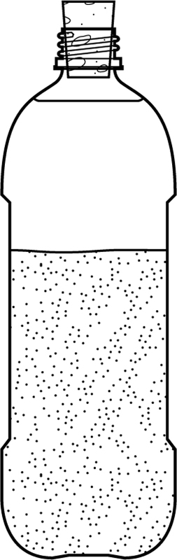
results
Which plant grew more quickly?
ANALYSis of THE results
1. Which bottle contained soil that was less depleted? Explain your answer.
2. What effect did soil depletion have on plant growth?
3. Why were you told to pinch off the cotyledons in this experiment?

4. What are the possible sources of error in this lab?
5. How could you improve the protocol for this lab?
Conclusion
1. What do you conclude from this lab?
2. Was your hypothesis confirmed or not? Explain your answer.
APPLICATION
A group of students would like to know how nitrogen deficiency in soil affects plant growth. How could they modify this lab to test for this effect?

