Water retention in soil horizons

Science labs
PROGRAMS: ST, EST, SE
LAB TYPE: Observation
CONCEPT: Soil profile (horizons)
student BOOK: Chapter 6, page 192
TOOLBOX: Page 33

GOAL
LAB 50
Observe how water is retained in different soil horizons.
Observation CRITERIA
1. In the table below, identify the five soil horizons and describe their composition.
Name of horizon | Composition
2. Match the following soil components to the appropriate horizon.
a) grass sod:
b) gravel:
c) sand:
d) black soil:
MATERIALS
• 4 filter papers • spatula
• 4 funnels • fine sand
• 4 250-mL Erlenmeyer flasks • gravel
• grass sod • distilled water
• scissors • 100-mL graduated cylinder
• black soil • stopwatch
• 250-mL beaker

pROCEDURE | 
1. Fold each filter paper in four to form a cone.
2. Place one cone in each funnel.
3. Place a funnel in each Erlenmeyer flask.
4. Cut a piece of grass sod large enough to cover the mouth of the first funnel completely.
5. Insert the grass sod into the funnel.
6. Measure about 100 mL of black soil into the beaker.
7. Carefully pour the black soil into the second funnel.
8. With your fingers, smooth the surface of the soil without compressing it.
9. Repeat steps 6 to 8 with the fine sand, pouring it into the third funnel.
10. Repeat steps 6 to 8 with the gravel, pouring it into the fourth funnel.
11. Pour 100 mL of distilled water into the graduated cylinder.
12. Start the stopwatch and pour the water slowly onto the grass sod, wetting its entire surface.
13. Record the time it takes for the water to flow into the flask.
14. With the graduated cylinder, measure the amount of water collected in the flask. Record
the amount.
15. Repeat steps 11 to 14 with the soil, sand and gravel.
16. Clean up and put away the materials.
EXPERIMENTAL SETUP
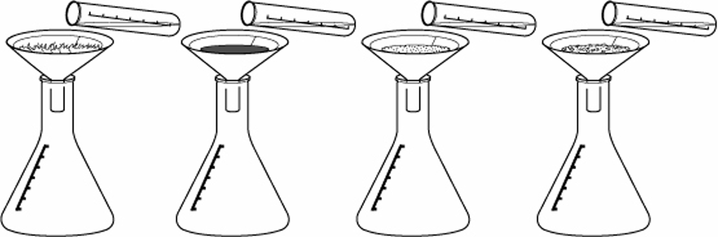

observations
Record your observations in the table below. Give your table a title.
Title:

Funnel contents | Flow time  (s) | Water collected  (mL)
Grass sod
Black soil
Sand
Gravel
REFLECTING ON YOUR OBSERVATIONS
1. Based on your observations, classify the soil components you tested in ascending order of speed of water flow.
2. Based on your observations, classify the soil components you tested in ascending order of water retention.
3. Why do you think the grass sod reduces the speed of water flow so effectively?
4. Based on your observations, identify the horizon described by each of the following statements. You may consider all horizons except parent rock.
a) Water seeps through it most easily.
b) It holds the most water.
5. Have your observations helped you understand how the different soil horizons affect water retention?
6. How could you improve the protocol for this lab?

