The effect of solenoid coils
in an electric motor

Science labs
PROGRAMS: EST, AST
LAB TYPE: Experiment
CONCEPT: Magnetic field of a solenoid
student BOOK: Chapter 5, page 169

GOAL
LAB 47
Determine how the number of turns in a solenoid affects its rotational speed in an electric motor.
1. What is the independent variable in this lab?
2. What is the dependent variable in this lab?
HypothEsIS
I think that
because
MatErials
• wide elastic band
• 2 large metal paper clips (modified for the experiment)
• D battery
• 7-coil solenoid (solenoid with 7 turns)
• permanent magnet
• 14-coil solenoid
• 21-coil solenoid
procedure | 
1. Assemble an electric motor, following steps a) to d):
a) Attach a paper clip to each terminal of the battery with an elastic band, as shown below.
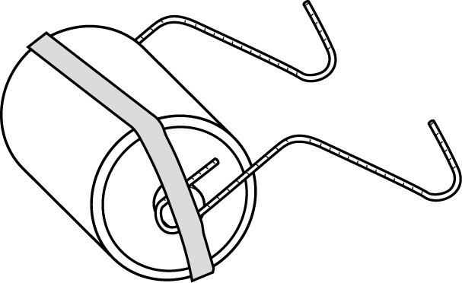

b) Place the 7-coil solenoid in the hooks formed by the paper clips.
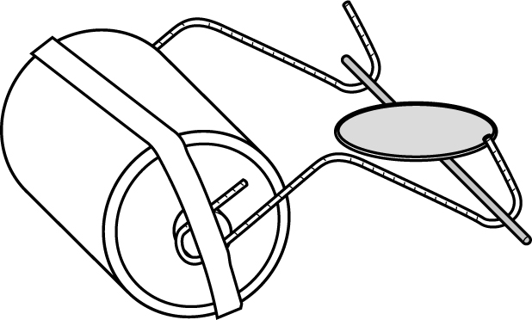
c) Place the magnet on the battery as shown below so that the solenoid begins to rotate.
If necessary, tap gently on the solenoid to get it started.
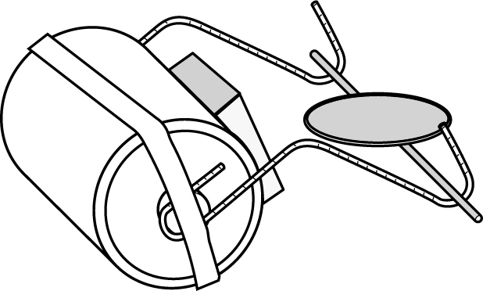
d) Adjust the motor parts so that the solenoid rotates constantly.
e) Observe and record the rotational speed of the solenoid.
2. Keep the same configuration for the motor, but replace the 7-coil solenoid with the 14-coil solenoid.
3. Adjust the motor parts as needed so that the solenoid rotates constantly.
4. Compare the rotational speed of the 14-coil solenoid with that of the 7-coil solenoid.
Record the result.
5. Repeat steps 2 and 3 with the 21-coil solenoid.
6. Compare the rotational speed of the 21-coil solenoid with that of the 7-coil and the 14-coil solenoids. Record the results.
7. Put away the materials.
results
Record your results in the table below. Give your table a title.
Title:

Number of turns | Rotational speed
7
14
21

ANALYSIS OF THE RESULTS
1. In the motor you assembled, how do you know that the interaction between two magnetic fields causes the motion of the solenoid? Which parts are responsible for creating the two magnetic fields?
2. Would the motor have worked if the battery were dead? Explain your answer.
3. How do additional turns in the solenoid affect the intensity of its magnetic field? Explain your answer, referring to your results.
4. How could you have tested whether the current intensity affects the intensity of the magnetic field?
5. What are the possible sources of error in this lab?
6. How could you improve the protocol for this lab?
Conclusion
1. What do you conclude from this lab?
2. Was your hypothesis confirmed or not? Explain your answer.
APPLICATION
An electric motor usually contains four main parts:
– a power supply, which provides the necessary electric current
– a stator, a stationary part, which generates a magnetic field
– a rotor, a moving part, which also generates a magnetic field
– brushes, which direct electric current from the power supply to the rotor
In the motor you assembled, identify the following parts:
a) power supply: |  |  |  | c) rotor:
b) stator: |  |  |  | d) brushes:

