The magnetic field of a solenoid

Science labs
PROGRAMS: EST, AST
LAB TYPE: Observation
CONCEPT: Magnetic field of a solenoid
student BOOK: Chapter 5, page 169

GOAL
LAB 46
Observe the magnetic field of a solenoid.
observation CRITERIA
1. What is a solenoid?
2. What direction do the magnetic field lines of a solenoid take?
3. How could you predict the direction of the magnetic field lines in an experiment?
4. How could you predict the direction of the magnetic field lines in theory?
MatErials
• electrical wire (500 mm long)
• piece of stiff cardboard (about 300 mm × 200 mm) with 8 holes in it
• 2 retort stands
• 2 universal clamps
• direct-current power supply
• iron filings
• compass
• 2 wires with alligator clips

pROCEDURE | 
1. Thread the wire through the holes in the cardboard to form a solenoid.
2. Using the ring stands and the universal clamps, hang the cardboard horizontally about
10 cm above the surface of the table.
3. Connect each end of the wire to the power supply.
4. Place the compass on the cardboard, near the solenoid.
5. Turn on the power supply to medium. Do not leave it on too long, or it will overheat.
6. Observe the compass and move it around the solenoid. Record your observations.
7. Take the compass off the cardboard.
8. Sprinkle iron filings on the cardboard.
9. Turn off the power supply. Observe the iron filings.
10. Draw the magnetic field lines.
11. Return the iron filings to their container.
12. Invert the wires connected to the power supply terminals.
13. Repeat steps 4 to 11.
14. Clean up and put away the materials.
Observations
Record your observations in the illustrations below.

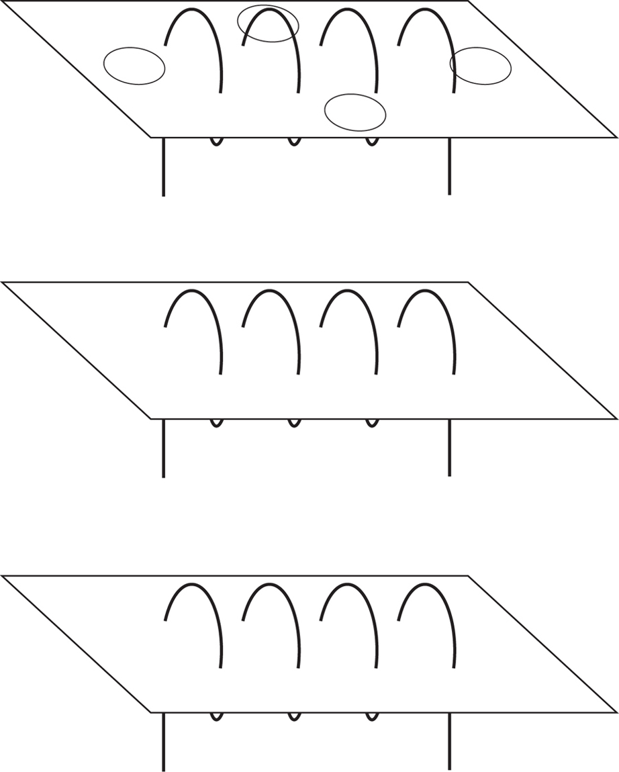
REFLECTING ON YOUR OBSERVATIONS
1. Have your observations helped you understand how a magnetic field forms around a solenoid? Explain your answer.
2. Does the direction of your magnetic field lines fit the theory? Explain your answer.
3. How could you improve the protocol for this lab?

