The magnetic field of a live wire

Science labs
PROGRAMS: ST, EST, AST
LAB TYPE: Observation
CONCEPT: Magnetic field of a live wire
student BOOK: Chapter 5, page 168

GOAL
LAB 45
Observe the magnetic field of a live wire.
OBSERVATION CRITERIA
1. What direction do the magnetic field lines take in the magnetic field of a live wire?
2. How could you predict the direction of the magnetic field lines in an experiment?
3. How could you predict the direction of the magnetic field lines in theory?
MatEriAlS
• electrical wire (200 mm long)
• piece of stiff cardboard (about 200 mm × 200 mm) with a hole in the middle
• 2 retort stands
• 2 or 3 universal clamps
• direct-current power supply
• 2 wires with alligator clips
• iron filings
• compass

pROCEDURE | 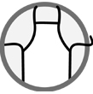
1. Thread the wire through the hole in the cardboard.
2. Using the retort stands and the universal clamps, hang the cardboard horizontally about
10 cm above the surface of the table. Make sure the cardboard is straight.
3. Connect each end of the wire to the power supply.
4. Place the compass on the cardboard, near the wire.
5. Turn on the power supply to medium. Do not leave it on for too long, or it will overheat.
6. Observe the compass and move it around the wire. Record your observations.
7. Take the compass off the cardboard.
8. Sprinkle iron filings on the cardboard.
9. Tap gently on the universal clamps several times to observe the magnetic field lines.
10. Turn off the power supply.
11. Observe the iron filings.
12. Draw the magnetic field lines.
13. Invert the wires connected to the power supply terminals.
14. Repeat steps 4 to 12.
15. Clean up and put away the materials.
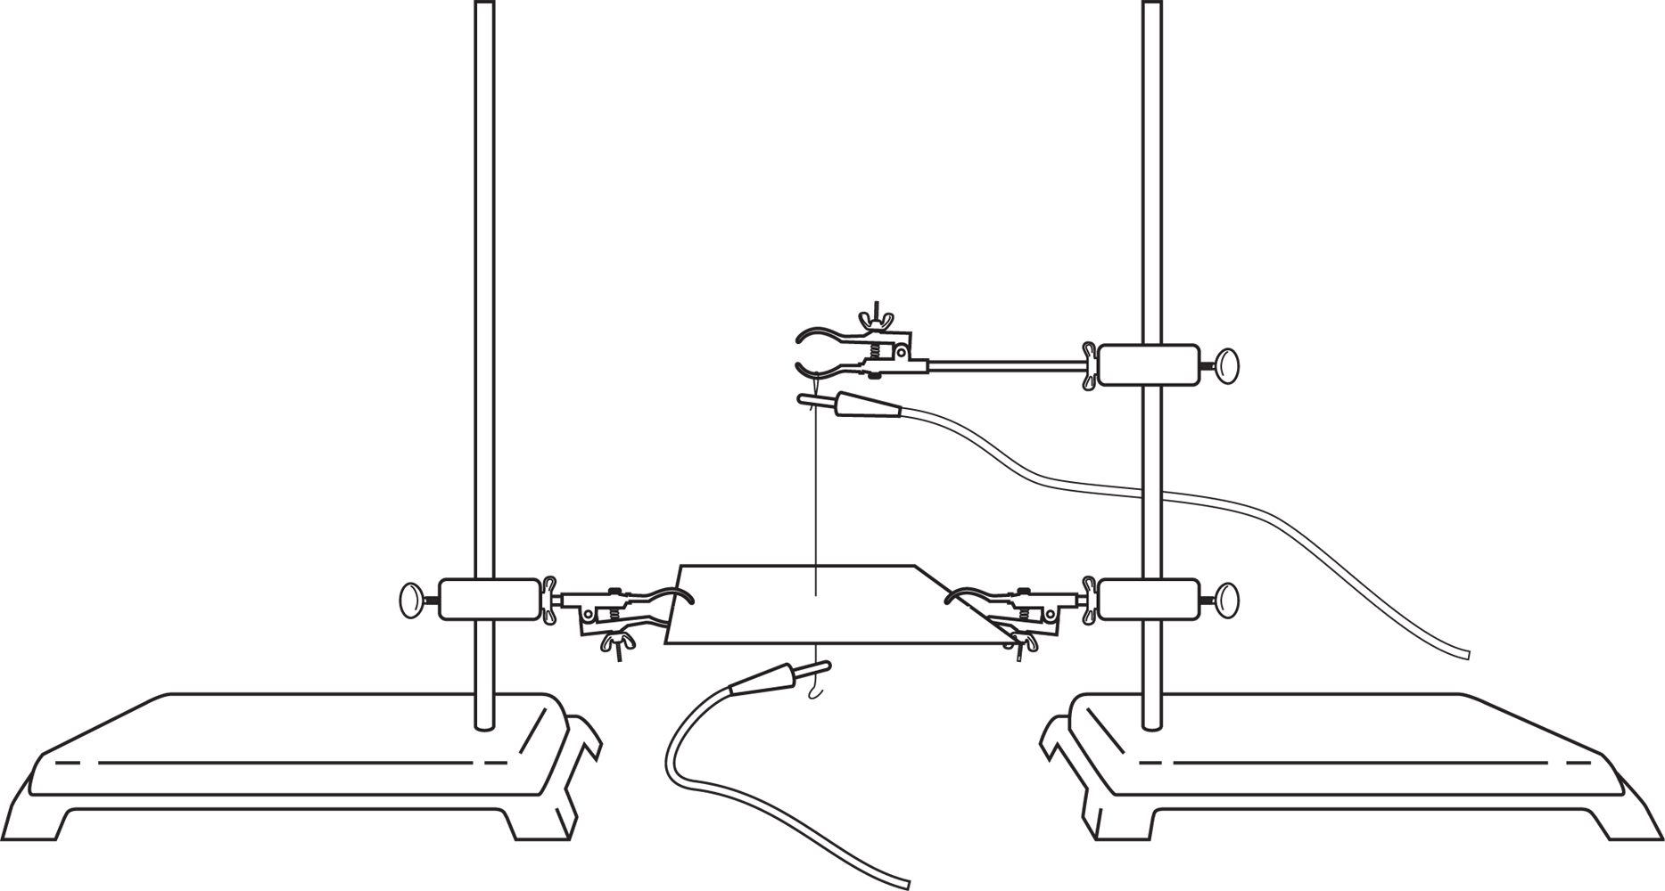
experimental setup
Observations
Record your observations in the illustrations below.
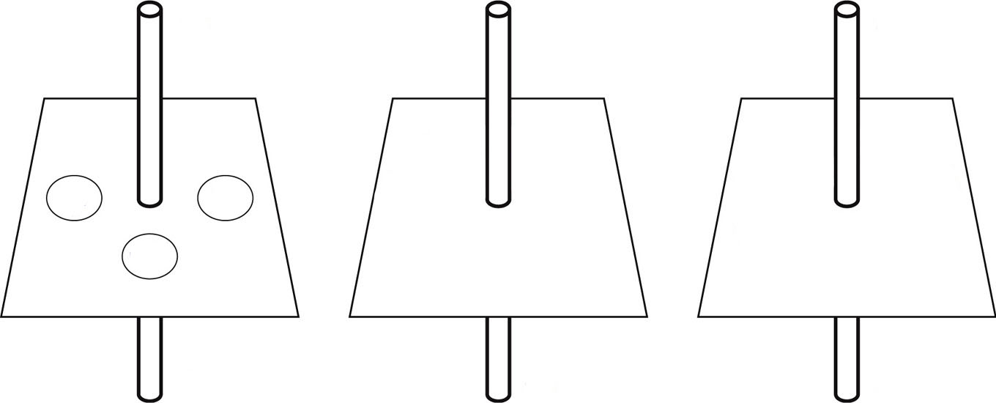

REFLECTING ON YOUR OBSERVATIONS
1. Have your observations helped you understand how a magnetic field forms around a live wire? Explain your answer.
2. Does the direction of your magnetic field lines fit the theory? Explain your answer.
3. How could you improve the protocol for this lab?

