Kirchhoff’s laws

Science labs
PROGRAM: EST
LAB TYPE: Observation
CONCEPT: Kirchhoff’s laws
student BOOK: Chapter 5, page 159
TOOLBOX: Pages 51–52

GOAL
LAB 43
Confirm Kirchhoff’s laws in a series circuit and a parallel circuit.
observation CRITERIA
1. What is Kirchhoff’s first law?
2. What must you measure to confirm Kirchhoff’s first law?
3. What is Kirchhoff’s second law?
4. What must you determine to confirm Kirchhoff’s second law?
5. How do Kirchhoff’s laws apply to a series circuit? Explain your answer, providing the relevant formulas.
6. How do Kirchhoff’s laws apply to a parallel circuit? Explain your answer, providing the relevant formulas.
MatEriAlS
• variable-intensity direct-current power supply
• 2 small light bulbs with bases
• 20-Ω resistor
• 10 wires with alligator clips
• ammeter
• voltmeter
• switch
pROCEDURE | 
1. Connect the various circuit elements as shown in the diagram for circuit A.
2. Turn the power supply on to three-quarters power (for example, 12 V).
3. Close the switch and make sure the circuit works.
4. Open the switch.
5. Break the circuit open at point A₁ on the diagram by disconnecting a wire.
6. Insert the ammeter in series with the circuit.
7. Close the circuit again by plugging a wire into the other terminal of the ammeter.
8. Make sure that the positive terminal of the ammeter is connected to the positive terminal of the power supply. If different ranges appear on the ammeter, take your reading on the highest range first.
9. Close the switch. If you cannot obtain a reading, choose the next highest range on the ammeter.
10. Record the current intensity shown on the ammeter.
- Disconnect the ammeter and then close the circuit again.
- Repeat steps 2 to 11 at each other point in the circuit A diagram. Remember to open the switch between readings.
- Connect a wire to each terminal of the voltmeter.

14. Connect the voltmeter to each side of element V₁ in the circuit diagram. Make sure the positive terminal of the voltmeter is connected to the positive terminal of the power supply.
If different ranges appear on the voltmeter, take your reading on the highest range first.
15. Close the switch.
16. Record the potential difference shown on the voltmeter.
17. Open the switch.
18. Disconnect the voltmeter.
19. Repeat steps 14 to 18 with each other element in circuit A.
20. Repeat the entire experiment, using circuit B.
21. Put away the materials.
CIRCUIT ASSEMBLY DIAGRAMS
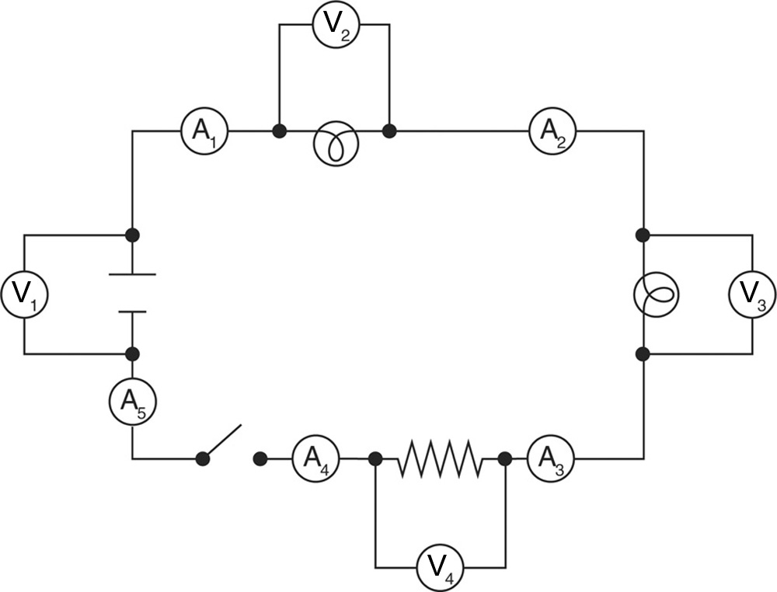
Circuit A
I_{total} = I₁ = I₂ = I₃ = I₄ = I₅
V_{total} = V₂ + V₃ + V₄

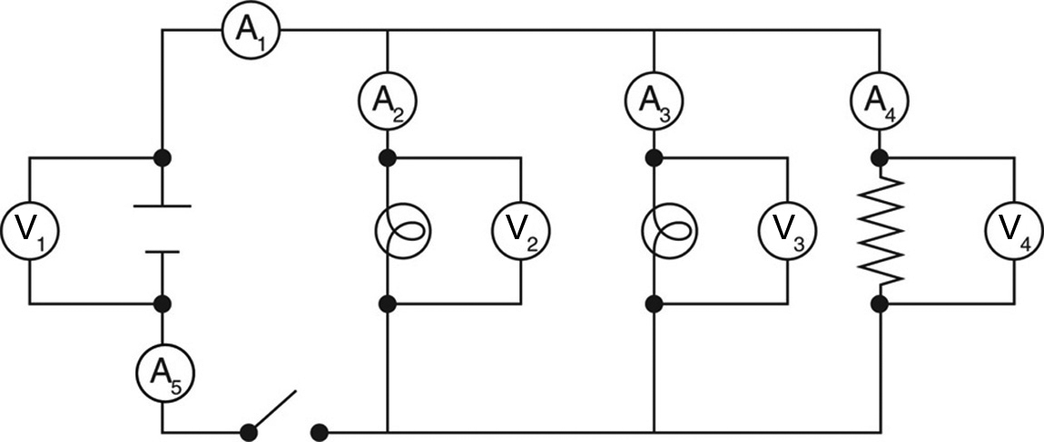
Circuit B
I_{total} = I₂ + I₃ + I₄
V_{total} = V₂ = V₃ = V₄

observations
Record your observations in the tables below. Give each table a title.
Title:

Point in circuit | Current intensity (A)
Point in circuit | Circuit A | Circuit B

Title:

Circuit element | Electrical potential difference (V)
Circuit element | Circuit A | Circuit B
REFLECTING ON YOUR OBSERVATIONS
1. Have your observations helped you understand Kirchhoff’s laws? Explain your answer.
2. Is circuit A a series circuit or a parallel circuit? Explain your answer.
3. Is circuit B a series circuit or a parallel circuit? Explain your answer.
4. For each circuit, which measurement represents the total current intensity?
5. For each circuit, which measurement represents the total electrical potential difference?
6. Use your observations for circuit A to confirm Kirchhoff’s laws. Show your calculations.
7. Use your observations for circuit B to confirm Kirchhoff’s laws. Show your calculations.
8. How could you improve the protocol for this lab?

