Electrical potential difference

Science labs
PROGRAMS: ST, EST, AST
LAB TYPE: Technique
CONCEPT: Electrical circuits
student BOOK: Chapter 5, page 156
TOOLBOX: Page 52

GOAL
LAB 42
Practise a method for measuring electrical potential difference.
MatEriAls
• small light bulb with base
• switch
• 6 wires with alligator clips
• variable-intensity direct-current power supply
• voltmeter
pROCEDURE | 
1. Connect the various elements as shown in the circuit diagram.
2. Connect a wire to each terminal of the voltmeter.
3. Connect the voltmeter to each side of element 1 in the diagram. Make sure that the
positive terminal of the voltmeter is connected to the positive terminal of the power supply.
If different ranges appear on the voltmeter, take your reading on the highest range first. If
you cannot obtain a reading, choose the next highest range
4. Turn on the power supply as instructed by your teacher.
5. Close the switch.
6. If you cannot obtain a reading, choose the next highest range on the voltmeter. Continue
until you obtain a reading.
7. Record the electrical potential difference shown on the voltmeter.
8. Open the switch.
9. Disconnect the voltmeter.
10. Repeat steps 2 to 9 with each other element in the circuit.
11. Put away the materials.

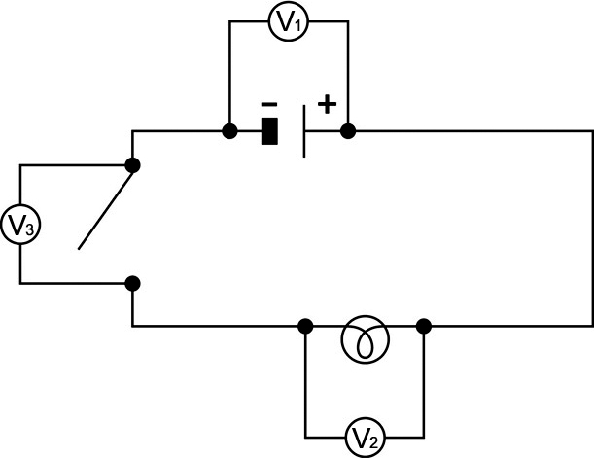
CIRCUIT ASSEMBLY DIAGRAM
ReSULTS
Record your results in the table below. Give your table a title.
Title:

Element | Electrical potential difference (V)
Reflecting on the lab technique
1. What is electrical potential difference?
2. Was the potential difference the same for each circuit element? Explain your answer.
3. Explain how a voltmeter measures potential difference.
4. What are the possible sources of error in this lab?
5. How could you improve the protocol for this lab?

