Current intensity

Science labs
PROGRAMS: ST, EST, AST
LAB TYPE: Technique
CONCEPT: Electrical circuits
student BOOK: Chapter 5, page 156
TOOLBOX: Page 51

goal
LAB 41
Practise a method for measuring the intensity of an electric current.
MatEriAlS
• small light bulb with base
• 6 wires with alligator clips
• variable-intensity direct-current power supply
• ammeter
• switch
pROCEDURE | 
1. Connect the various elements as shown in the circuit diagram.
2. Break the circuit open at point 1 on the diagram by disconnecting a wire.
3. Insert the ammeter in series with the circuit.
4. Close the circuit again by plugging a wire into the other terminal of the ammeter, connecting it to the element that you disconnected in step 2.
5. Make sure that the positive terminal of the ammeter is connected to the positive terminal of the power supply.
6. If different ranges appear on the ammeter, take your reading on the highest range first.
7. Adjust the intensity of the power supply according to the teacher’s instructions.
8. Close the switch.
9. If you cannot obtain a reading, choose the next highest range on the ammeter. Continue moving down the ranges until you obtain a reading. Take careful note of the units of measurement.
10. Record the current intensity shown on the ammeter.
11. Open the switch.
12. Disconnect the ammeter and then close the circuit again.
13. Repeat steps 2 to 12 at points 2 and 3 on the diagram.
14. Put away the materials.

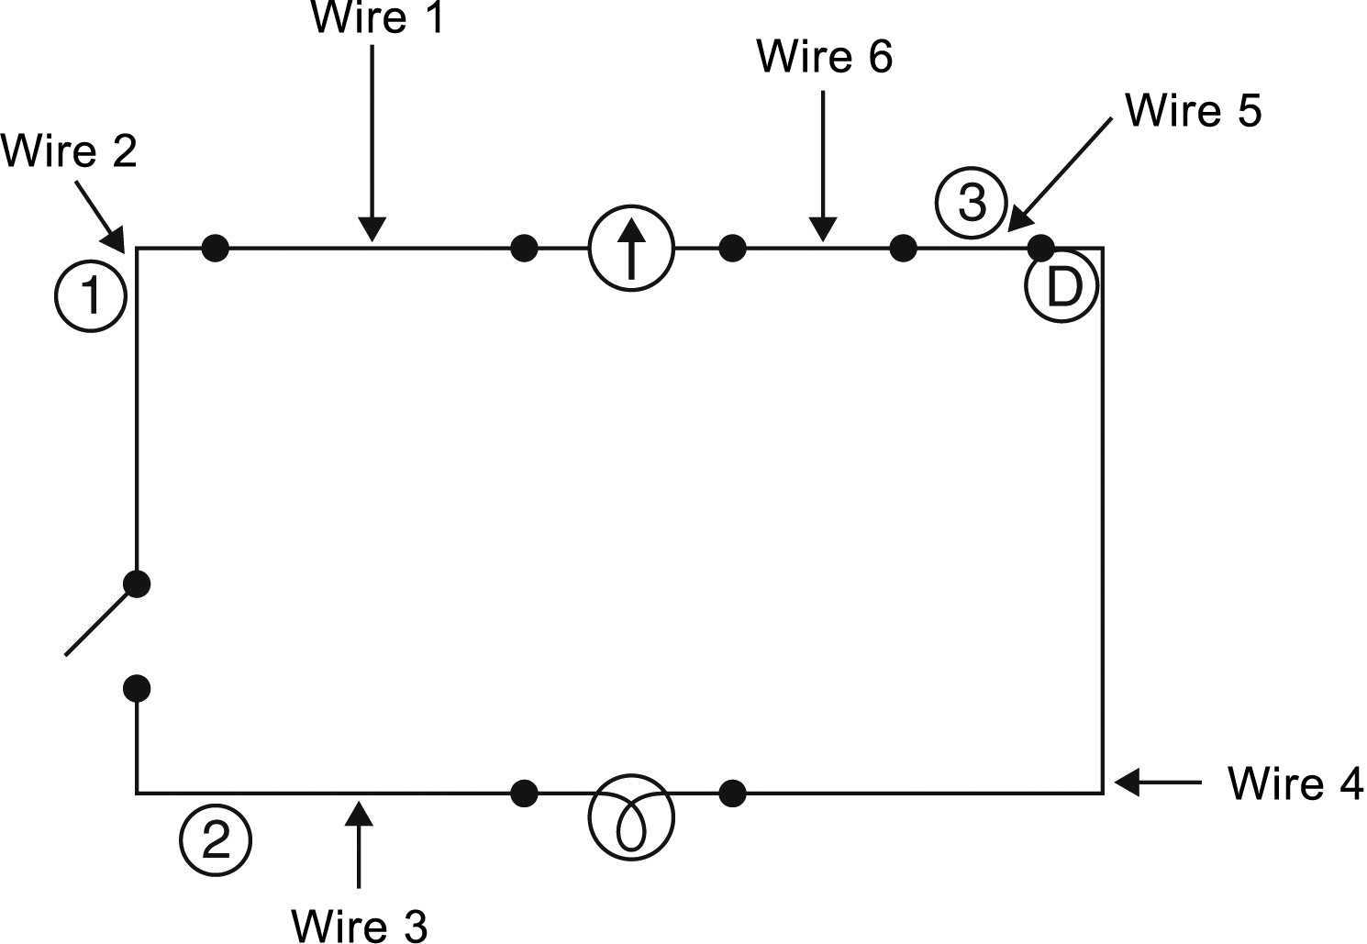
CIRCUIT ASSEMBLY DIAGRAM

RESULTS
Record your results in the table below. Give your table a title.
Title:

Location of ammeter | Current intensity (A)
Reflecting on the lab technique
1. What is current intensity?

2. Was the current intensity the same at each point in the circuit? Explain your answer.
3. Explain how an ammeter measures current intensity.
4. What are the possible sources of error in this lab?
5. How could you improve the protocol for this lab?

