Charging an object

Science labs
PROGRAMS: ST, EST, AST
LAB TYPE: Observation
CONCEPT: Static electricity
student BOOK: Chapter 5, page 146

goal
LAB 39
Observe different methods of charging an object.
OBSERVATION CRITERIA
1. Complete the following statements describing how electrical charges behave.
a) Electrical charges of the same sign
b) Electrical charges of opposite signs
2. For each of the following statements, identify the method of charging an object.
a) The charge of an object is shared with another object when the two come into contact.
b) Electrons are pulled away from one object to another.
c) The charging results in two objects carrying opposite charges.
d) A charged object causes the charges of an uncharged object to separate. The uncharged object then carries a partial positive charge on one side and a partial negative charge on the other side.

e) The charging results in two objects carrying the same charge.
MatEriAlS
• strip of polyethylene
• scrap of wool
• retort stand
• universal clamp
• pith ball covered with metallic paint and suspended from a silk thread
pROCEDURE | 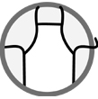
1. Place your ear close to the strip of polyethylene and rub one end of the strip against the scrap of wool.
2. Record the sound you hear.
3. Bring the polyethylene strip close to the pith ball.

4. Observe and record the effect on the pith ball.
5. Allow the pith ball to free itself from the polyethylene strip. If it does not come away on its own, repeat steps 1 and 2.
6. Rub the polyethylene strip against the scrap of wool again.
7. Bring the strip close to the pith ball.
8. Observe and record the effect on the pith ball.
9. Put away the materials.
EXPERIMENTAL SETUP

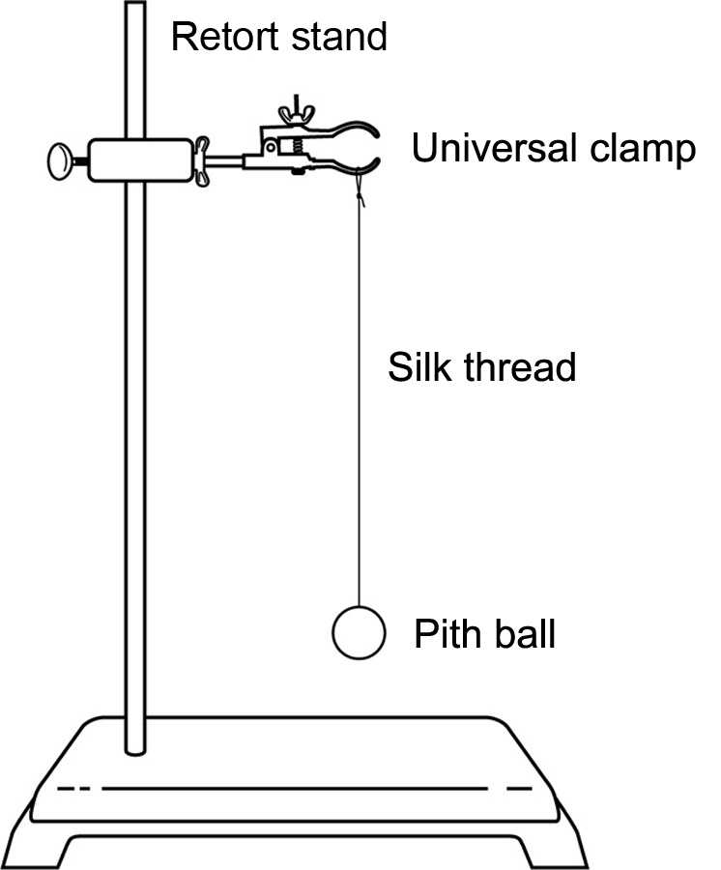

Observations
Record your observations in the table below. Give your table a title.
Title:

Procedure | Observation | Result
Step 1 | Sound made by rubbing
Step 3 | Effect on pith ball
Step 7 | Effect on pith ball

REFLECTING ON YOUR OBSERVATIONS
1. What method was used to charge the strip of polyethylene?

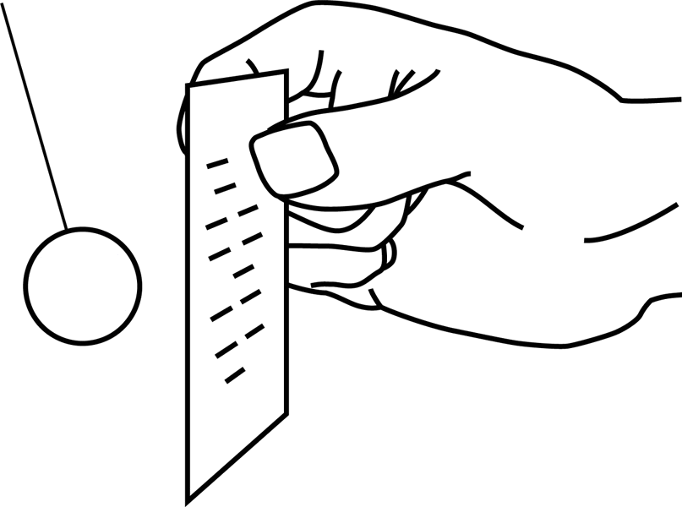
2. a) In the illustration below, the polyethylene strip carries a negative charge (excess of electrons) after being charged. Make “+” and “–” signs on the pith ball to show how its electrical charges must be distributed to obtain the effect observed in step 3 of the lab procedure.

b) What method of charging an object is illustrated above?

3. What method of charging an object caused the pith ball to come and cling to the polyethylene strip?
4. Based on the electrical charges of the polyethylene strip and the pith ball, explain the effect on the pith ball observed in step 7 of the lab procedure.
5. Have your observations helped you understand the methods of charging an object? Explain your answer.
6. How could you improve the protocol for this lab?

