Gas from photosynthesis

Science labs
PROGRAMS: ST, EST, SE
LAB TYPE: Experiment
CONCEPT: Photosynthesis and respiration
student BOOK: Chapter 4, page 123
TOOLBOX: Pages 40–41

GOAL
LAB 37
Identify the gas released by an aquatic plant during photosynthesis, using a variety of tests.
1. What is the independent variable in this lab?
- What is the dependent variable in this lab?
HypothEsIS
I think that
because
MatEriAlS
• 3 1000-mL beakers
• 2700 mL of 0.1 mol/L sodium bicarbonate (NaHCO₃) solution
• 3 bunches of fresh waterweed (Elodea)
• 3 cutoff plastic funnels (See note at end of lab.)
• 3 test tubes (15 mm × 125 mm) with stoppers (No. 0)
• test-tube rack
• lamp with 100-W bulb
• dropper bottle of limewater
• wooden splints
• matches or lighter
pROCEDURE | 
1. Fill one beaker with 900 mL of sodium bicarbonate (NaHCO₃) solution.
2. Place one bunch of waterweed in the solution.
3. Cover the waterweed with a funnel. Make sure the funnel stem is completely submerged in the solution.
4. Fill a test tube with water.
5. Turn the test tube upside down in the funnel, making sure no air enters the test tube.

6. Repeat steps 1 to 5, preparing two other identical setups.
7. Place all three beakers under the lamp light for at least one day or until the test tubes are almost entirely filled with gas.
8. Keeping the mouth of the test tube under water, lift each test tube off its funnel and insert a stopper.
9. Place the test tubes in the test-tube rack.
10. Add several drops of limewater to a test tube. Observe whether the limewater turns milky
and record the results.
11. Light a wooden splint and then blow out the flame.
12. Quickly open a second test tube and immediately insert the glowing splint. Observe whether the glowing splint reignites and record the results.
13. Light another wooden splint and keep it lit.
14. Quickly open the third test tube and immediately place the burning splint at its mouth. Observe whether an explosion occurs and record the results.
15. Clean up and put away the materials.
EXPERIMENTAL SETUP
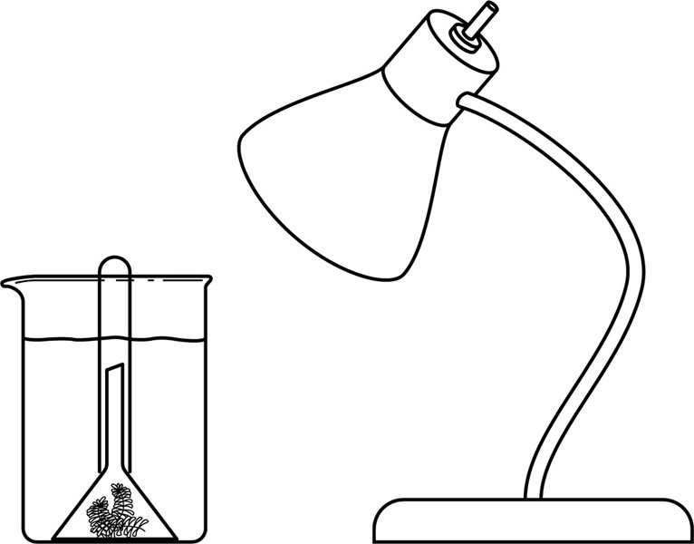
ReSULTS
Record your results in the table below. Give your table a title.
Title:

Test | Reaction
Limewater
Glowing splint
Burning splint
ANALYSIS OF the RESULTS
1. Based on the results of your tests, write your deductions about the type of gas released by the waterweed.
Test | Deduction
Limewater
Glowing splint
Burning splint
2. Knowing that the gas released by waterweed (and other plants) is one of the main gases in the atmosphere, can you now identify it more easily? Explain your answer.
3. How could you have confirmed the type of gas released by the waterweed?
4. Why did you have to place your beakers under a light?
5. What are the possible sources of error in this lab?

6. How could you improve the protocol for this lab?
Conclusion
1. What do you conclude from this lab?
2. Was your hypothesis confirmed or not? Explain your answer.
APPLICATION
In a sealed greenhouse containing numerous plants and a few animals, when would the concentration of oxygen be highest: during the day or at night? Explain your answer.

