Bernoulli’s principle

Science labs
PROGRAM: AST
LAB TYPE: Observation
CONCEPT: Bernoulli’s principle
Student BOOK: Chapter 3, page 98

Goal
LAB 28
Observe Bernoulli’s principle at work.
Observation criteria
1. What is Bernoulli’s principle?
2. What is pressure?
3. What is lift?
MatEriAlS
• sheet of paper • pencil • adhesive tape
• ruler • scissors • drinking straw
pROCEDURE | 
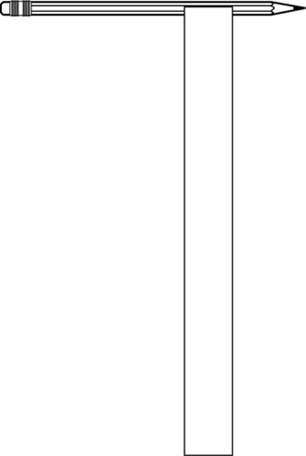
1. Draw a rectangle measuring 30 mm x 280 mm on the sheet
of paper.
2. Cut out the rectangle.
3. Tape one short edge (30 mm) of the rectangle to the pencil
so that it hangs perpendicular to the pencil.
4. Hold the pencil by one end so that the strip of paper hangs freely.
5. Blow gently through the straw on the upper surface of the strip of paper.
6. Observe and record the effect on the strip of paper.
7. Blow hard through the straw on the upper surface of the strip of paper.
8. Observe and record the effect on the strip of paper.
9. Put away the materials.
observations
Record your observations in the table below. Give your table a title.
Title:

Intensity of air flow | Effect on strip of paper
Reflecting on your observations
1. Have your observations helped you understand Bernoulli’s principle? Explain your answer.
2. What makes the strip of paper “fly”? Explain your answer.
3. Give a few examples of applications of Bernoulli’s principle.
4. How could you improve the protocol for this lab?

