Pressure in a liquid

Science labs
PROGRAM: AST
LAB TYPE: Experiment
CONCEPT: Archimedes’ principle
student BOOK: Chapter 3, page 95

TOOLBOX: Page 22

Part A
GOAL
LAB 27

Using a U-tube manometer, determine the relationship between
the pressure in a liquid and the density of the liquid.
1. What is the independent variable in this lab?
2. What is the dependent variable in this lab?
HypothEsiS
I think that
because
GOAL
Part B
Using a U-tube manometer, determine the relationship between pressure
and depth in a liquid.
1. What is the independent variable in this lab?
2. What is the dependent variable in this lab?
HypothEsIS
I think that
because
MatEriAlS
• balance (accurate to 0.01 g)
• 50-mL graduated cylinder
• 3 containers of more than 1 L, each filled with a different liquid
(water, methanol, ethylene glycol, saltwater solution, etc.)
• 2 30-cm rulers
• 1000-mL graduated cylinder or container more than 40 cm high
• U-tube manometer
• insulating tape
• 40-cm glass stirring rod
pROCEDURE | 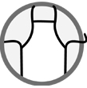
1. Measure the density of each of the three liquids.
a) Weigh the empty 50-mL graduated cylinder. Record its mass.
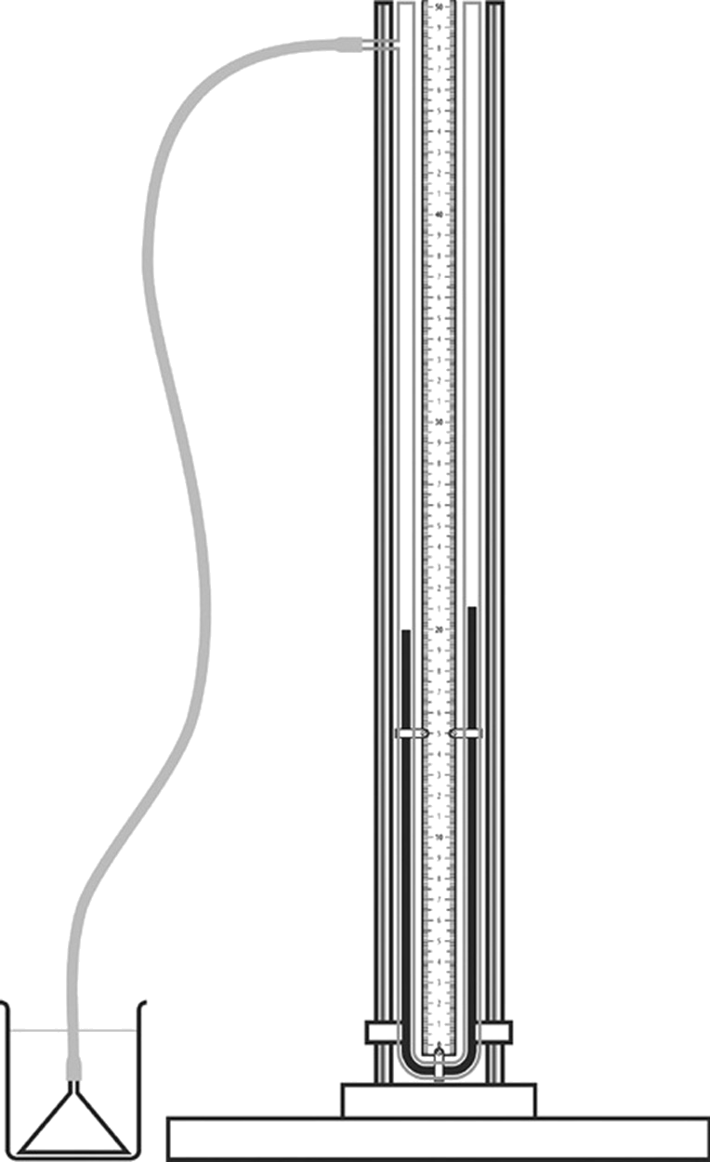
b) Pour 50 mL of one liquid into the graduated cylinder.
c) Weigh the graduated cylinder with the liquid. Record its mass.
d) Calculate the density of the liquid (in g/mL).
e) Repeat steps b) to d) with each of the other liquids.
2. Attach the rulers to the 1000-mL graduated cylinder to create
a scale of 40 cm, with 0 cm at the top of the cylinder
and 40 cm at the bottom.
3. Fill the 1000-mL graduated cylinder with one of the liquids to
the 0-cm mark on the rulers.
4. Measure the pressure outside the liquid with the manometer.
This measuremement corresponds to the 0 setting.
5. Attach the glass stirring rod to the conical end of the manometer
tube with insulating tape.
6. Insert the end of the tube in the liquid. Use the glass stirring rod
to push and keep the conical end of the tube below the surface
of the liquid.
7. Each time the end of the tube sinks 10 cm, measure
the pressure. The pressure equals the difference in height
between the two columns of liquid in the manometer.
Record the pressure readings.
8. Empty the graduated cylinder, rinse it and wipe it dry.
9. Repeat steps 3 to 7 with each of the other liquids.
10. Clean up and put away the materials.

REsults
Record your results in the tables below. Give each table a title.
Title:

Type of liquid | Mass  (g) | Volume  (mL) | Density  (g/mL)
Liquid 1:
Liquid 2:
Liquid 3:

Title:

Depth  (cm) | Pressure in liquid 1  (cm) | Pressure in liquid 2  (cm) | Pressure in liquid 3  (cm)

GRAPHS
1. Plot the pressure in each liquid as a function of depth. Draw one curve for each liquid. Give your graph a title.
Title:

2. Plot the pressure in each liquid as a function of its density. Draw one curve for all three liquids using the pressure readings at the greatest depth. Give your graph a title.
Title:

AnalysIS OF THE RESULTS
1. Describe the appearance of the line on your graph showing the pressure in the liquids as a function of their densities.
2. How does the pressure in a liquid vary with the density?
3. Describe the appearance of the lines on your graph showing the pressure in each liquid as a function of depth.
4. How does the pressure in a liquid vary with depth?
5. Does the pressure vary with depth in the same way for each test liquid?
6. How is pressure measured with a U-tube manometer?
7. What are the possible sources of error in this lab?
8. How could you improve the protocol for this lab?

Conclusion
1. Complete the sentences below:
a) The greater the density of a liquid, the
the pressure in the liquid.
b) As the depth in a liquid increases, the pressure in the liquid
.
2. What do you conclude from this lab?
3. Were your hypotheses confirmed or not? Explain your answer.
APPLICATION
When we swim toward the bottom of a pool, why does it feel like our ears become plugged?

