Effective force

Science labs
LAB 22
PROGRAMS: EST,SE
LAB TYPE: Experiment
CONCEPT: Effective force
student BOOK: Chapter 3, page 88

Goal
Determine how the slope of an inclined plan influences the effective force of gravity on an object.
1. What is the independent variable in this lab?
2. What is the dependent variable in this lab?
HypothEsIS
I think that
because
MatErialS
• balance • modified protractor (with the part below the 0°–180° line removed)
• cart • dynamometer
• inclined plane
pROCEDURE | 
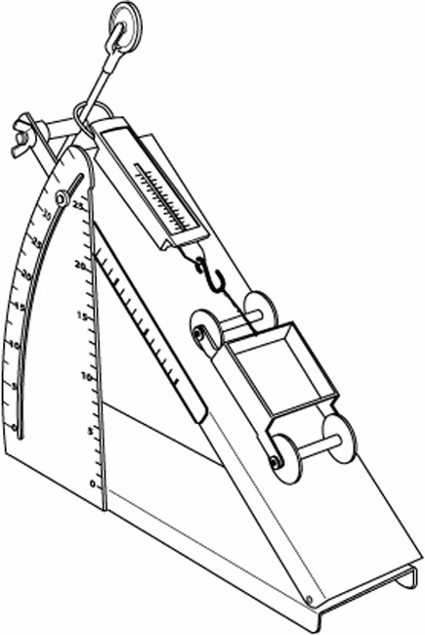
1. Weigh the cart and record its mass.
2. Set the inclined plane flat on the table so that the angle it forms is 0°.
3. Attach the dynamometer to the upper surface of the inclined plane
as shown opposite.
4. Set the dynamometer to 0 N.
5. Hook the cart to the dynamometer.
6. Raise the inclined plane to create an angle of 5° with the table.
7. Record the force applied to the dynamometer.
8. Repeat steps 6 and 7, increasing the angle by 5° each time,
up to a maximum of 40°.
9. Put away the materials.

REsults
Record your results in the table below. Give your table a title.
Title:

Angle |  | Effective force applied to cart (N)
 |  | Measured experimentally |  | Calculated
Mass of cart:
CalculATIONS
Calculate the effective force applied to the cart at each angle of the inclined plane. Record your answers in the table of results above.

Analysis of the results
1. What is the effective force?
2. What force is responsible for the movement of the cart on the inclined plane?
3. What is the relationship between the effective force and the angle of the inclined plane? Explain your answer.
4. At what angle would the effective force be greatest? Explain your answer.
5. What are the possible sources of error in this lab?
6. How could you improve the protocol for this lab?

Conclusion
1. What do you conclude from this lab?
2. Was your hypothesis confirmed or not? Explain your answer.
APPLICATION
A 25-kg box is placed on an inclined plane. Knowing that a force of 75 N opposes the sliding of the box, at what angle will the box begin to move? Show your calculations.

