The effect of friction

Science labs
PROGRAM: AST
LAB TYPE: Experiment
CONCEPT: Types of forces
student BOOK: Chapter 3, page 84

GOAL
LAB 20
Study the various factors that may affect the force of friction.
1. What is the independent variable in this lab?
2. What are the dependent variables in this lab?
HypothEsIS
I think that
because
MatEriAlS
• pulley with attachments
• string
• block of wood (35 mm × 35 mm × 200 mm), fitted with a hook, its four sides covered with rubber, plastic, felt and sandpaper, respectively, and its mass written on one end (in kg)
• ruler
• set of weights with hooks
• sheet of aluminum foil (150 mm × 200 mm)
• a piece stiff cardboard (250 mm × 400 mm) covered with aluminum foil
pROCEDURE | 
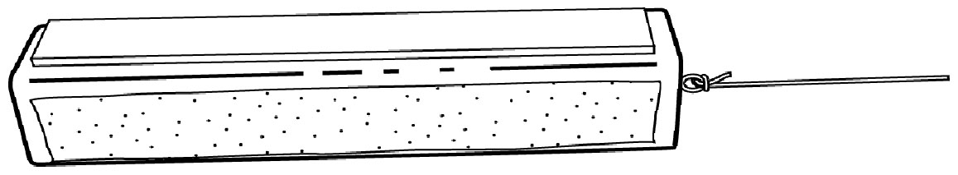
Factor 1: Type of surface
1. Attach the pulley to one end of the table.
2. Tie one end of the string to the hook on the wooden block and make a loop
at the other end of the string for attaching weights.

3. Use the ruler to make sure the string is parallel to the surface of the table. Measure the height of the block and the height of the pulley. Raise or lower the pulley, if necessary,
so that it is at the same height as the block.
4. Hook a weight to the loop in the string and hang the string over the pulley.
5. Give the block a slight push. If it moves at a constant speed, the suspended weight produces a force equivalent to the force of friction between the block and the table. If the block stops, gradually increase the value of the suspended weight until you obtain a constant speed. Record the type of surface rubbing against the table and the value of the suspended weight.
6. Repeat steps 3 to 5 with each of the other sides of the block.
Factor 2: Force applied
1. Set up the experiment as for Factor 1.
2. Place the block surface of least frictional force face-down on the table.
3. Place a 100-g weight on top of the block.
4. Hook a weight to the loop in the string and hang the string over the pulley.
5. Give the block a slight push. If it moves at a constant speed, the suspended weight produces a force equivalent to the force of friction between the block and the table. If the block stops, gradually increase the value of the suspended weight until you obtain a constant speed. Record the value of the suspended weight.
6. Repeat steps 3 to 5 three times, first with a 150-g weight on top of the block,
then with a 200-g weight and finally with a 250-g weight. Record the values observed.
Factor 3: Identical surfaces
1. Cover the wooden block with aluminum foil, spreading the foil carefully to make a smooth surface.
2. Set up the experiment as for Factor 1, but this time place the block on the cardboard covered with aluminum foil.
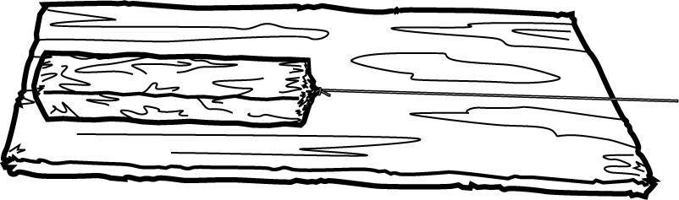

3. Place a 100-g weight on top of the block.
4. Hook a weight to the loop in the string and hang the string over the pulley.
5. Give the block a slight push. If it moves at a constant speed, the suspended weight produces a force equivalent to the force of friction between the block and the table. If the block stops, gradually increase the value of the suspended weight until you obtain a constant speed. Record the value of the suspended weight.
Factor 4: Lubricant
1. Set up the experiment as for Factor 3.
2. Sprinkle a few drops of water on the cardboard covered with aluminium foil.
3. Place the aluminum-covered block on the drops of water.
4. Determine the value of the weight that must be suspended over the pulley for the block
to move.
5. Record the value.
rEsults
Conversion reminder: 1 kg = 9.807 N
Factor 1: Type of surface
Material | Suspended weight  (kg) | Force  (N)
Rubber
Plastic
Felt
Sandpaper
Factor 2: Force applied
Added weight  (kg) | Suspended weight  (kg) | Force  (N)
0.100 kg
0.150 kg
0.200 kg
0.250 kg
Factor 3: Identical surfaces
Material | Suspended weight  (kg) | Force  (N)
Aluminum/aluminum

Factor 4: Lubricant
Lubricant | Suspended weight  (kg) | Force  (N)
Water
Analysis of the results
1. Classify the block surfaces in increasing order of frictional force.
 | A. |  |  | C.
 | B. |  |  | D.

2. Did increasing the value of the weight on top of the block affect the frictional force? Explain your answer.
3. By covering the wooden block with aluminum foil to match its surface to the contact surface, was the frictional force reduced? Explain your answer.
4. Did adding a lubricant to the contact surface affect the frictional force? Explain your answer.
5. What are the possible sources of error in this lab?
6. How could you improve the protocol for this lab?
Conclusion
1. What do you conclude from this lab?
2. Was your hypothesis confirmed or not? Explain your answer.

APPLICATION
1. How can you move a heavy piece of furniture? Refer to what you have learned in this lab about the force of friction.
2. What is the main reason for putting oil in a gas engine?

