An electric shoebox?
PROGRAMS: ST, EST, AST
METHOD: Technological analysis
CONCEPT: Conduction
STUDENT BOOK: Chapter 14
TOOLBOX: Pages 89–90

Info brief activities
INFO BRIEF 19
What is an electric shoebox? It is simply a shoebox with an electrical wire coming out of it. The challenge is to pass a ring of wire along the length of the shoebox wire without making contact. If you do make contact, a bulb will light up. In this activity, you will build an electric shoebox. Then, you will perform a technological analysis of the object to understand how it is made and how it works.
For help in answering the activity questions, read pages 459–469 of your student book.
BUILDING THE technical object
1. To build your electric shoebox, you will need the following materials:
Materials
• shoebox (with lid) • markers
• 14-gauge electrical wire (at least 1200 mm) • tape measure
• 24-gauge electrical wire (at least 700 mm) • combination pliers
• light bulb with base and wires • wire strippers
• 9-V battery • retractable utility knife
• duct tape • cutting mat
• insulating connector • ruler
• 2 short electrical wires with alligator clips
2. Build your shoebox, following the steps in the manufacturing process sheet in the appendix to this activity.
what is the technical object used for?
3. What is the purpose of the electric shoebox?
how does It work?
4. What happens when the ring of wire touches the shoebox wire? Why?
5. Draw the circuit diagram of the technical object—the electrical circuit you have just built.
Circuit diagram
6. Is the electric current in your circuit direct or alternating? Explain your answer.
7. Which component of the technical object performs each of the following functions?
a) power supply
b) conduction
c) insulation
d) protection

e) control
how is it built?
8. Complete the technical diagram for the electric shoebox:
a) Label the parts.
b) Complete the materials legend.
c) Indicate the locations of links between components and the shoebox lid, using the appropriate symbol (X).
Technical diagram

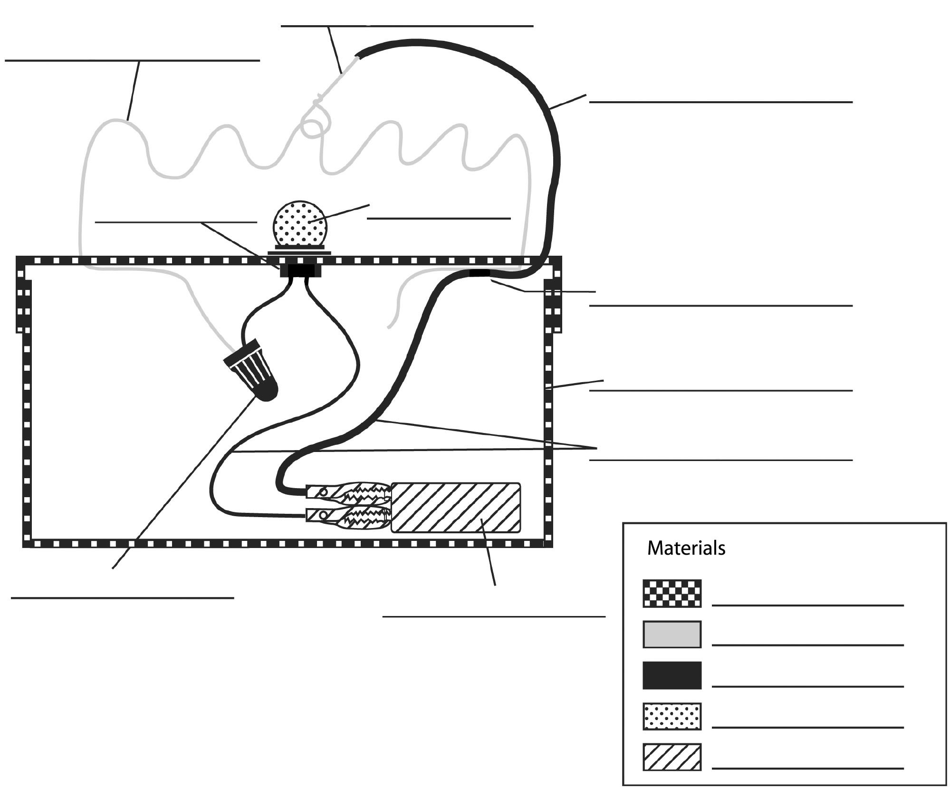
9. How could you improve your electric shoebox?

Appendix
manufacturing process sheet – electric shoebox
Main materials: shoebox, 14- and 24-gauge electrical wires, light bulb with base and wires, 9-V battery, duct tape, insulating connector, electrical wires with alligator clips
No. | Operation | Illustration |  | Materials
10 | Measuring and laying out
11 | Make a centred mark at each end of the top of the lid. | 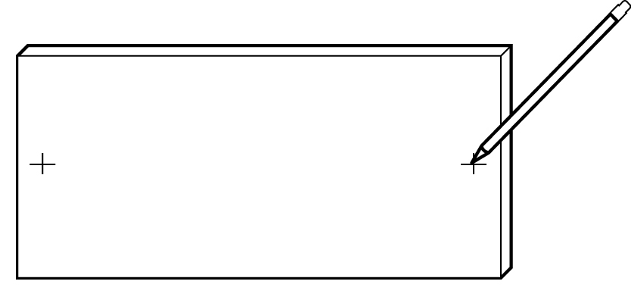 |  | • Marker
12 | Make a mark at one corner of the top of the lid. | 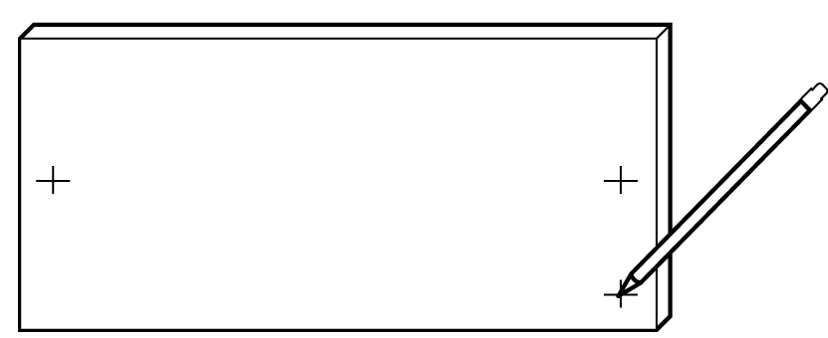 |  | • Marker
13 | Make a mark at the centre of the top of the lid. | 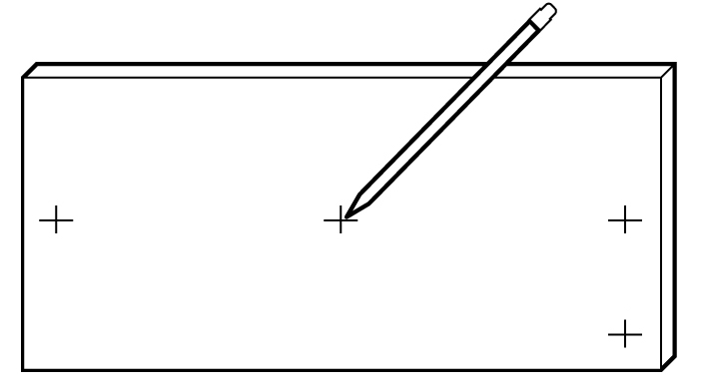 |  | • Marker
14 | Measure and cut a  1200-mm length of  14-gauge electrical wire. | 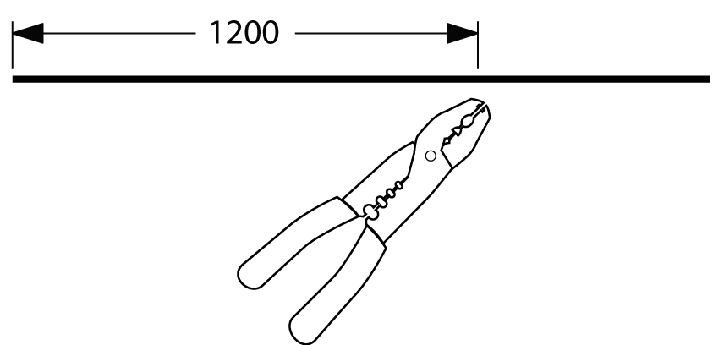 |  | • Tape measure  • Combination pliers

15 | Measure and cut a 700-mm length of 24-gauge electrical wire. | 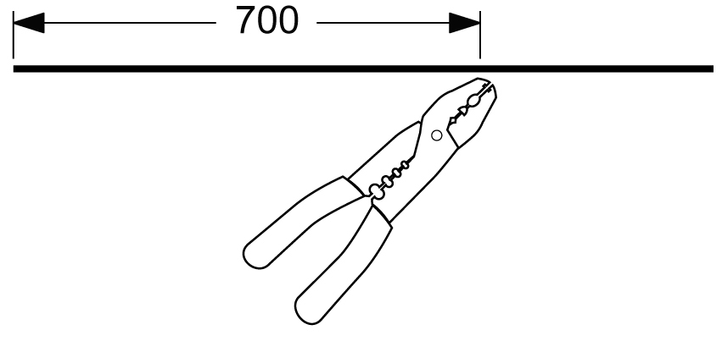 | • Tape measure  • Combination pliers
20 | Machining
21 | Strip the casing off the 1200-mm length of wire (see the Toolbox, p. 89). | 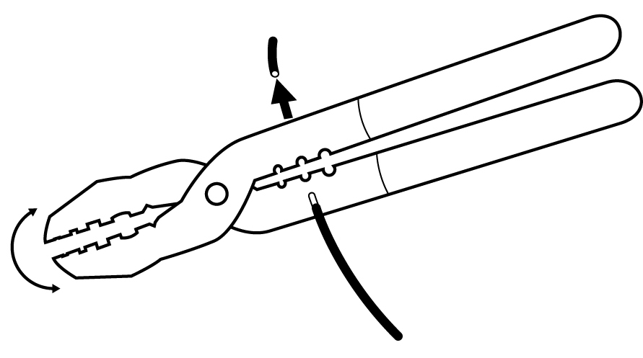 | • Wire strippers
22 | Shape the 1200-mm length of wire into a series of waves. | 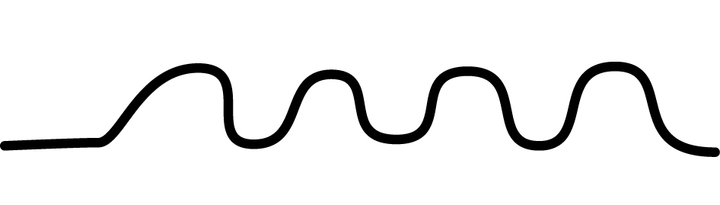
23 | At each of the three marks you made at the ends of the lid, cut a hole large enough for a wire to pass through. | 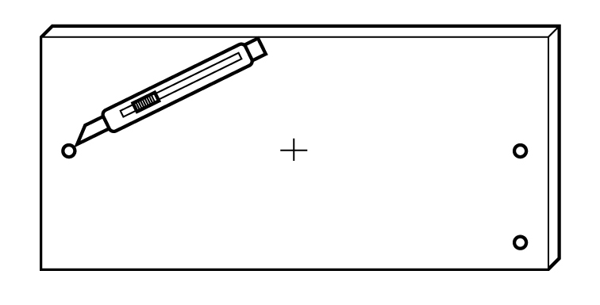 | • Retractable utility knife  • Cutting mat
24 | At the mark you made at the centre of the lid, cut a hole large enough to fit the base of the light bulb. | 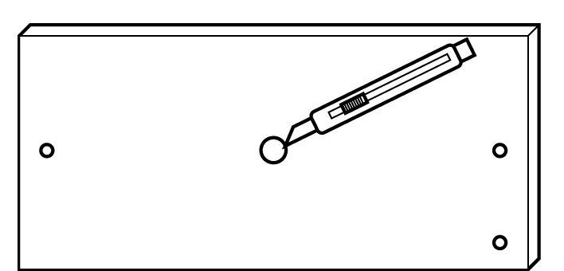 | • Retractable utility knife  • Cutting mat

25 | Strip 300 mm of casing off one end of the  24-gauge wire and 10 mm off the other end. |  | 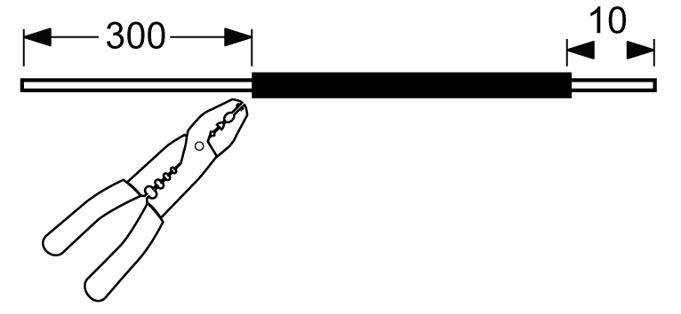 | • Wire strippers  • Ruler
30 | Assembling and finishing
31 | Insert the light bulb into the hole at the centre of the lid. Tape the base in place with duct tape. |  | 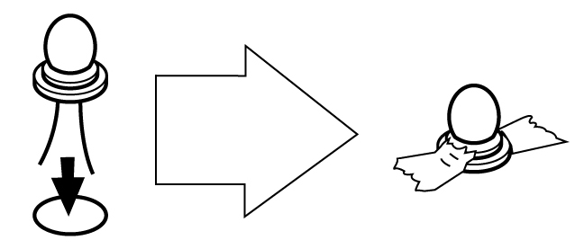
32 | Tape the battery to the bottom of the box with duct tape. |  | 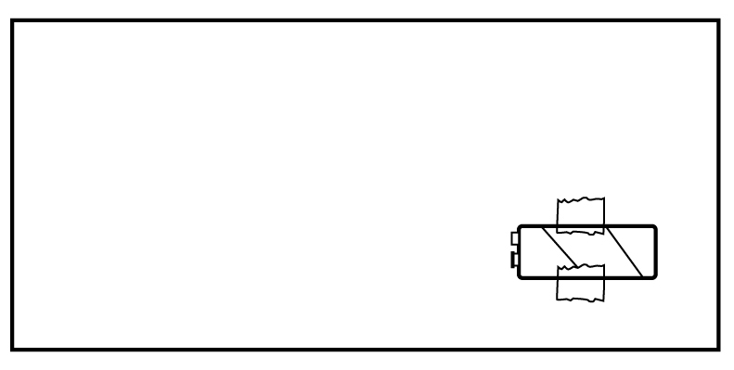
33 |  | Insert opposite ends of the 14-gauge wire into the centred holes at the ends of the lid. Tape each wire in place to the underside of the lid, leaving the ends of the wire free. | 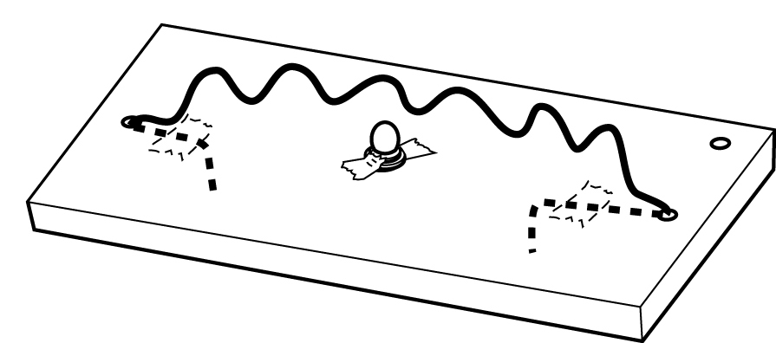

34 | Insert one end of the 14-gauge wire and one wire from the light bulb base into the insulating connector. Twist the connector to splice the wires together (see the Toolbox, p. 90). | 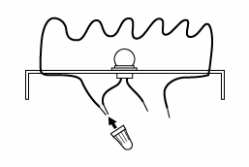
35 | Insert the stripped  10-mm end of the  24-gauge wire into the hole at the corner of the lid. Tape the wire in place to the underside of the lid, leaving the stripped 10-mm end free. | 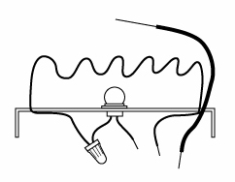
36 | Make a ring around the 14-gauge wire with the 300-mm stripped end of the 24-gauge wire. | 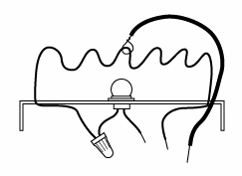

37 | Attach one end of  a wire with alligator clips to the end of the 24-gauge wire inside the box and attach the other end to a battery terminal. | 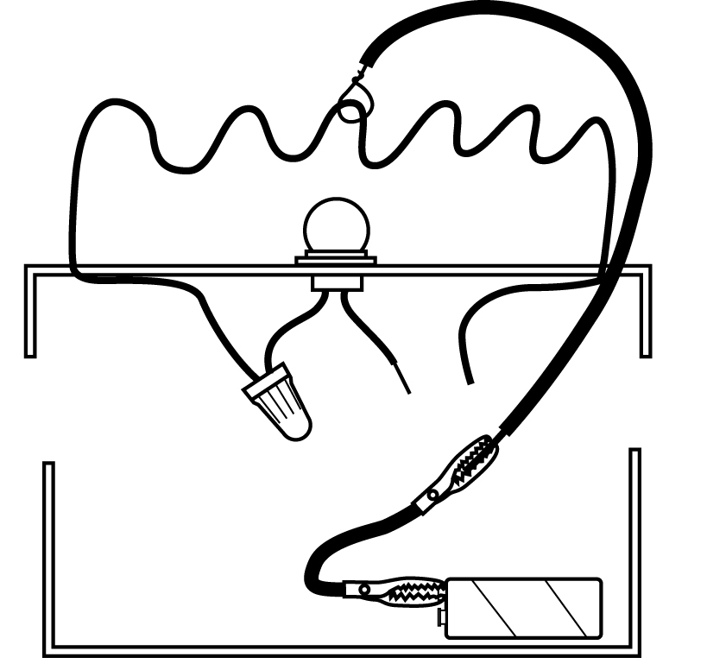
38 | Attach one end of the second wire with alligator clips to the free wire from the light bulb base. Attach the other end of the wire to the other battery terminal. | 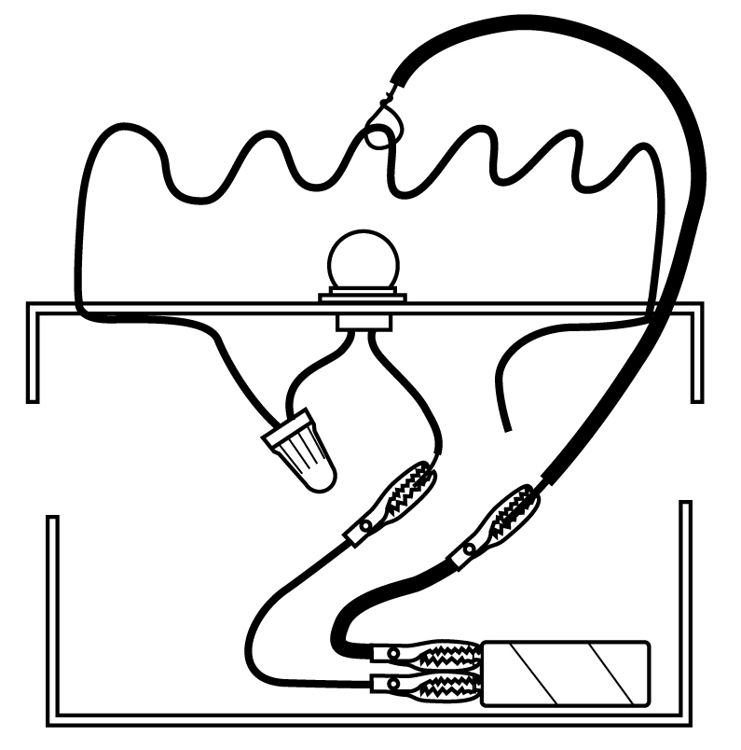
39 | Decorate your game of skill. | 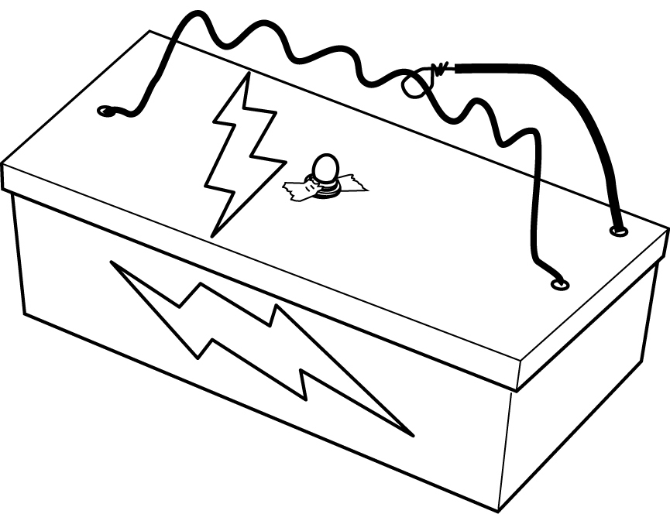 | • Markers

