Changing gears
PROGRAMS: ST, EST, AST
Method: Observation
CONCEPT: Speed changes
STUDENT BOOK: Chapter 13

Info brief activities
Many mechanical objects that are part of our everyday lives contain motion transmission systems. In these systems, some parts may turn at different speeds from others. In this activity, you will observe speed changes in a gear train.
For help in answering the activity questions, read pages 435–438, 442–443 of your student book.
IDENTIFYING OBSERVATION CRITERIA
1. When does a speed change occur in a motion transmission system?
INFO BRIEF 18
2. When building a gear train, three elements must be considered. Briefly describe these three elements.
ESTABLISHING AN OBSERVATION PROTOCOL
3. To build your gear train, you will need the following materials:
Materials
• 4 gear templates (See the appendix to this activity.) • cutting mat
• scissors • retractable utility knife
• 2 sheets of foam core (400 mm × 200 mm) • nail
• pencil • 4 25-mm paper fasteners
4. Follow the protocol below to build and operate your gear train.
Protocol | 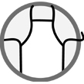
1. Cut out the four templates with scissors.
2. Trace the outline of the four templates onto a single sheet of foam core.
3. Place the sheet of foam core on the cutting mat and cut out the gears with the retractable utility knife.
4. Use the nail to punch a hole in the centre of each of the gears.
5. Use the paper fasteners to attach the gears to the second sheet of foam core as shown below.
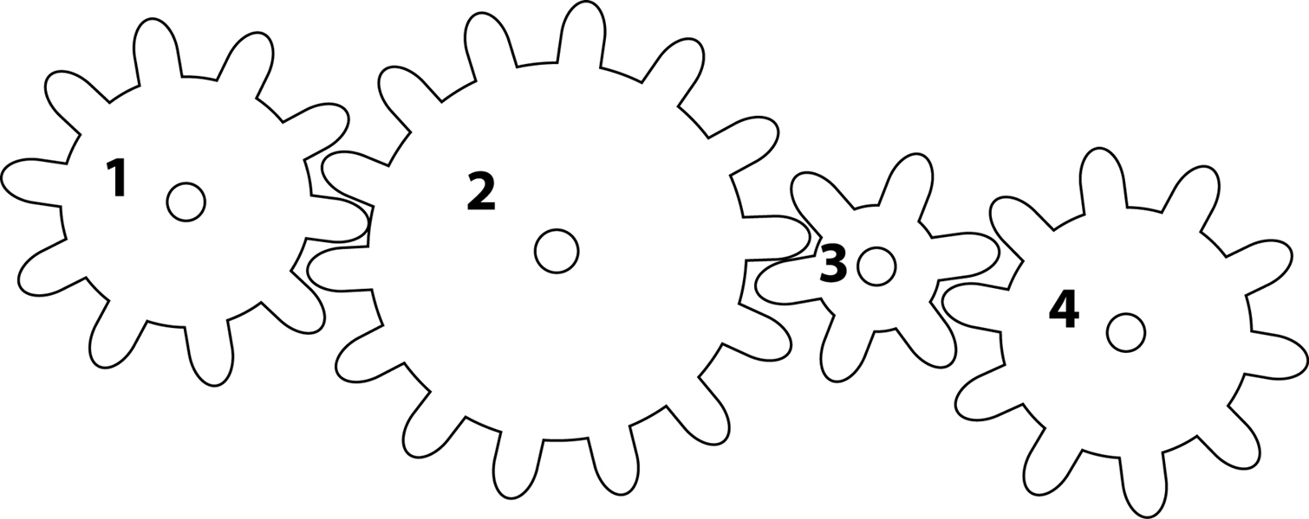
6. Record the number of teeth on each gear.
7. Turn gear 1 clockwise and record the direction of rotation of the other three gears.
8. Repeat step 7, turning gear 1 counterclockwise this time.
9. Activate the system by turning one gear. Compare the speed of rotation of the four gears. Record your observations in question 7.
APPLYING THE OBSERVATION PROTOCOL
5. Record your observations of the number of teeth on each gear in the table below. Give your table a title.

Title:

Gear | Number of teeth
1
2
3
4

6. Record your observations of the direction of rotation of each gear in the table below. Give your table a title.

Title:

Gear | Direction of rotation
1 | Clockwise | Counterclockwise
2
3
4
7. Complete the following sentences to describe the speed changes you observed in the gear train.
 | a) One turn of gear 2 equals |  | of gear 3.
 | b) One turn of gear 2 equals |  | of gear 1.
 | c) One turn of gear 1 equals |  | of gear 4.
 | d) One turn of gear 1 equals |  | of gear 3.
REFLECTING ON YOUR APPROACH
8. Which gear in your gear train turned the fastest? Explain your answer.
9. Which gear in your gear train turned the most slowly? Explain your answer.
10. Calculate the speed ratio between . . .
a) gear 1 and gear 2
b) gear 1 and gear 3
c) gear 1 and gear 4
d) gear 2 and gear 3
11. Were your observations confirmed by the calculations in question 10? Explain your answer.
12. Did your gear train work well? If not, what was the problem?
13. How could you improve your gear train?

appendix
gear templates
