An information chain
PROGRAM: EST
METHOD: Modelling
CONCEPTS: Gene
Protein synthesis
STUDENT BOOK: Chapter 11

Info brief activities
For protein synthesis to occur, the information contained in the form of DNA in the genes in cell nuclei must be transcribed to messenger RNA. This information is then translated into proteins with the help of transfer RNA in the ribosomes. In this activity, you will model the first part of this complex mechanism—the transcription of DNA—to obtain a clearer picture of the entire process.
For help in answering the activity questions, read pages 353–359 of your student book.
identifying the process to model
1. What is the name of the DNA segments that contain information for making proteins?
INFO BRIEF 16
2. DNA is composed of a series of chemical units. Label the diagram below by identifying the following elements:
• a nucleotide
• a nitrogenous base
• a phosphate group
• a sugar
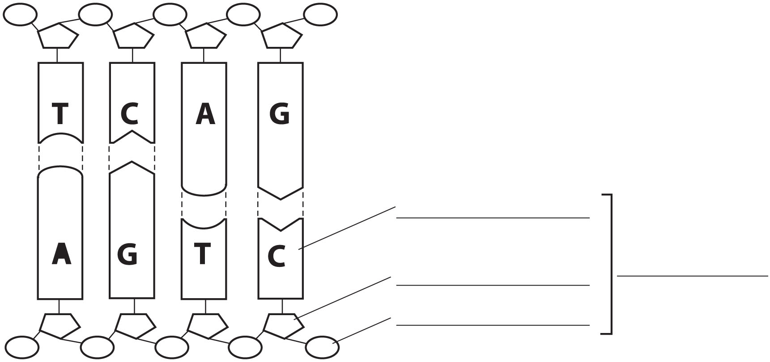

3. What are the nitrogenous bases that constitute the nucleotides of DNA? Give the name of each base and the letter used to represent it.
4. The pairing of nitrogenous bases in DNA is not a matter of chance. Explain the pairing pattern.
5. Two molecules play key roles in the process of transcribing the information in cells: DNA and RNA. These molecules are very similar, but they also differ in several ways. Explain their differences by completing the table below.
The main differences between DNA and RNA
 | DNA | RNA
Number of strands
Nitrogenous bases | Adenine, cytosine, guanine and | Adenine, cytosine, guanine and
Sugar in the molecule | Deoxyribose
6. Number the following steps of transcription in chronological order, from 1 to 5.
Transcription step | Chronological order
a) The messenger RNA detaches from the DNA.
b) The messenger RNA moves toward a ribosome.
c) The double helix of the DNA is unzipped.
d) The messenger RNA leaves the nucleus.
e) A messenger RNA molecule is built from the coding strand of the DNA by adding nucleotides according to the rules of base pairing.

7. Explain the base pairing rules during transcription.
a) is added to the to pair with the adenine on the DNA.
b) is added to the to pair with the thymine on the DNA.
c) is added to the to pair with the guanine on the DNA.
d) is added to the to pair with the cytosine on the DNA.
planning Your model
8. To model the transcription mechanism, you will have to represent the following elements:
• deoxyribose • cytosine
• ribose • guanine
• phosphate groups • thymine
• adenine • uracil
Complete the diagram below by indicating how you will use the materials at your disposal to model each of the elements.
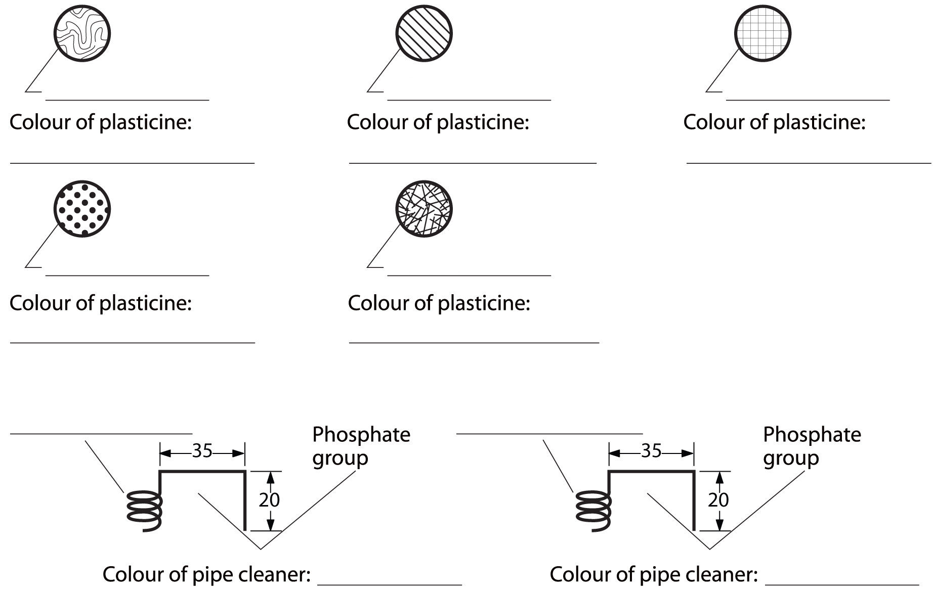

9. With the materials at your disposal, you will be able to model the shape of the DNA ladder.
In a DNA molecule, . . .
a) which chemical units make up the rungs of the ladder?
b) which chemical units make up the sides of the ladder?
In your model, . . .
c) what will you use to represent the rungs of the ladder?
d) what will you use to represent the sides of the ladder?
BUILDING YOUR model
10. The following sequence of nucleotides appears on the coding strand for the transcription of a DNA molecule:
A-T-C-T-G-A
a) What is the complementary sequence for this DNA strand?
b) Using the materials at your disposal, build a DNA molecule with these two strands. Place the coding strand below its complementary strand.
c) Draw your model in the box below.

11. On your model, show what happens to the two DNA strands when transcription begins. Draw the results in the box below.
12. Now use your model to represent the transcription process. Show the mRNA before it detaches from the DNA. Draw the result in the box below.

validating YOUR model
13. Has this activity helped you understand the DNA transcription mechanism? Explain your answer.
14. What other materials could you have used to model transcription? Give a few examples.
15. Did your model represent the real shape of DNA? Would that have been possible with the materials at your disposal?
16. What would you have to add to this modelling activity to illustrate the entire mechanism of protein synthesis?

