Germs we can’t live without
PROGRAMS: ST, EST
METHOD: Empirical
CONCEPT: Nitrogen cycle
STUDENT BOOK: Chapter 8

Info brief activities
Many elements are vital to living creatures, including carbon, hydrogen, oxygen, nitrogen, phosphorus and sulphur. These elements are made available through biogeochemical cycles, in which the elements are used and recycled. In this activity, you will learn more about the nitrogen cycle.
Identifying the research subject
For help in answering questions 1 to 8, read pages 258–259 of your student book.
1. What is the most abundant source of nitrogen on Earth?
info brief 11
2. Which organisms need nitrogen? What do they need it for?
3. What is the nitrogen cycle?
4. Which microorganisms are essential to the nitrogen cycle?
5. What are the five main processes in the nitrogen cycle?
• |  |  |  | •
• |  |  |  | •
•
6. How do animals obtain the nitrogen they need?
7. In which of the Earth’s spheres does the nitrogen cycle take place?

8. How can human activities disrupt the nitrogen cycle?
planning your research
9. The following organisms each play a role in the nitrogen cycle:
 | A. Bacillus | E. Taraxacum officinale
 | B. Sylvilagus floridanus | F. Azotobacter
 | C. Nitrobacter | G. Nitrosomas
 | D. Pseudomonas
What information would you need to determine the process in the nitrogen cycle in which each of these organisms participates?
conducting your research
10. Read Appendix 1 of this activity to match the organisms in question 9 with the various processes in the nitrogen cycle. Then, use the information you have gathered to complete the diagram in Appendix 2.
reflecting on your approach
11. What additional information would help you understand more about bacterial activity in the nitrogen cycle?
12. Has this activity helped you understand the nitrogen cycle? Explain your answer.

appendix 1
organisms involved IN THE NITROGEN CYCLE
The following are brief descriptions of some of the organisms that play a role in the nitrogen cycle:  A. Species of the genus Bacillus are bacteria in the Bacillaceae family that live in the soil and water. These bacteria are saprophytes, which means that they feed on decaying organic matter.  B. The eastern cottontail (Sylvilagus floridanus) lives in southern Québec and eastern North America. Its fur is greyish brown, and unlike the snowshoe hare, it does not turn white in winter. It lives in fields, on the edges of forests and even in city parks. It eats a variety of herbaceous plants, including goldenrod, plantain, clover and dandelions. In winter it grazes on tree bark.  C. Bacteria of the genus Nitrobacter are chemoautotrophs, which means that they use inorganic chemicals as energy sources. Nitrobacters transform nitrites (NO₂–) into nitrates (NO₃–) through oxidation. |  |  | D. Pseudomonas bacteria live in flooded soils, where little oxygen is available.  They convert nitrates into nitrogen gas (N₂), which escapes into the atmosphere.  E. Taraxacum officinale, or dandelions, are yellow herbaceous plants of the Asteraceae family. They flower in the spring and are found in all the populated regions of the world. Their fruit, each carried by a pappus, can travel long distances on dry, windy days.  F. Bacteria of the genus Azotobacter live in the soil and water. They are heterotrophic, which means that they feed on organic matter. This type of bacteria contains nitrogenase, an enzyme that transforms atmospheric nitrogen into ammonia (NH₃).  G. Nitrosomas bacteria are chemoautotrophs, like nitrobacters. They live in the soil and in fresh water. Nitrosomas transform ammonium (NH₄⁺) into nitrites through oxidation.

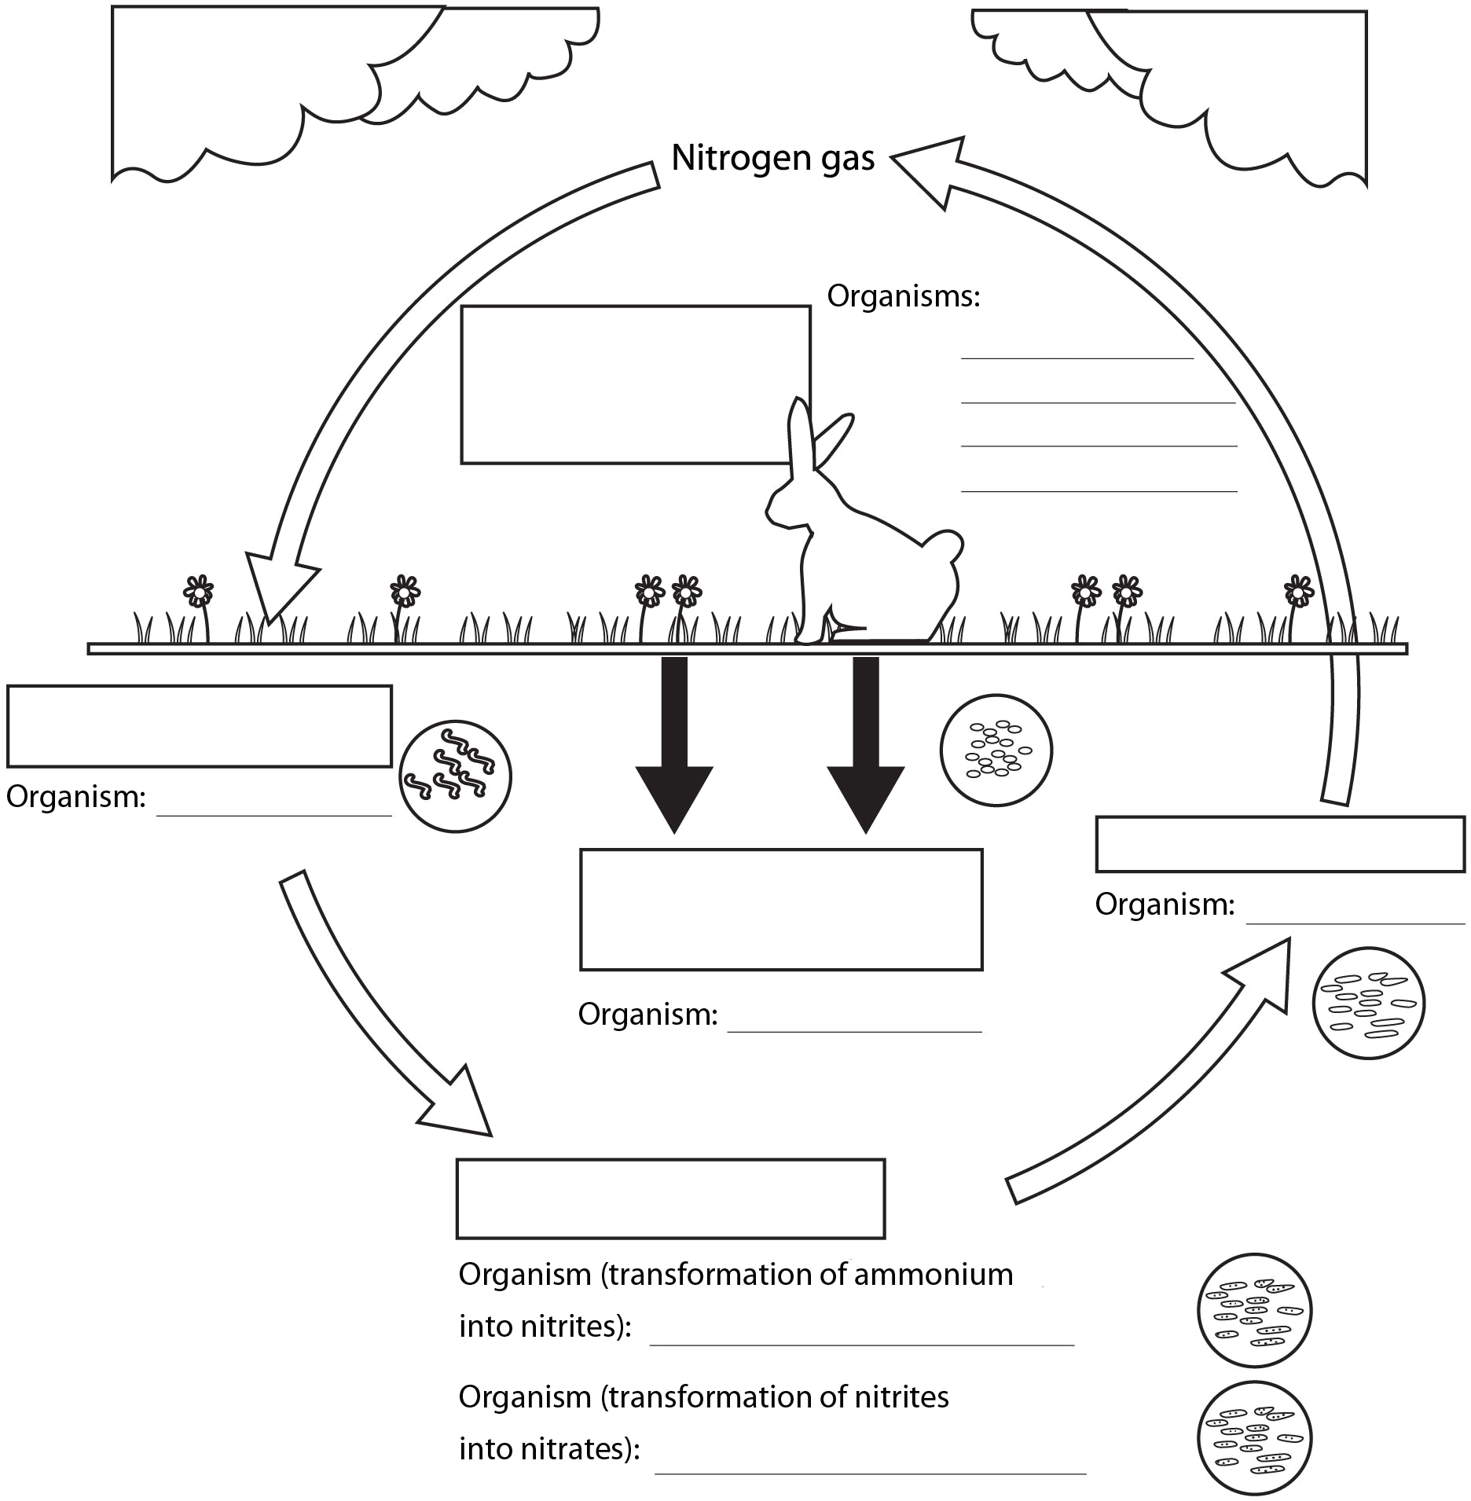
appendix 2
the nitrogen cycle
Complete the diagram below of the nitrogen cycle by writing the names of the processes in the boxes and the names of the organisms involved in these processes on the appropriate lines.

