Blowing in the wind
PROGRAMS: ST, EST, SE
METHOD: Technological design process
CONCEPT: Atmospheric circulation
STUDENT BOOK: Chapter 7
TOOLBOX: Page 75

Info brief activities
Wind force can vary greatly from gentle breezes that barely ruffle the leaves on a tree to violent gusts during blinding snowstorms. Meteorologists rely heavily on wind data to predict the weather. With the object you build in this activity, you will be able to tell the force of the wind without watching the weather channel.
For help in answering the activity questions, read pages 224 and 226–228 of your student book as well as page 75 of the Toolbox.
IDENTIFYING AND MEETING A NEED
- In this activity, you will build an anemometer out of simple materials.
What can you measure with this instrument?
info brief 9
IDENTIFYING THE WORKING PRINCIPLES
2. Complete the design plan below for the anemometer you will build, indicating:
a) the motion of the straw
b) the motion of the toothpick
c) the force that makes the anemometer work
Design plan
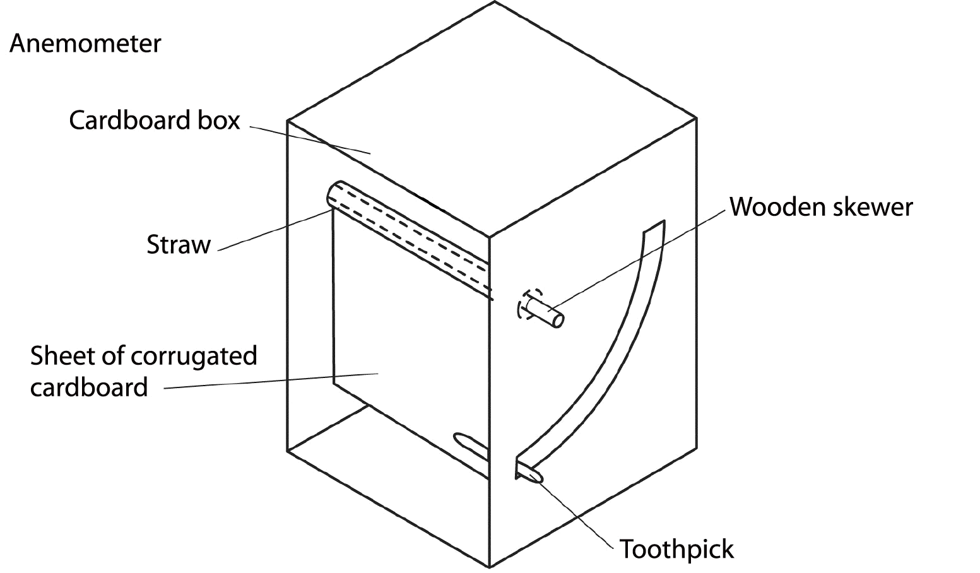

3. What movement of air in the troposphere makes the anemometer work?
4. What creates wind?
5. In what direction do prevailing winds blow in North America?

EST

SE

SE
6. Which circulation cell creates the prevailing winds in Québec?

EST
IDENTIFYING THE BUILDING PRINCIPLES
7. To build your anemometer, you will need the following materials:
Materials
• cardboard box such as a shoe box (at least 11 cm deep), without the lid
• sheet of corrugated cardboard
• wooden skewer
• straw
• toothpick
• adhesive tape
• ruler
• pencil
• compass
• retractable utility knife
• scissors
8. Using the above list of materials, complete the technical diagram for the anemometer on the following page:
a) Label the parts.
b) Complete the materials legend.
c) Indicate the locations of the linking component with the appropriate symbol (X).
d) Illustrate the types of guiding ensured by certain parts.
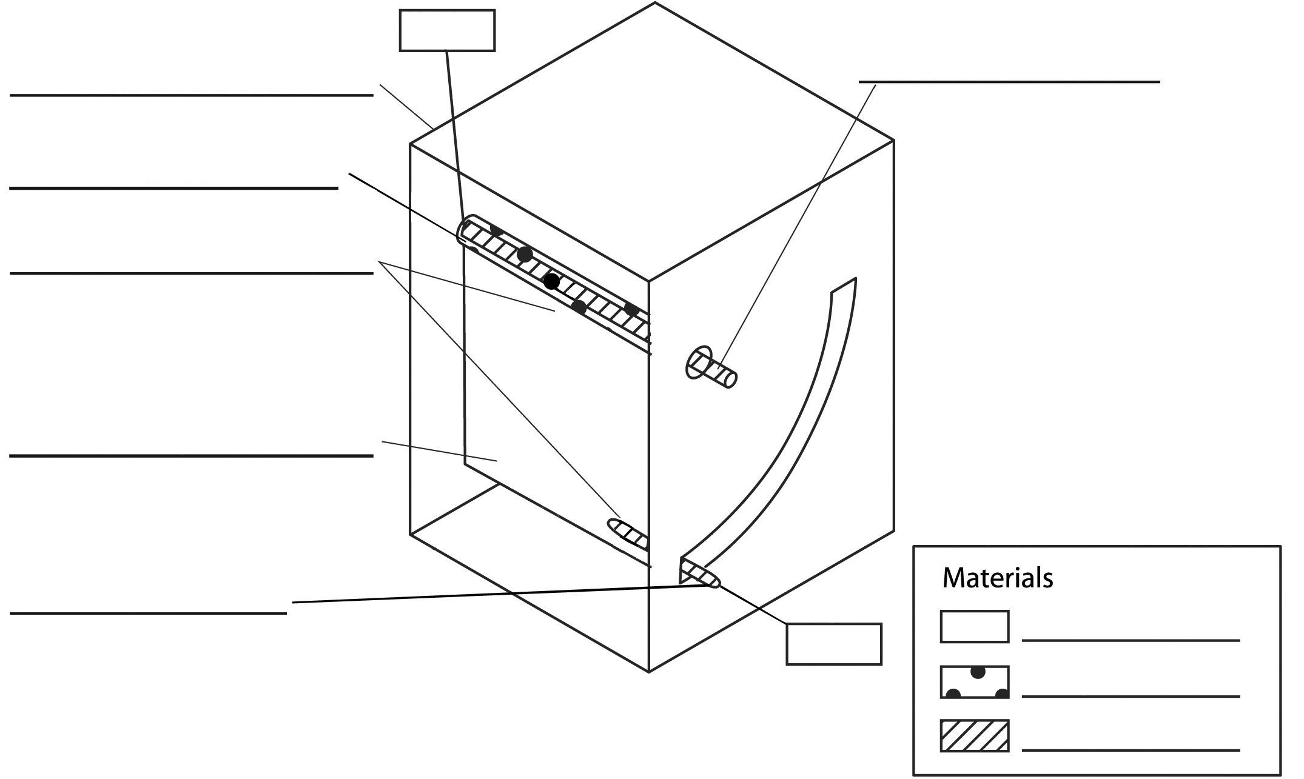
Technical diagram

BUILDING AND TESTING A PROTOTYPE
9. Build your prototype following the steps described in the manufacturing process sheet in the appendix.
10. Take your anemometer outdoors to see if it works. You will have to place a heavy object (such as your student book) on top of the anemometer to prevent the wind from blowing it over, but make sure the object does not stop the wind from entering the device. Does your anemometer work as expected? If not, what is wrong with it?
11. How must you position your anemometer to measure the force of the wind?

12. Explain how your anemometer works by completing the following sentence:
The stronger the wind blows,
13. Your anemometer has no scale to measure the exact force of the wind. How could you create an accurate scale?
14. Your anemometer is made of very light materials. What materials would be more appropriate if you wanted to use it to measure strong winds?
15. What could you add to your anemometer (besides a scale of measurement), or how could you adapt it to make it more effective?

APPENDIX
manufacturing process sheet – anemometer
Main materials: cardboard box, sheet of corrugated cardboard, wooden skewer, straw, toothpick, adhesive tape
No. | Operation | Illustration |  | Materials
10 | Measuring and laying out
11 | Draw a circle slightly larger than the diameter of the wooden skewer on each side of the box, 10 mm from the front edge and 40 mm from the top. | 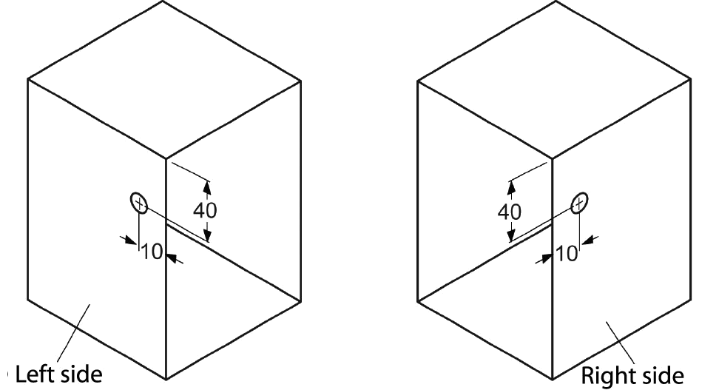 |  | • Ruler  • Pencil  • Compass
12 | On one side of the box, draw a horizontal line and a vertical line, tangent to the circle. | 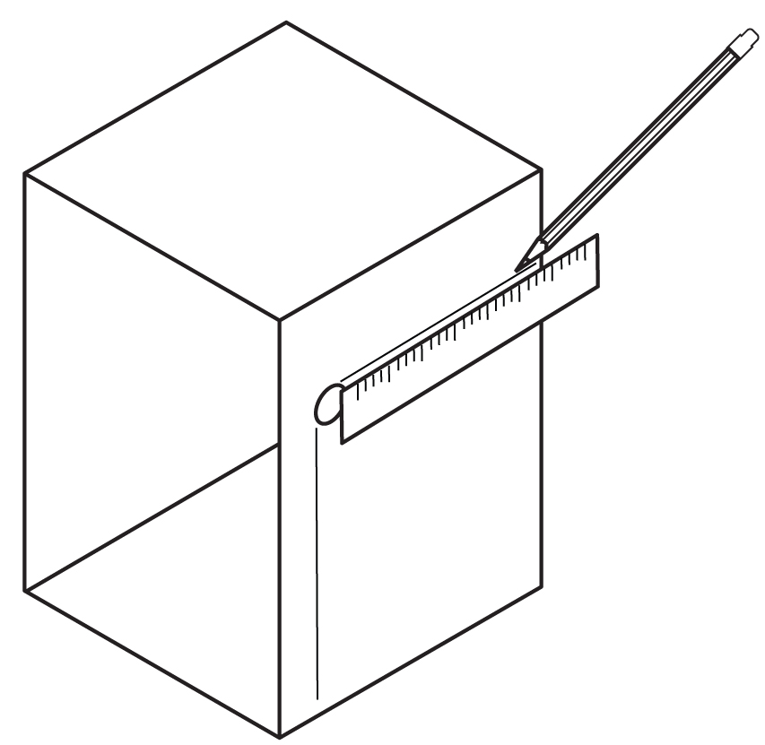 |  | • Ruler  • Pencil
13 | Place the point of the compass at the centre of the circle and draw an arc with a radius of 80 mm between the two lines. Draw a second arc with a radius of 90 mm. | 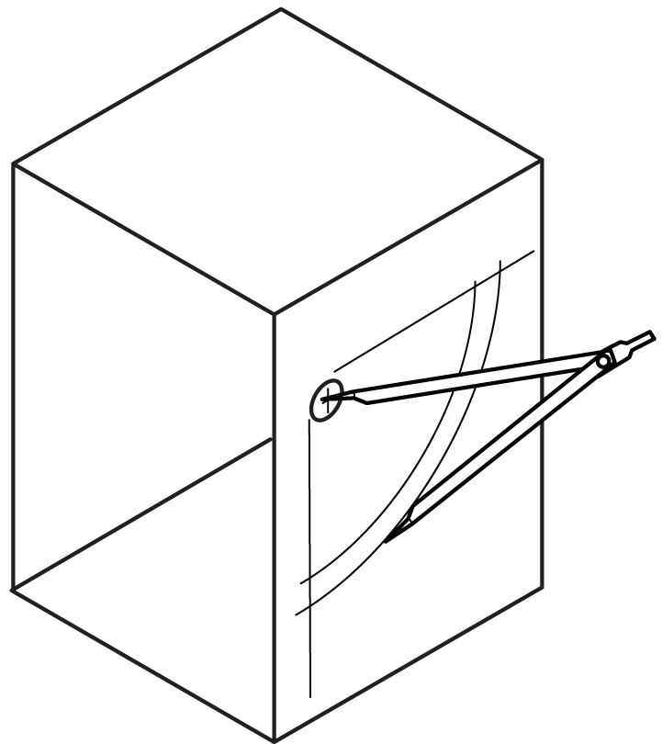 |  | • Ruler  • Pencil  • Compass

14 | On the sheet of corrugated cardboard, draw a rectangle 90 mm high and 10 mm narrower than the opening of the box. | 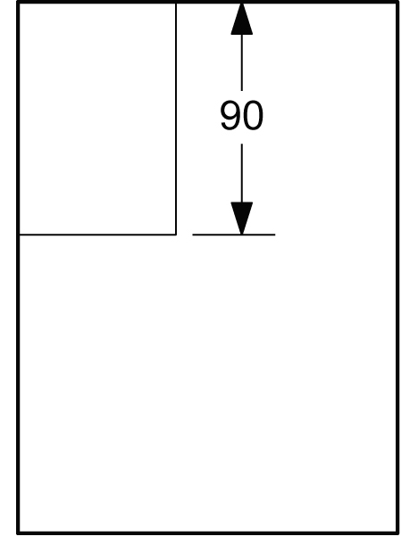 | • Ruler  • Pencil
20 | Machining
21 | Cut out the two circles and the arc. | 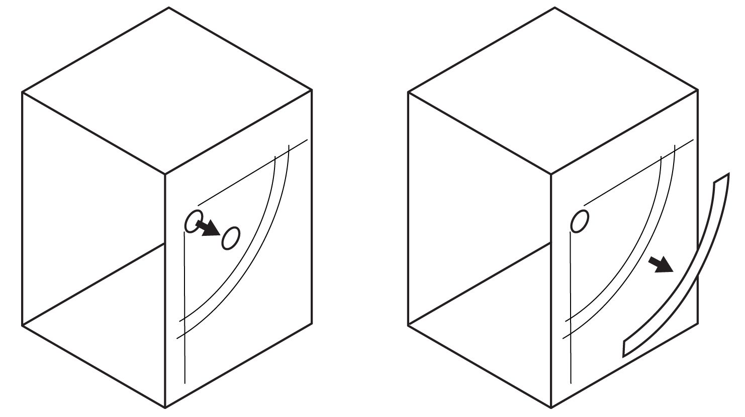 | • Retractable utility knife
22 | Cut out the cardboard rectangle. | 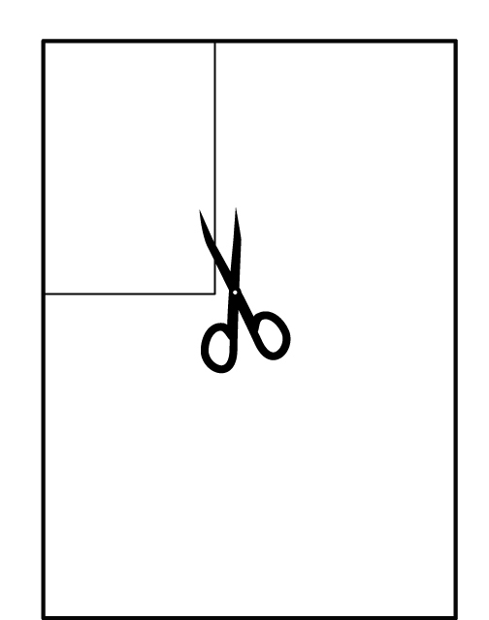 | • Scissors
23 | Cut the straw to a length equal to the width of the cardboard rectangle. | 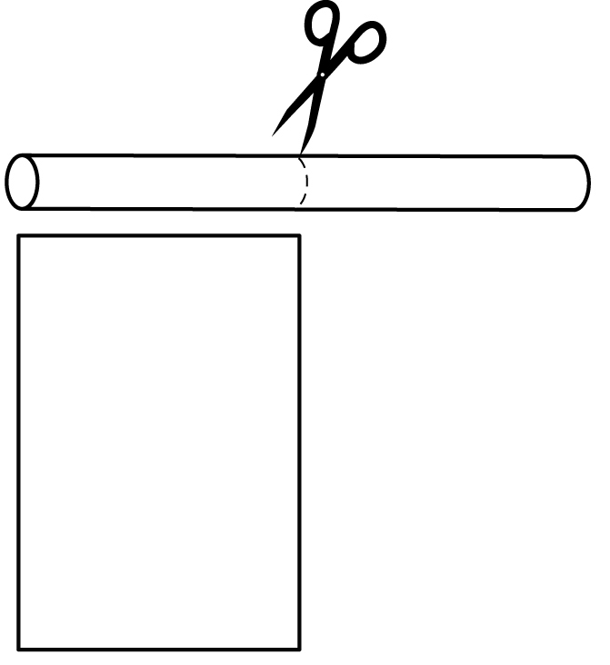 | • Scissors

30 | Assembling
31 | Attach the straw across the top of the cardboard rectangle with adhesive tape. | 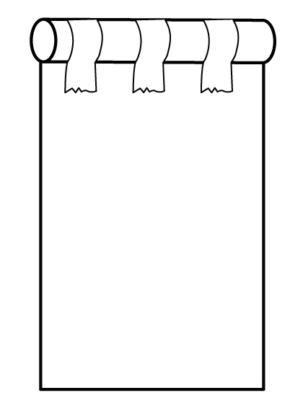
32 | Insert the wooden skewer through one hole in the box. Insert the skewer through the straw and then through the second hole in the box. | 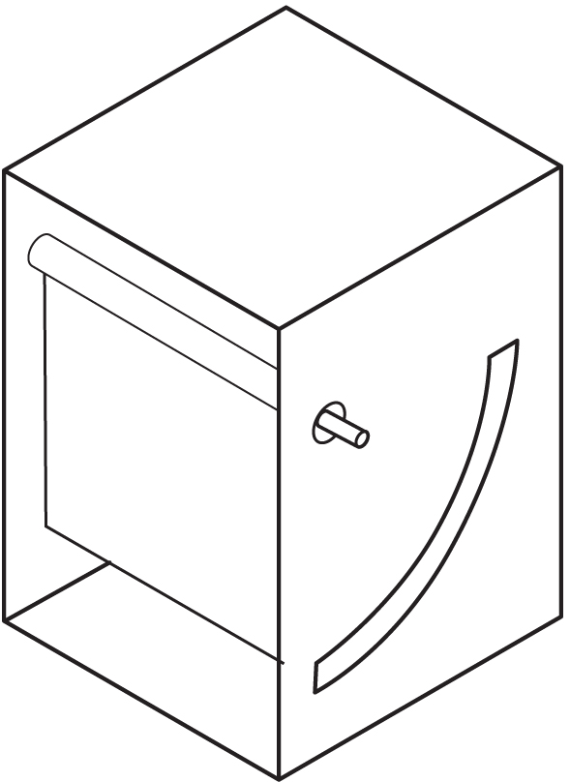
33 | Insert the toothpick inside the bottom of the cardboard rectangle so that one end of it protrudes into the arc and can move without friction along the arc opening. | 