Electricity in the air
PROGRAMS: ST, EST, AST
METHOD: Technological design process process
CONCEPTS: Static electricity
Electrical charge
Coulomb’s law (EST)
STUDENT BOOK: Chapter 5

Info brief activities
Many objects can be charged with static electricity. But how can you check whether an object is charged? In this activity, you will use some simple materials to build an instrument for observing the presence of static electricity.
For help in answering the activity questions, read pages 141–149 of your student book.
identifying and meeting a need
- In this activity, you will learn how to build a leaf electroscope. What is a leaf electroscope?
info brief 6
identifying the working principles
2. Complete the design plan for the electroscope you will build, by indicating:
a) the path travelled by electrons when a negatively charged ruler touches the electroscope
b) the movement of the aluminum foil
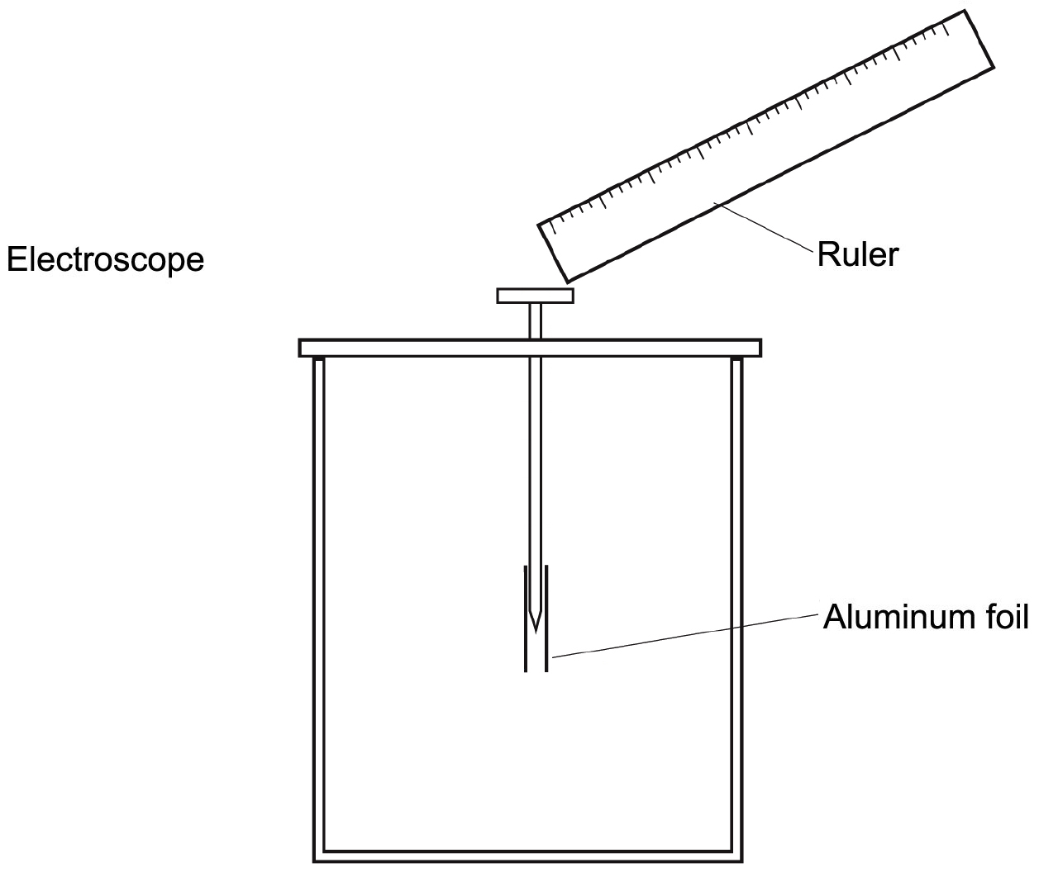
Design plan

3. What phenomenon allows electrons to pass from the ruler to the electroscope?
4. Why do the foil leaves repel each other when the electroscope is charged?
identifying the building principles
5. To build your electroscope, you will need the following materials:
Materials
• clear plastic jar • adhesive tape
• sheet of cardboard • pencil
• sheet of aluminum foil • ruler
• 4-cm (or longer) nail • scissors
6. Using the above list of materials, complete the technical diagram of the electroscope:
a) Label the parts.
b) Complete the materials legend.
c) Indicate the location of the linking component with the appropriate symbol (X).
Technical diagram
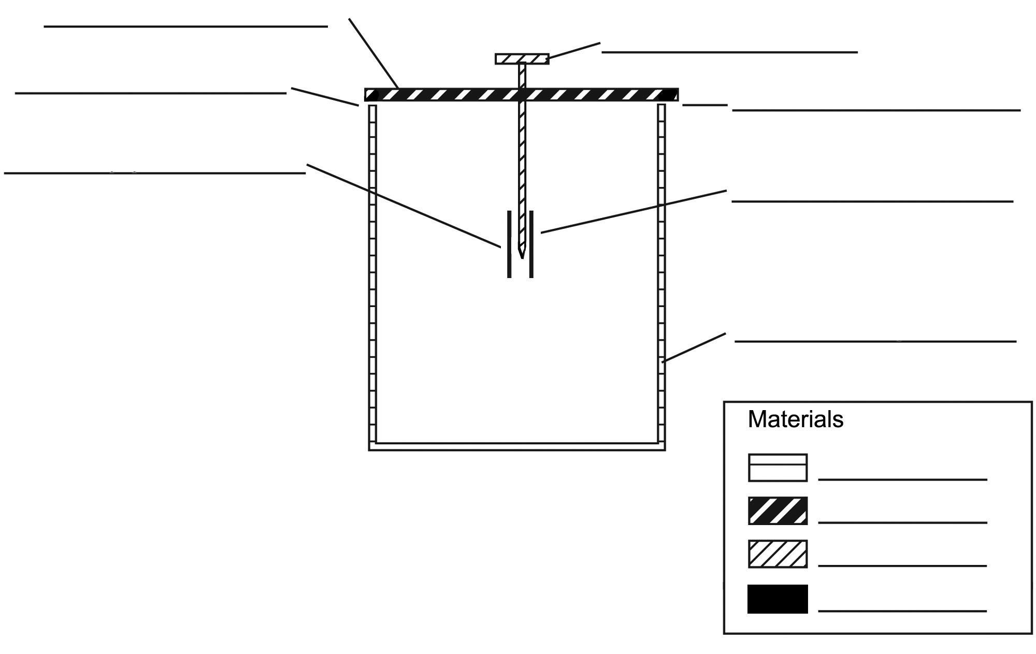

building and testing a prototype
7. Build your prototype electroscope, following the steps in the manufacturing process sheet in the appendix to this activity.
8. Check to see whether the electroscope works. Charge a plastic ruler with a scrap of wool and touch the nail in the electroscope with the ruler. Does the electroscope react as you expected? If not, explain your answer.
9. How did you charge the ruler?
10. Why was the ruler negatively charged?
11. How did you charge the electroscope?
12. What was the charge on the electroscope? Explain your answer.
13. You may have noticed that the closer you moved the ruler to the electroscope, the farther away the aluminum foil leaves moved from each other. On the other hand, the farther away you moved the ruler, the closer the foil leaves came to each other. What law explains this phenomenon? What does this law state?

EST

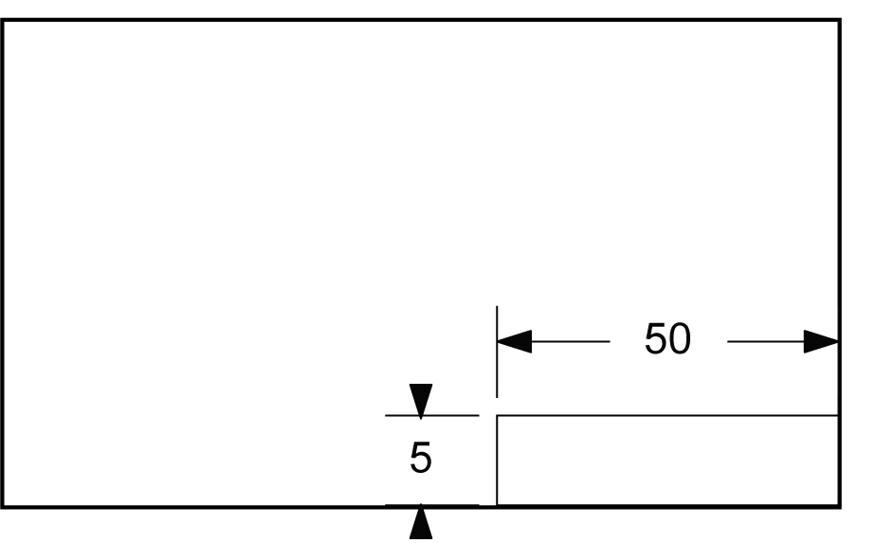
appendix
MANUFACTURING PROCESS SHEET – ELECTROSCOPE
Main materials: clear plastic jar, sheet of cardboard, sheet of aluminum foil, 4-cm (or longer) nail, adhesive tape
No. | Operation | Illustration |  | Materials
10 | Measuring and  laying out
11 | Turn the jar upside down on the sheet of cardboard and trace a circle around the bottom edge. | 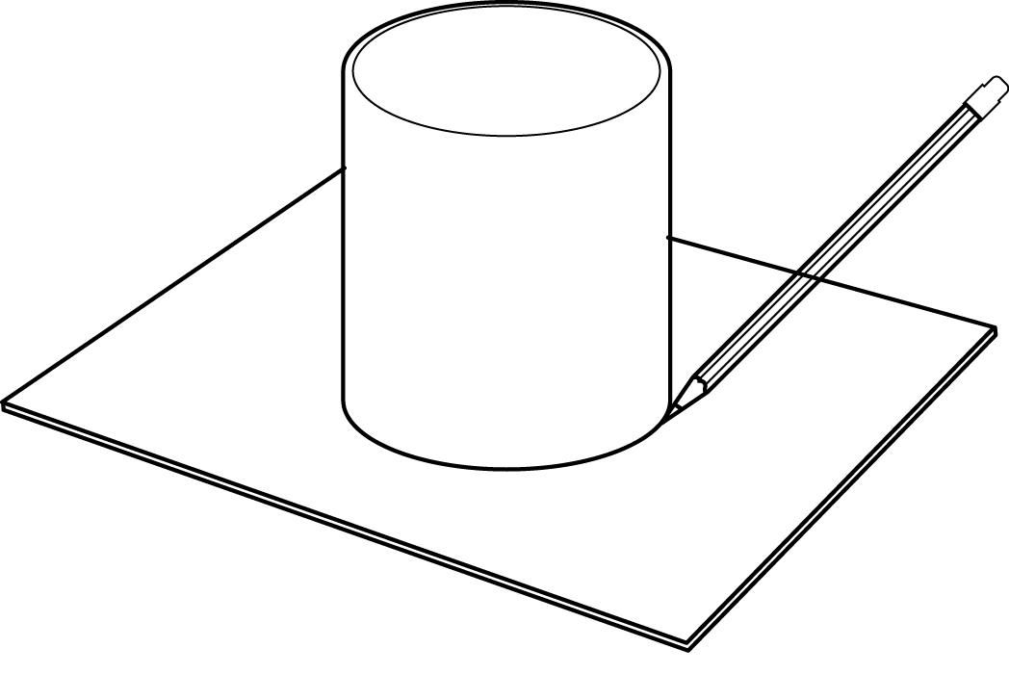 |  | • Pencil
12 | Draw a 50 mm ×  5 mm rectangle on the sheet of aluminum foil. |  |  | • Ruler  • Pencil
20 | Machining
21 | Cut out the circle of cardboard. | 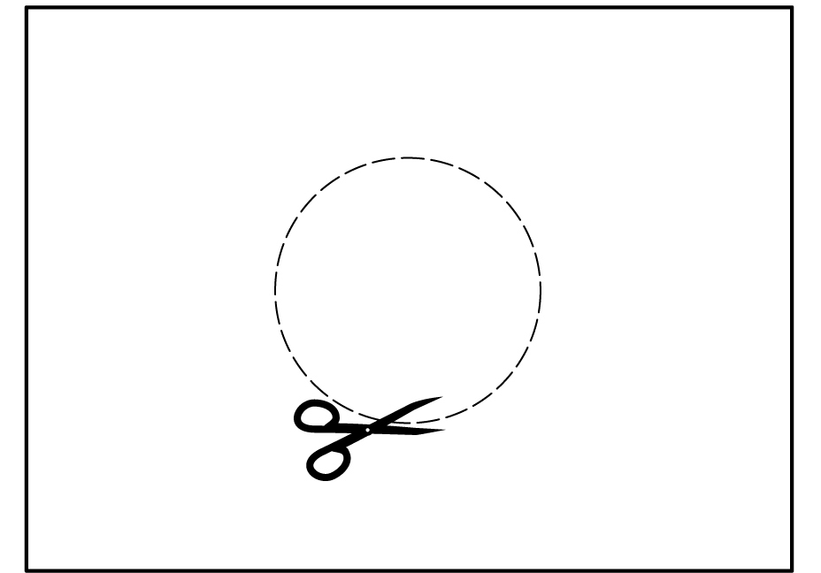 |  | • Scissors

22 | Cut out the rectangle of aluminum foil. | 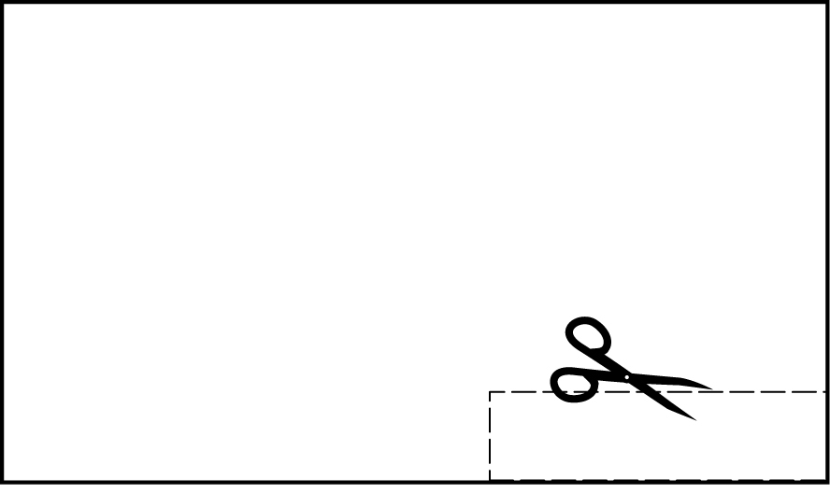 | • Scissors
23 | Fold the aluminum foil rectangle in half and cut along the fold to obtain two 25-mm-long rectangles. | 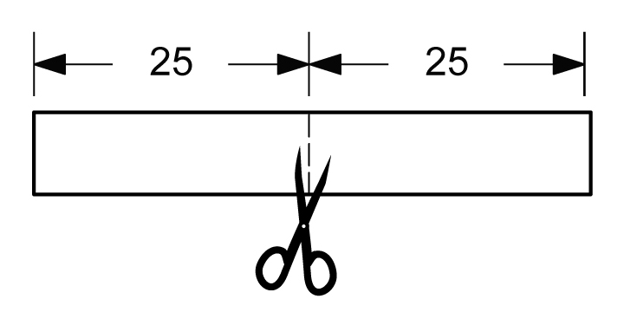 | • Scissors
30 | Assembling
31 | Insert the nail through the centre of the cardboard circle, leaving a 10-mm length above the circle, between the nail head and the cardboard surface. | 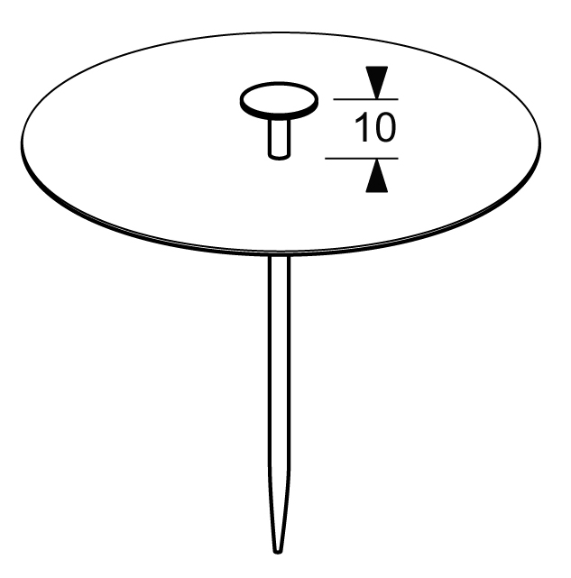
32 | Place the two aluminum foil rectangles face to face, one on each side of the lower tip of the nail so that a 10-mm length of the nail tip is between the rectangles. | 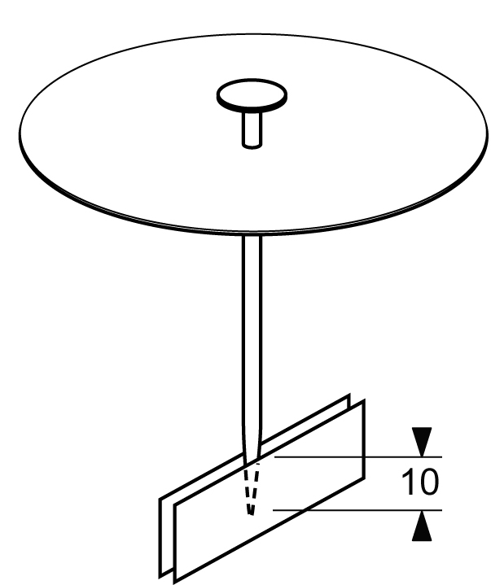

33 | Tape the foil rectangles to the nail. | 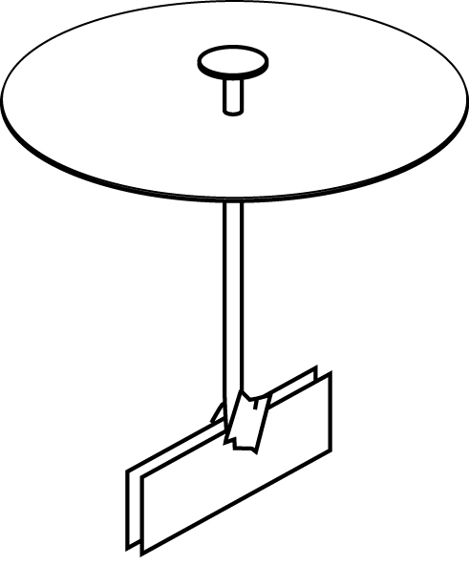
34 | Place the cardboard circle on the jar so that the nail tip with the foil rectangles is inside the jar. | 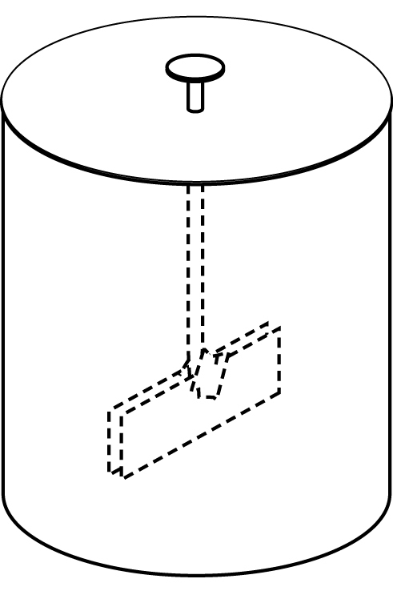
35 | Tape the cardboard circle to the top of the jar. | 