NOTES to TEACHERS
CHAPTER 1
REAL JUICE OR SWEETENED
FRUIT-FLAVOURED WATER?
Comment
It would be instructive to have students bring drink labels to class and compare the information
on them.
It would also be instructive to link this activity with the new edition of Canada's Food Guide, which recommends limiting the intake of juices, eating more fruit and drinking more water.
MAKING A THOUGHTFUL CHOICE
Comment
Students can be left to find information on their own. If they have access to a computer, you may direct them to the appropriate sections of the Observatory Companion Website (under Info briefs: activities).
Be sure to tell students that all sources of information are not equally reliable and that opinions are not always impartial (advise them to read part 4 of the Toolbox, if applicable).

CHAPTER 2
A MAGIC KEY
Comment
• Ask students to come to class with a key they want to colour or no longer use.
• Prior to the activity, prepare enough copper chloride solution to give 150 mL to each student
or team of students. Consult the product data sheet as needed (see Companion Website).
OUT OF SIGHT
Comment
Ready-made models sold on the market can also be used for this modelling activity.
Suggested materials
• polystyrene balls or marshmallows
• stir sticks or toothpicks

CHAPTER 3
GAS UNDER PRESSURE
Comment
A smaller balloon may be used, but there will be problems fitting it around the neck of the bottle. A 1-L
bottle will work better with a smaller balloon.
Alternative
Below is another protocol for observing the relationship between gas pressure and volume. You may
recommend the protocol suggested in the activity or else the one described below:
Materials
• clear plastic bottle (2 L or 1 L)
• inflatable balloon (30 cm or 22 cm)
• drinking straw
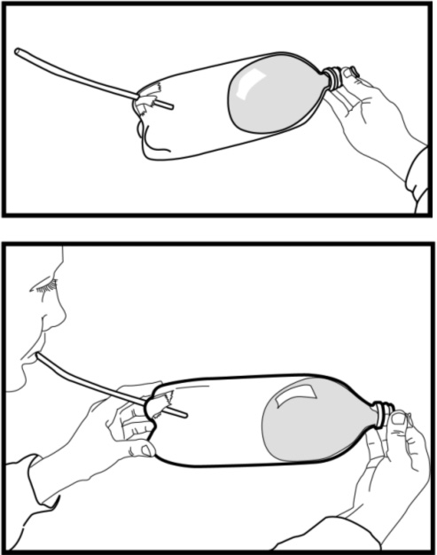
• transparent adhesive tape or adhesive putty
Procedure
1. Make a hole in the bottom of the bottle just large enough
to insert the drinking straw.
2. Keep part of the straw outside the bottle and secure it with
the adhesive tape or adhesive putty to prevent air from
escaping through the hole.
3. Hold the balloon by the end and insert into the bottle. Blow
until the balloon is partially inflated.
4. Squeeze the tip of the balloon between your fingers to keep
it inflated.
5. Blow into the straw and observe what the balloon does.
6. Suck air from the bottle through the straw and observe
what the balloon does.

BLOOD PRESSURE
Comment
At the start of this activity, demonstrate what happens in atherosclerosis by modelling the blockage of blood flow in an artery.
Materials
• clear or transparent plastic bottle (500 mL or 1 L)  • drinking glass (diameter smaller than funnel diameter)  • plastic funnel (8 cm or 10 cm in diameter)  • 200 mL of tap water (cold)  • red colouring (optional) | • graduated cylinder (100 mL or 200 mL)  • about 2 mL of margarine  • plastic or metal knife  • toothpick  • stopwatch

Procedure
1. Tell students that the funnel represents an artery.
2. Colour the water with a few drops of red colouring to simulate blood (optional).
3. Plug the funnel with your finger to keep the water from flowing through, then slowly pour in
100 mL of water.
4. Assign a student to time how long the water takes to go through the funnel.
5. Put the mouth of the funnel over the mouth of the bottle and remove your finger. Let the water
run through and record the flow time.
6. Empty the water from the bottle.
7. Using the knife, place a small amount of margarine in the tube of the funnel. Fill about half of
the tube and tamp the margarine so it stays in place when water flows through the tube.
8. Insert a toothpick to make a hole in the middle of the tube so that liquid can stream through.
9. Fill the funnel again with 100 mL of water and record the time the liquid takes to flow into
the bottle.
Water flow time – open funnel: about 2 seconds.
Water flow time – partly clogged funnel: 4-5 minutes.
Note: Flow time (step 9) will depend on the size of the hole made with the toothpick.

Drawing a conclusion
• Lead students to conclude that the fat deposited in the arteries will gradually clog them and
interfere with blood flow.
Making the connection
• After the demonstration, ask students to explain the connection between blood pressure and
atherosclerosis.
One consequence of atherosclerosis (arteries blocked by fatty deposits) is hypertension, also known
as high blood pressure. This occurs when the artery diameter becomes narrower owing to partial
blockage and blood pressure increases to ensure sufficient flow for oxygenating the body.
CHAPTER 4
PEERING ABOVE THE CROWD
Comment
• Juice or cream boxes of the same size (about 7 cm at the base and 24 cm high) may also be used. Ask students to bring some boxes from home and make sure they are properly rinsed to prevent bad odours.
• Since a large supply of glass mirrors may be costly, plastic mirrors may be used instead.
NOT IN PLAIN SIGHT
Comment
You may have students conduct a similar sampling survey among their family and friends.
You may suggest that students use spreadsheet-type software to keep track of their data.

CHAPTER 5
SAME OR DIFFERENT?
Comment
If you plan to demonstrate the observation method in class, start by assigning a number to
each student. Instead of writing their names in the table, students can simply record their
assigned numbers.
Alternatives for choosing a group to observe
• students entering school in the morning
• students from another class
• the students’ families
MULTIPLICATION AND DIVISION
Comment
Have pipe cleaners of different colours on hand for this activity.
Alternative
• Ask students to model only one method of reproduction.
• Divide the class into two teams: one can model mitosis, the other meiosis.
• Have students compare their models.
– What do the models have in common?
– What are their principal differences?
CHAPTER 6
A HEALTHY LUNCH BOX
Alternatives
Instead of having students plan their own lunch box menu, suggest that they plan a menu for one of the following people:
• 5-year-old boy
• 30-year-old woman
• 22-year-old runner
• 62-year-old sedentary man with high blood pressure
Students could also analyze their own lunch box contents to see whether they are following the recommendations of Canada’s Food Guide. In this case, they should determine how many servings of each food group they have in their lunch boxes.
You can ask the students to share their healthy menu with the group. This could give them new lunch ideas.
Canada’s Food Guide is available online. A link to Health Canada's Website is provided on the Observatory Companion Website (under Info briefs: activities).
ATTACK AND COUNTERATTACK
Comment
The castle on the next page may be used as a basic model illustrating the body’s
defence mechanisms.
Students are to represent the body's two ways of protecting itself:
• The white cells stage a frontal attack on antigens (foreign substances such as toxins and microorganisms) by digesting them.
• The white cells secrete antibodies that attack the antigens.

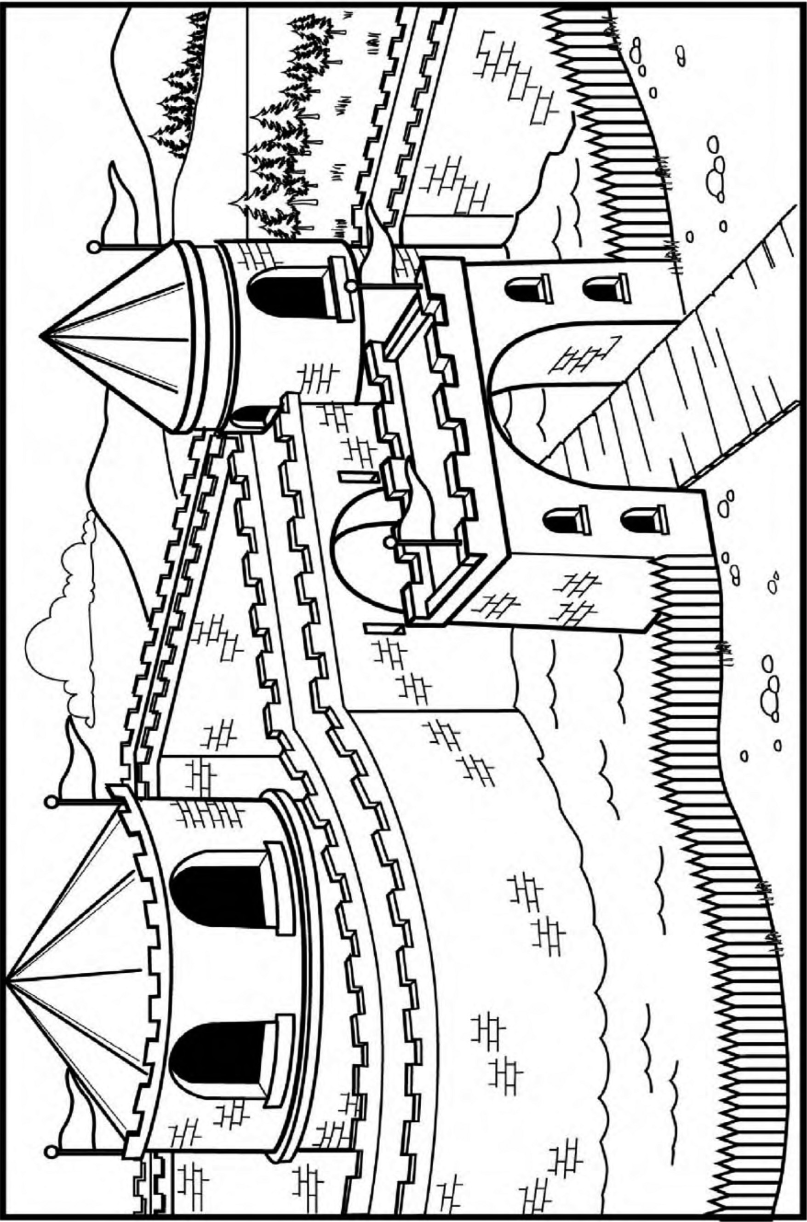
CHAPTER 7
HELMETS: TO WEAR OR NOT TO WEAR
Comment
Students can be left to find information on their own. If they have access to a computer, you may
direct them to the appropriate sections of the Observatory Companion Website (under Info briefs:
activities).
Be sure to tell students that all sources of information are not equally reliable and that opinions are not always impartial (advise them to read part 4 of the Toolbox if applicable).
SYSTEM IN PERIL
Comment
Students can be left to find information on their own. If they have access to a computer, you may direct them to the appropriate sections of the Observatory Companion Website (under Info briefs: activities).
Be sure to tell students that all sources of information are not equally reliable and that opinions are not always impartial (advise them to read part 4 of the Toolbox if applicable).

CHAPTER 8
ENHANCED FOODS
Comment
The suggested activity does not fully apply the experimental method, but only certain steps of
the method.
BOY OR GIRL?
Comment
Students can be left to find information on their own. If they have access to a computer, you may direct them to the appropriate sections of the Observatory Companion Website (under Info briefs: activities).
Be sure to tell students that all sources of information are not equally reliable and that opinions are not always impartial (advise them to read part 4 of the Toolbox if applicable).
Alternatives
• Ask students to write a newspaper or magazine article on the subject.
• Ask students to make a poster illustrating their position on the subject.
CHAPTER 9
CONQUERING SPACE
Alternative
Suggest that students choose a planet of the solar system and find the desired information about past and present space probes launched to that planet. If you choose this alternative, give students time to browse the Internet prior to the activity period.
Name of  space probe | Space agency | Launch date | Objective | Success (S)  Failure (F)
Pioneer 1 and 3 | NASA | 1958 | Reach the Moon. | F
Luna 2 | Russian Space Agency | September 12, 1959 | Reach the Moon. | S
Luna 3 | Russian Space Agency | October 4, 1959 | Photograph the hidden side of the Moon. | S
Ranger 7 | NASA | July 28, 1964 | Photograph the lunar surface. | partial S
Surveyor 1 | NASA | May 30, 1966 | Send back photos of the Moon. | S
Surveyor 3 | NASA | 1967 | Send back images; collect samples. | S
Surveyor 5 | NASA | 1967 | Analyze soil samples in situ. | S
Luna 16 | Russian Space Agency | September 12, 1970 | Collect samples of lunar soil. | S
Luna 17 | Russian Space Agency | November 10, 1970 | Land a robotic spacecraft on the Moon. | S
Venera 7 | Russian Space Agency | 1970 | Enter the atmosphere and land  on Venus. | S
Mariner 9 | NASA | May 1971 | Photograph Mars. | S
Mars 2 and 3 | Russian Space Agency | May 1971 | Send back data about the planet. | partial S
Pioneer 10 | NASA | March 3, 1972 | Measure the environment of Jupiter. | S
Venera 8 | Russian Space Agency | 1972 | Analyze Venusian rocks. | S
Pioneer 11 | NASA | April 5, 1973 | Explore Jupiter and Saturn, then  explore outside the solar system. | S

Name of  space probe | Space agency | Launch date | Objective | Success (S)  Failure (F)
Mars 4, 5, 6 and 7 | Russian Space Agency | July/August 1973 | Explore Mars. | F
Mars 5 | Russian Space Agency | July 25, 1973 | Send back images from Mars. | partial S
Luna 21 | Russian Space Agency | October 4, 1959 | Land a second robotic spacecraft on  the Moon. | S
Mariner 10 | NASA | November 3, 1973 | Photograph the surface of Mercury. | S
Viking 1 | NASA | August 20, 1975 | Detect possible life on Mars and  conduct soil analyses. | S
Viking 2 | NASA | September 9, 1975 | Detect possible life on Mars and  conduct soil analyses. | S
Venera 9 and 10 | Russian Space Agency | October 1975 | Land on Venus and photograph  the surface. | S
Pioneer Venus  1 and 2 | NASA | December 1978 | Map the surface of Venus and  analyze the composition of the  planet's atmosphere. | S
Voyager 1 and 2 | NASA | 1980–1981 | Observe Jupiter and its satellites;  overfly Saturn. | S
Venera 13 and 14 | Russian Space Agency | 1982 | Obtain colour images of the surface of Venus. | S
Venera 15 and 16 | Russian Space Agency | 1983 | Make radar observations of the surface of Venus. | S
Vega 1 and 2 | Russian Space Agency | 1985 | Release a balloon probe in the atmosphere of Venus. | S
Phobos 1 and 2 | Russian Space Agency | July 1988 | Explore Mars' satellite. | F
Magellan | NASA | May 5, 1989 | Transmit radar images from the surface of Venus. | S
Galileo | NASA | October 1989 | Study Jupiter and its satellites. | S
Mars Global  Surveyor | NASA | November 7, 1996 | Inaugurate new Mars  exploration program. | S
Mars 96 | Russian Space Agency | November 1996 | Explore Mars. | F
Mars Pathfinder | NASA | 1997 | Explore Mars. | S
Mars Climate  Orbiter | NASA | 1998 | Explore Mars. | F
Mars Polar Lander | NASA | 1999 | Explore Mars. | F
Mars Odyssey | NASA | April 7, 2001 | Explore Mars. | S

NIGHT SKIING OR STARGAZING?
Comment
Students can be left to find information on their own. If they have access to a computer, you may direct them to the appropriate sections of the Observatory Companion Website (under Info briefs: activities).
Be sure to tell students that all sources of information are not equally reliable and that opinions are not always impartial (advise them to read part 4 of the Toolbox if applicable).

CHAPTER 10
CREATOR OR DESTROYER?
Comment
Students can be left to find information on their own. If they have access to a computer, you may direct them to the appropriate sections of the Observatory Companion Website (under Info briefs: activities).
Be sure to tell students that all sources of information are not equally reliable and that opinions are not always impartial (advise them to read part 4 of the Toolbox if applicable).
Alternative
• Ask students to write a newspaper or magazine article on the subject.
WITNESSES TO HISTORY
Comment
The transparencies supplied with this activity may be used to help students with their observations. You will find them following the activity answer key.
CHAPTER 11
ROUND, ROUND AND ROUND AGAIN
Comment
The answers in the answer key took into account analysis of the compass pictured below. Note that technological analysis for most bow compasses would produce the same answers.
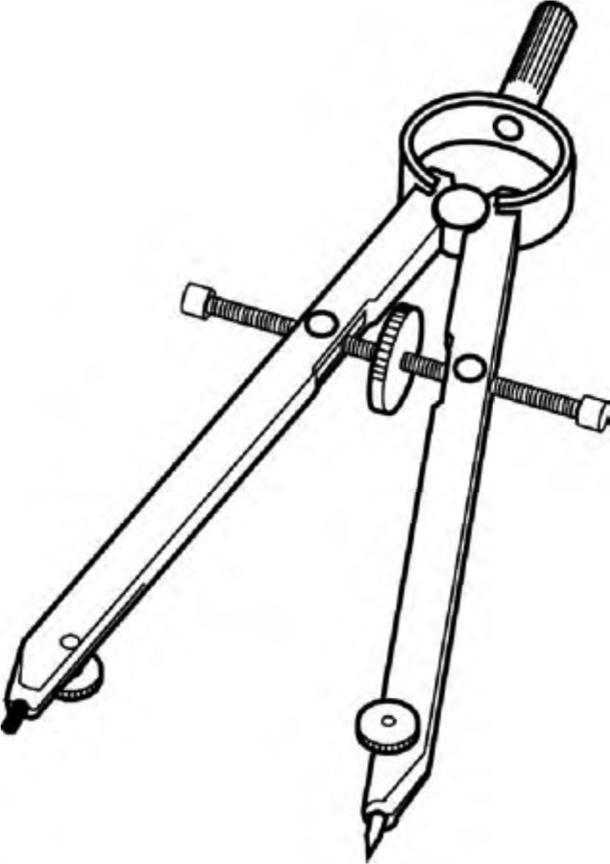
CURVES AND LINES
Comment
Each student should have a ruler, a T-square, two set squares and a compass for this activity.

CHAPTER 12
THE RIGHT STUFF
Comment
• The answer key for the table of results in question 12 lists the samples to provide for students and the numbers to assign those samples. You may write the sample numbers on masking tape, then apply the tape to the corresponding material.
• Wood or modified-wood materials can be purchased at hardware stores.
– Look first for ACQ treated wood because it is easier to distinguish from untreated wood.
– Do not choose treated plywood. It will not have the same greenish colour as treated wood.
– For flake board, choose particleboard.
– For fibreboard, choose medium density fibreboard (MDF).
• For the metals, you may use electrodes sold by most science equipment suppliers.
• Have students work in teams of four or five to cut down on the number of samples you need to supply.
BONDS, WEAK AND STRONG
Comment
If possible, supply the technical objects shown on the next page so students can observe the different types of links. You could also ask them to bring the objects suggested below to class. Have them work in teams to cut down on the number of technical objects you need to supply.
Other technical objects illustrating different types of links
• Fixed link
calculator
• Rotating link
door hinge, cover of portable phone, laptop screen
• Sliding link
combination square
• Sliding rotating link
flask mouth
• Spherical link
joystick, clip-on table lamp
• Helical link
screw and nut, corkscrew
• Objects having more than one link
vise (sliding and helical links)
NOTE
If you cannot supply these suggested technical objects, hand out the following page of illustrations.

