The gas produced
from baker’s yeast
Goal
Verify which of the following gases is released by the activity of baker’s yeast: hydrogen, oxygen
or carbon dioxide.
1. What is the independent variable in this lab?
2. What is the dependent variable in this lab?
Hypothesis
I think that
because
Materials
• gas collection apparatus  • 4 test tubes (15 mm × 125 mm)  • test-tube rack  • 3 stoppers (No. 00)  • 500-mL Erlenmeyer flask or Florence flask and one-hole stopper (No. 7)  • glass elbow tube  • 600-mL beaker  • flexible tubing  • hot plate  • ring stand | • thermometer  • thermometer clamp or universal clamp and perforated cork stopper  • container of dry baker’s yeast  • spatula  • 50-mL graduated cylinder  • container of table sugar (sucrose)  • glass stirring rod  • wood splints  • matches  • dropper bottle of limewater

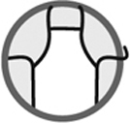
Procedure
Preparing setup for gas collection
1. Fill the gas collection apparatus one-third full with distilled water.
2. Fill one test tube with distilled water.
3. Block the test tube with a finger, then upend it and place it in the apparatus.
Make sure no air enters the test tube.
4. Repeat steps 2 and 3 for the three other test tubes.
5. Place the three stoppers near the apparatus.
6. Place the test-tube rack near the apparatus.
7. Insert the glass elbow tube into the perforated stopper.
8. Connect the other end of the elbow tube to the apparatus with flexible tubing.
Preparing mixture to activate yeast
1. Pour about 250 mL of distilled water into the beaker.
2. Heat the beaker until the water reaches 37ºC.
3. Pour 10 mL of baker’s yeast into the Erlenmeyer flask.
4. Add 45 mL of table sugar to the flask.
5. Pour the heated water into the flask.
6. Mix slowly and carefully.
7. Close the flask with the perforated stopper.
Gas collection apparatus
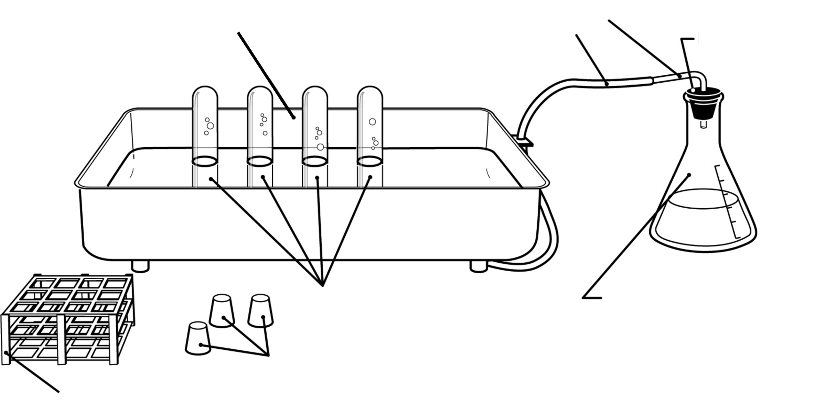
Test-tube rack
Glass elbow tube

Perforated stopper
Erlenmeyer flask
Flexible tubing
Test tubes
Stoppers

Collecting gas
1. Position one upended test tube over the gas-release opening at the bottom of the apparatus.
2. When the test tube fills with gas, remove it from the apparatus and place it on the test-tube rack.
3. Position the second test tube over the opening and fill it with gas.
4. Move the test tube out of the way to another part of the apparatus.
5. Repeat steps 3 and 4 in turn with the other two test tubes.
6. Stopper the three test tubes in the apparatus without removing them from the water.
7. Remove the test tubes and place them on the rack.
Glowing splint test
1. Light a wood splint, then extinguish the flame.
2. Open one test tube and immediately insert the glowing splint.
3. Observe if the splint reignites or not. Record the result.
Burning splint test
1. Light a wood splint.
2. Open the second test tube and immediately insert the flaming splint.
3. Observe if an explosion occurs or not. Record the result.
Limewater test
1. Collect a sample of limewater from the dropper bottle.
2. Open the third test tube and immediately add 20 drops of limewater.
3. Observe if the limewater turns cloudy or not. Record the result.
4. Clean up and put away materials.
Results
Record your results in the table below. Give the table a title.

Title:
Test | Result
Analysis of the results
1. Based on your results for each test, what are your conclusions on the nature of the gas released
during activity of baker’s yeast?
Test | Conclusion
2. Why was the first test tube filled with gas set aside during the experiment?
3. What are the possible sources of error in this lab?
4. How could you improve the protocol for this lab?
Conclusion
1. Complete the following sentence:
The gas released by activity of baker’s yeast is
2. Was your hypothesis confirmed or not? Explain your answer.

