Studying a fresh
calf bone
LAB 68
OBSERVATION
STUDENT BOOK | Chapter 7, page 221

Goal
Locate and observe the structures of bones.
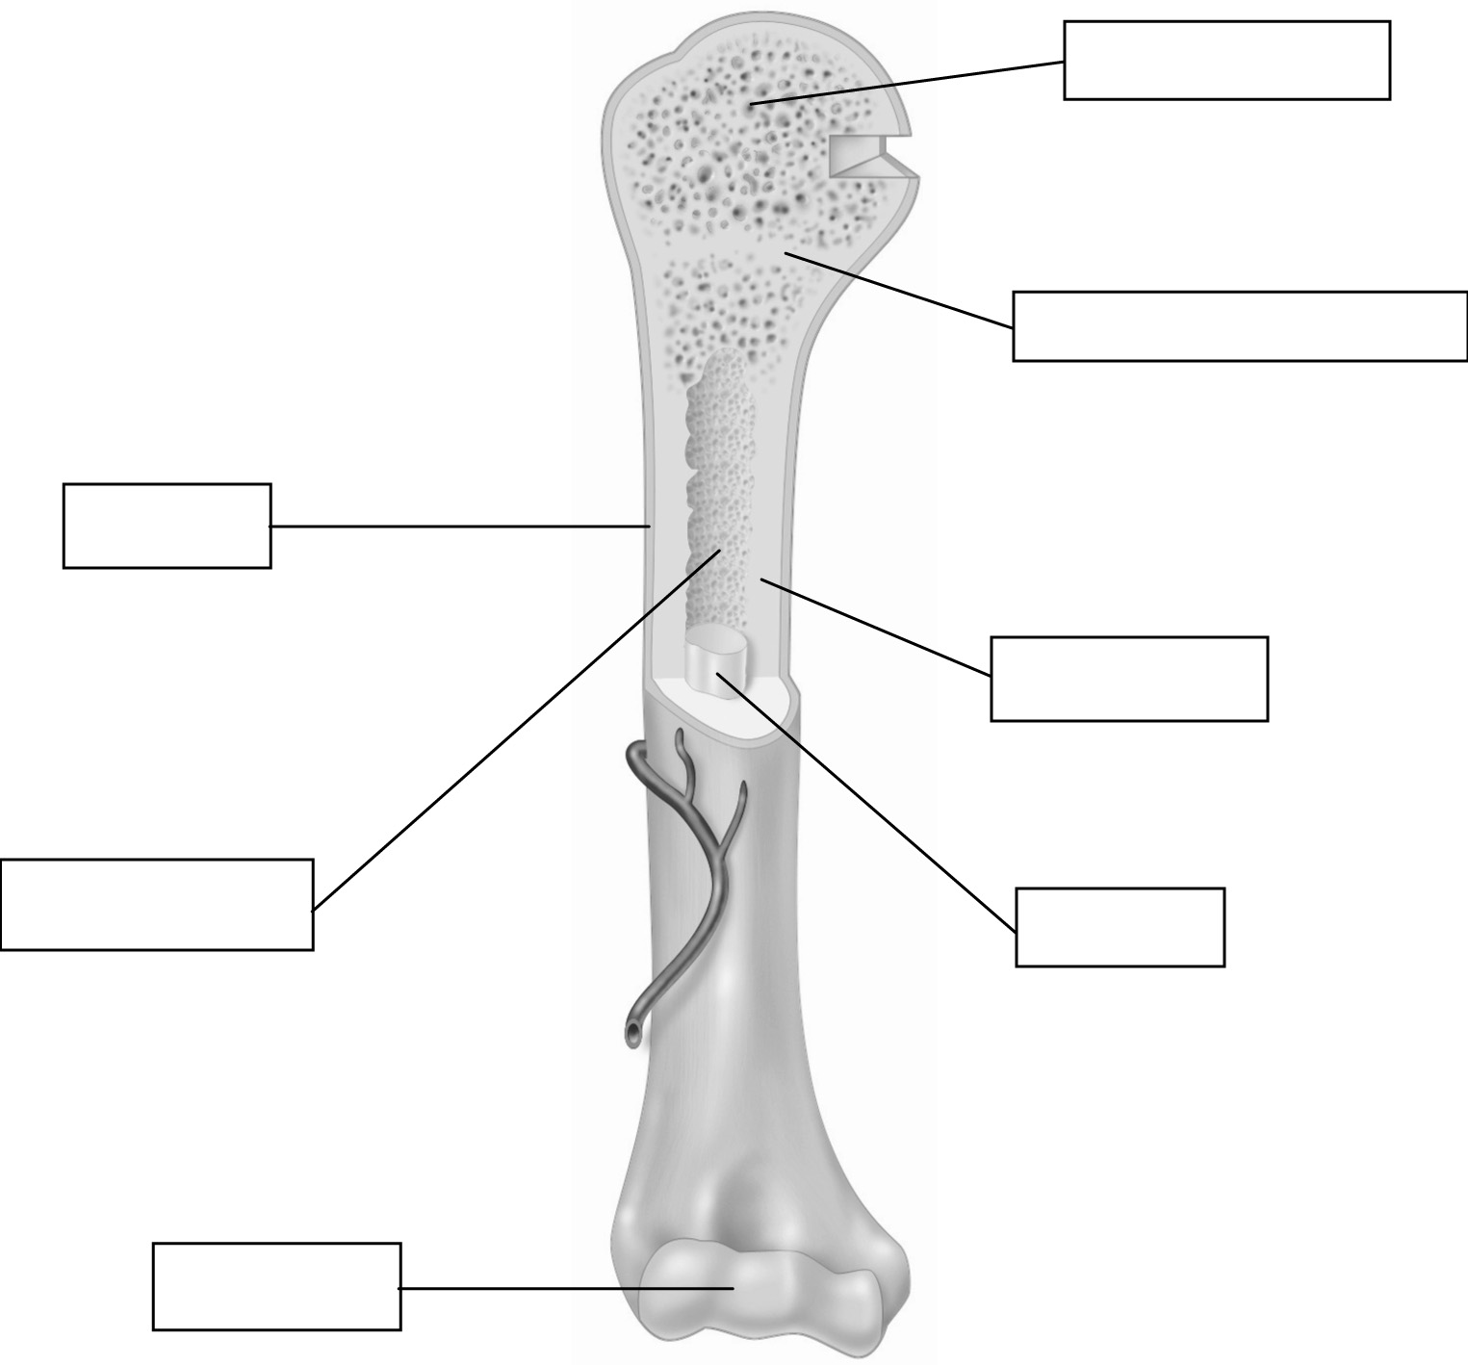
Observation criteria
Periosteum
Medullary cavity
Epiphyseal cartilage
1. Identify the missing structures in the figure above.
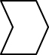
2. Identify the characteristics that will help you to recognize the structures identified in question 1
when observed during this lab. Record your answers in the table below.
Structure | Characteristics
Materials
• gloves  • fresh calf bone sawed lengthwise  • dissecting pan  • scalpel or knife  • dissecting needle |  | • watch glass or Petri dish  • ruler  • paper towel  • toothpicks  • adhesive paper
Procedure
1. Place two layers of paper towel at the bottom of the dissecting pan.
2. Place the calf bone cut-side up in the dissecting pan.
3. Observe the exterior of the bone. Record its overall shape, the shape of the extremities and
the shape of the centre.
4. Pierce the bone in different places with the dissecting needle. Record the name and texture
of the bone tissue found.
5. Detach part of the periostieum with the scalpel. Record its colour and texture.
6. Remove the marrow with the scalpel. Place it on the watch glass. Record its colour and texture.
7. Locate the epiphyseal cartilage—a dark area of the cartilage. Measure its thickness. Record
the result.
8. Measure the thickness of the periosteum. Record the result.
9. Locate each part observed and identify it with a toothpick and adhesive paper.
10. Dispose of the bone as directed by your lab instructor.
11. Clean up and put away materials.
OBSERVATIONS
Record your observations in the table below. Give the table a title.

Title:
Structure | Observations
Entire bone | Overall shape:  Form of extremities:  Form of centre:
Bone tissue | Name of extremities:  Texture of extremities:  Name of centre:  Texture of centre:
Periosteum | Colour:  Texture:  Thickness:
Marrow | Colour:  Texture:
Epiphyseal cartilage | Thickness:
Reflecting on tour observations
1. Do your observations help you to better understand the structures of bone? Explain your answer.
2. The bone you observed belongs to what category?
3. What is the function of cartilage?
4. What is the function of bone marrow?
5. Are all bones similar? Explain your answer.
6. If you had observed a bull bone, would you have found epiphyseal cartilage? Explain your
answer
7. How could you improve the protocol for this lab?

