Dissecting the eye
of a mammal
LAB 64
OBSERVATION
STUDENT BOOK | Chapter 7, page 213

Goal
Locate and observe the structures of the eye.
Observation criteria
1. Identify the main structures of the eye.
2. In the table below, record the characteristics that will help you to identify each of these structures
when observed during this lab.
Structure | Characteristics
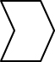
Materials
• gloves
• eye of a mammal
• scalpel or knife
• dissecting forceps
• dissecting scissors
• dissecting pan
• 4 watch glasses or Petri dishes
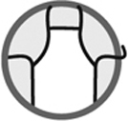
Procedure
1. Observe the exterior of the eye. Note the overall shape.
2. Locate and identify the structures connected around the eye.
3. Locate the optic nerve. Note the colour and texture.
4. Locate the iris. Note the colour and shape.
5. With the scalpel, make an incision around the eyeball as shown in the
illustration at top.
6. Collect the liquid that seeps out of the eye on one watch glass. Note
the name, colour and texture of the liquid.
7. With the dissecting scissors, separate the eye into two pieces by cutting
along the incision made in step 5 as shown in the illustration at bottom.
8. With the dissecting forceps, carefully detach the internal membrane at
the back of the eye. Identify the structure attached to it.
9. Spread out the membrane collected in step 8 on the second watch glass.
Note the name, colour, thickness and texture.
10. With the dissecting forceps, carefully detach the second internal
membrane at the back of the eye.
11. Spread out the membrane collected in step 10 on the third watch glass. Note the name, colour, thickness and texture.
12. Observe the remaining internal membrane at the back of the eye. Note the name, colour, thickness and texture.
13. At the front of the eye, locate the membrane in front of the iris. Note the name, shape
and colour.
14. Collect the liquid in front of the iris on the fourth watch glass. Note the name, colour and
texture of the liquid.
15. Locate the lens and remove it from the eye. It is possible that the lens may have seeped
out with the liquid collected in step 14.
16. Observe and note the colour, shape and texture of the lens.
17. Dispose of the eye as directed by your lab instructor.
18. Clean up and put away materials.
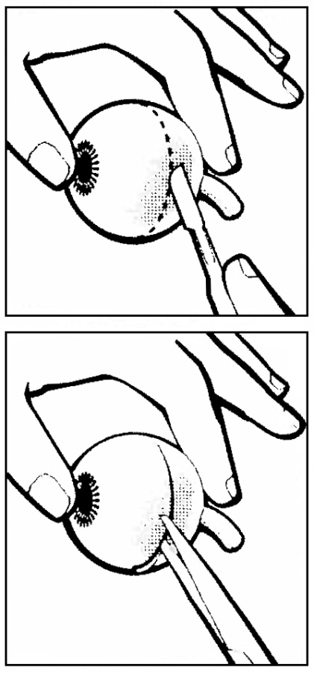
Observations
Record your observations in the table below. Give the table a title.

Title:
Structure | Observations
Overall shape of eye
Structures attached around eye
Optic nerve | Colour:  Texture:
Iris | Colour:  Shape:
Liquid that fills eyeball | Name:  Colour:  Texture:
First membrane at rear of eye | Name:  Colour:  Thickness:  Texture:
Second membrane at rear of eye | Name:  Colour:  Thickness:  Texture:
Third membrane at rear of eye | Name:  Colour:  Thickness:  Texture:
Membrane in front of iris | Name:  Shape:  Colour:
Liquid in front of iris | Name:  Colour:  Texture:
Lens | Colour:  Shape:  Texture:
Reflecting on your observations
1. Why is the pupil black in colour?
2. What is the function of the optic nerve?
3. What is the function of the muscles attached to the eye?
4. Are the two liquids collected from the eye similar? If not, how do they differ?
5. Why is the retina the first membrane at the back of the eye?
6. Did your observations help you to better understand the structures and functioning of the eye?
Explain your answer.
7. How could you improve the protocol for this lab?

