Dissecting
a pig’s heart
LAB 59
OBSERVATION
STUDENT BOOK | Chapter 6, page 185

Goal
Locate and observe structures of a mammal’s heart.
Observation criteria
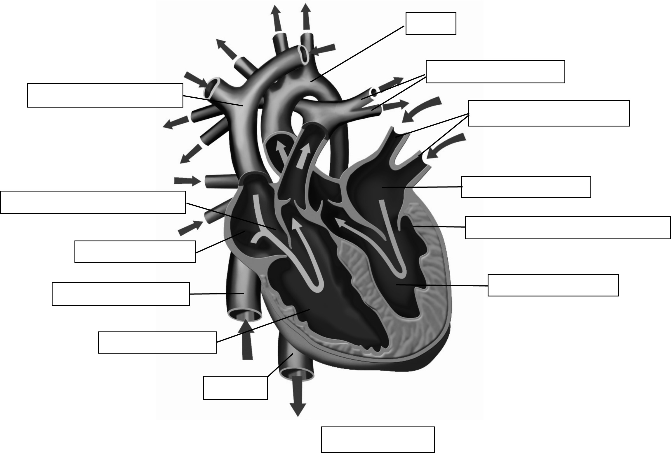
Identify the structures of the heart indicated in Figure 1.
Left atrium
Right atrium
Right ventricle
Front view
Left ventricle

Figure 1 Structures of the heart
Materials
• gloves  • pig heart  • dissecting pan | • glass stirring rod  • dissecting scissors  • dissecting forceps
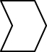

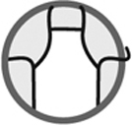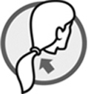
Procedure
Examination of heart exterior and attached blood vessels
1. Observe the exterior of the heart. Note its overall shape, colour and size.
2. Observe the atriums and the ventricles. Compare the size and surface of these two types
of cavities.
3. Locate the pulmonary trunk (bulge at the base of the pulmonary arteries) and the aortas.
Note the cavities in which they are found.
4. Place the heart in the dissection pan so the anterior surface can be observed—the tip of
the heart should be to the right.
5. Insert the glass stirring rod into the opening of the aorta and toward the heart. Press lightly
and gently. Note the cavity in which the tip of the stirring rod is positioned.
6. Insert the stirring rod into the pulmonary trunk and toward the heart. Press lightly and gently. Note the cavity in which the tip of the stirring rod is positioned.
7. Turn over the heart to observe the posterior surface.
8. Locate the inferior vena cava linked to the superior vena cava.
9. Insert the stirring rod into the superior vena cava and toward the heart. Press lightly and
gently. Note the cavity in which the tip of the stirring rod is positioned.
10. Press the stirring rod a little deeper. Note the cavity in which the tip of the stirring rod
is now positioned.
11. Locate the four openings of the four pulmonary veins.
12. Insert the stirring rod into one of the pulmonary veins and toward the heart. Press lightly and gently. Note the cavity in which the tip of the stirring rod is positioned.
13. Press the stirring rod a little deeper. Note the cavity in which the tip of the stirring rod is
now positioned.
14. Compare the thickness of the vein walls to those of the aorta and the pulmonary trunk. Note
the difference.
Dissection of right ventricle
1. Turn over the heart to observe the anterior surface. The tip of the heart should be to the right.
2. Locate the intraventricular sulcus: a pale structure located between the two ventricles.
3. Insert the dissecting scissors into the opening of the pulmonary trunk.
4. Cut along the pulmonary trunk as shown in Figure 2.
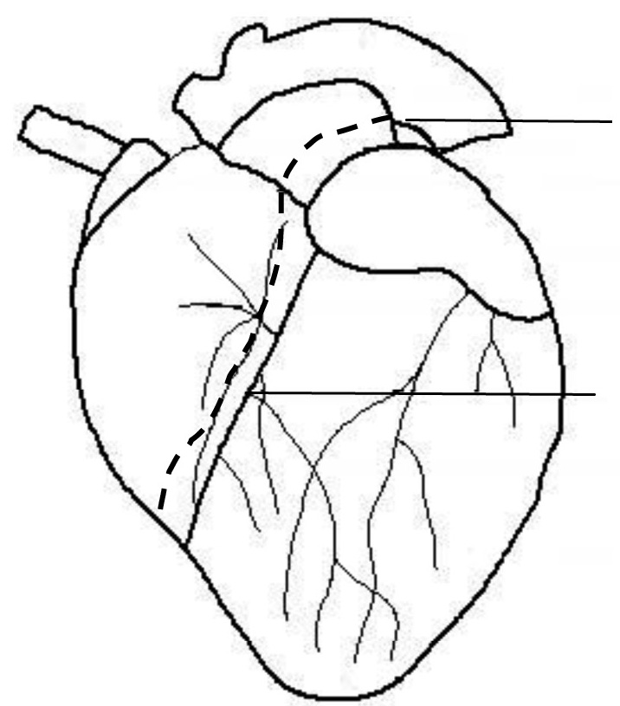
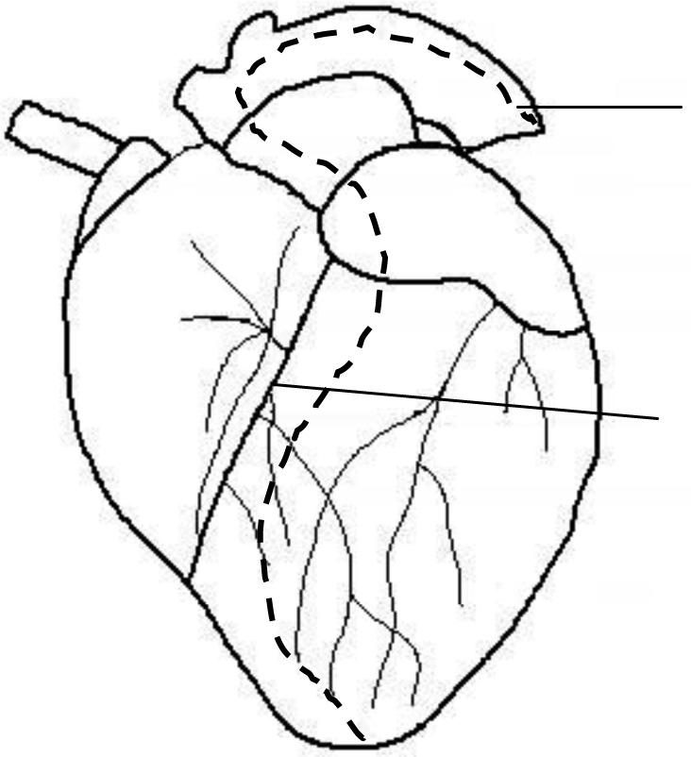
Intraventricular sulcus
Cut line
Cut line
Intraventricular sulcus
Figure 2 Dissection of right ventricle
5. Observe the interior of the right ventricle by spreading the walls with the dissecting forceps. Note the appearance of the inner walls.
6. Observe the whitish strip located at the tip of the orifice toward the atrium. This is the mitral valve. Note its texture.
Dissection of left ventricle
1. Insert the dissecting scissors into the opening of the aorta.
2. Cut along the aorta. Continue cutting into the left ventricle along the intraventricular sulcus
to the tip of the heart as shown in Figure 3.
Figure 3 Dissection of left ventricle
Cut line

3. Observe the interior of the left ventricle by spreading the walls with the dissecting forceps. Compare the appearance of the inner walls of the left ventricle to those of the right ventricle.
4. Observe the whitish strip located at the tip of the orifice toward the atrium. This is part of the tricuspid valve (the other side is usually not visible with this cut). Compare its texture to that
of the mitral valve.
5. Compare the thickness of the left ventricle walls to those of the right ventricle.
Dissection of right atrium
1. Turn over the heart to observe the posterior surface.
2. Insert the glass stirring rod into the opening of the superior vena cava and out through the inferior vena cava.
3. Cut along the stirring rod with the dissecting scissors.
4. Make a second incision perpendicular to the first, then cut the walls of the right atrium.
5. Observe the interior of the right atrium walls. Compare the thickness of the walls to those of the ventricles.
6. The walls of the right atrium include two distinct regions. Note the appearance of the regions.
Dissection of left atrium
1. Cut the walls of the left atrium with the dissecting scissors.
2. Observe the interior of the left atrium walls. Compare the thickness of the walls to those of
the right atrium.
3. Compare the thickness of the left atrium walls to those of the right atrium.
4. Dispose of the heart as directed by your lab instructor.
5. Clean up and put away materials.
Observations
Record your observations in the table below. Give the table a title.

Title:
Step | Observations
Examination of heart exterior and attached blood vessels
Overall shape, colour and size of heart
Comparison of size and surface of atriums
and ventricles

Location of pulmonary trunk and aorta
Cavity that stirring rod enters when inserted
into aorta
Cavity that stirring rod enters when inserted into
pulmonary trunk
First cavity that stirring rod enters when inserted
into superior vena cava
Second cavity that stirring rod enters when
inserted into superior vena cava
First cavity that stirring rod enters when inserted
into pulmonary vein
Second cavity that stirring rod enters when
inserted into pulmonary vein
Thickness of vein walls compared to those of
aorta and pulmonary trunk
Dissection of right ventricle
Appearance of inner walls of right ventricle
Texture of tricuspid valve
Dissection of left ventricle
Appearance of inner walls compared to those
of left and right ventricles
Texture of mitral valve compared to that of
tricuspid valve
Thickness of left ventricle walls compared to
those of right ventricle
Dissection of right atrium
Thickness of right atrium walls compared to
those of ventricle walls
Appearance of regions of right atrium walls
Dissection of left atrium
Appearance of left atrium walls compared to
those of right atrium
Thickness of left atrium walls compared to those
of right atrium
Reflecting on your observations
1. What structure of the heart is the source of blood circulating in the aorta? Explain your answer.
2. What structure of the heart is the source of blood circulating in the pulmonary arteries, which
originate in the pulmonary trunk? Explain your answer.
3. What structure of the heart takes blood circulating in the vena cavas? Explain your answer.
4. What structure of the heart takes blood circulating in the pulmonary veins? Explain your answer.
5. The walls of the heart are mostly made up of muscles. What cavity sends blood with the most
pressure? Explain your answer.
6. Why are walls of the atrium so thin?
7. Did your observations help you to better understand the structure and functioning of a
mammal’s heart?
8. How could you improve the protocol for this lab?

