Blood circulation
in a goldfish’s tail
LAB 58
OBSERVATION
STUDENT BOOK | Chapter 6, page 184
TOOLBOX | Page 23, 25

Goal
Observe how blood circulates in a goldfish’s tail.
Observation criteria
1. What elements of blood have enough colour to be seen circulating in a goldfish’s tail?
2. Where are these elements of blood in a goldfish’s tail being directed:
a) if they circulate in the arteries or arterioles?
b) if they circulate in the veins or venules?
3. In what vessels do these elements of blood circulate single-file? Why do they do so?
Materials
• light microscope
• 50-mL beaker
• aquarium
• 2 pieces of gauze
• Petri dish
• fish net
• goldfish
• dropper

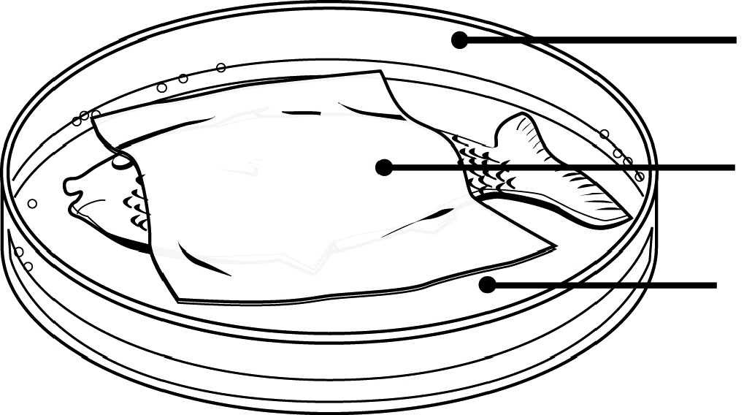
Moistened gauze
Aquarium water
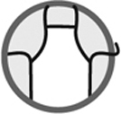
Procedure
1. Set the microscope to a magnification of about 100x.
Open Petri dish
2. Pour 25 mL of water from the aquarium into the beaker.
3. Moisten the pieces of gauze in the beaker.
4. Place one piece of gauze at the bottom of the Petri dish.
5. Cover the bottom of the Petri dish with a small amount of water from the beaker.
6. Catch a goldfish with the fish net.
7. Place the goldfish on the gauze in the Petri dish. Be sure one gill lies on the gauze.
8. Cover the other gill with the second piece of gauze. Be sure the tail extends from the gauze.
9. Place the Petri dish under the microscope.
10. Observe the tail of the goldfish.
11. Draw part of the goldfish’s tail:
a) Choose a location where several blood vessels are visible.
b) Illustrate the red blood cells and the cells of the tail.
c) Indicate the base and the tip of the tail.
d) Identify the blood vessels and indicate the direction in which the red cells circulate.
12. Place the goldfish back into the aquarium.
13. Clean up and put away materials.
Observations
Illustrate your observations in the space below. Indicate the degree of magnification.
Give the illustration a title.

Title:

Magnification:
Reflecting on your observations
1. Why should the gills of the fish be covered with moistened gauze?
2. During your observations, why did you not use:
a) a lower degree of magnification?
b) a higher degree of magnification?
3. How far away from the cells are the capillaries located? Explain your answer.
4. Did your observations help you to better understand blood circulation? Explain your answer.
5. How could you improve the protocol for this lab?

