Determining vital
lung capacity
Goal
Determine vital lung capacity.
Observation criteria
1. What gas is a waste product for the human organism and must be expelled during exhalation?
2. How is this gas formed in the human organism?
3. What system expels this gas?
4. Is this the only gas expelled by the human organism during exhalation?
5. What are the principal muscles responsible for respiration?
6. How do these muscles act during exhalation?
Materials
• wash bottle of water  • 100-mL graduated cylinder  • plastic bottle (5 L or more) and cap  • marker | • basin or sink  • flexible tubing (length of about 50 cm)  • cotton ball  • alcohol

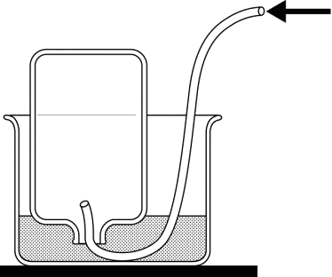
Breath exhaled

Procedure
Calibration of spirometer
1. Measure into the graduated cylinder 100 mL of water.
2. Pour the water into the plastic bottle.
3. Mark the level of the water on the bottle.
4. Repeat steps 1 to 3 until the bottle is full.
5. Empty the bottle.
6. Record next to each marking its corresponding volume.
Measurement of vital lung capacity
1. Assign a task for each team member.
– Test subject: Person whose vital lung capacity is measured
– Experimenter: Person who holds bottle and reads measurement obtained.
2. Fill the calibrated bottle.
3. Cap the bottle.
4. Pour water into the basin or sink to a level of 10 cm.
5. Upend the bottle in the basin so the neck is submerged.
6. Remove the cap.
7. Hold the bottle so it does not touch the bottom of the basin.
8. Insert the end of the flexible tubing into the bottle.
9. Measure the vital lung capacity of the test subject as follows:
a) Have the test subject breathe deeply.
b) Have the test subject place the other end of the tubing in his/her mouth.
c) Have the subject exhale into the tubing for as long as possible.
10. Remove the tubing from the bottle while keeping
the neck submerged.
11. Cap the bottle while keeping the neck submerged.
12. Observe and record the volume of air in the bottle.
13. Repeat steps 2 to 12 to take a second measurement.
14. Clean the end of the tubing that the test subject placed
in his/her mouth with the cotton ball and alcohol.
15. Put away materials.
Observations
Record your observations in the table below. Give the table a title.

Title:
Test | Volume of air measured  (mL)
Reflecting on your observations
1. Calculate the average of the two measurements obtained.
2. Vital lung capacity usually corresponds to 80 percent of the total volume of air contained in the
lungs. Calculate the total volume of air contained in the lungs of the test subject.
3. How could you improve the protocol of this lab?

