Oxygen content
in the air
LAB 53
OBSERVATION
STUDENT BOOK | Chapter 6, page 172

Goal
Determine oxygen content in the air.
Observation criteria
1. What gas is essential to human survival?
2. Where is this gas found?
3. What function helps you to obtain this gas?
4. What gas causes the formation of rust?
Materials
• wash bottle of distilled water
• 600-mL beaker
• 2 test tubes (18 mm × 150 mm)
• steel wool (diameter of about 20 mm)
• Petri dish
• 25 mL of white vinegar
• 50-mL graduated cylinder
• tongs
• 30-cm ruler

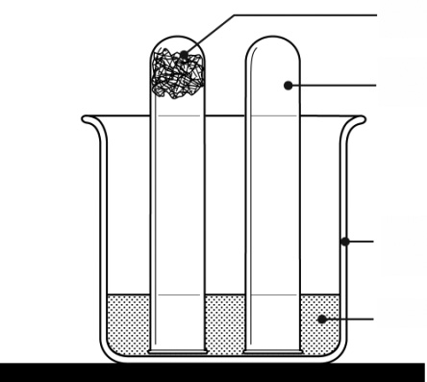
Steel wool
Test tube
Beaker
Water
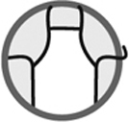
Procedure
Part i
1. Pour 200 mL of distilled water into the beaker.
2. Carefully upend one test tube in the beaker without letting in water.
3. Place the steel wool on the Petri dish.
4. Measure 25 mL of white vinegar in the graduated cylinder.
5. Pour the vinegar onto the steel wool.
6. Remove excess vinegar from the steel wool by shaking it with the tongs.
7. Place the steel wool at the bottom of the second test tube.
8. Upend the test tube and make sure the steel wool stays at the bottom. Break up the steel
wool if necessary.
9. Carefully upend the test tube in the beaker without letting in water.
10. Leave the setup until the next lab class.
Part ii
1. Observe the changes in the steel wool. Record
your observations.
2. Measure the height of the column of water in the
test tube containing the steel wool. Record the result.
3. Measure the height of the column of air in the other
test tube. Record the result.
4. Clean up and put away materials.
Observations
Record your observations in the table below. Give the table a title.

Title:
Observation | Result
Reflecting on your observations
1. What explains the change observed with the steel wool?
2. Why did water rise in the test tube containing the steel wool?
3. Calculate the relationship (in percentage) between the height of the water column and the
height of the air column.
4. What does this percentage relationship indicate?
5. Compare the value obtained to the theoretical value of about 21 percent.
6. What are the possible sources of error in this lab?
7. How could you improve the protocol for this lab?

