Nutrient absorption
Goal
Observe the capacity of starch and glucose to pass through a membrane similar to the wall of the
digestive tract.
Observation criteria
1. What is absorption?
2. What is a nutrient?
3. What is the category of nutrients to which glucose and starch belong?
4. Between starch and glucose:
a) which is a simple carbohydrate?
b) which is a complex carbohydrate?
c) which is considered a nutrient?
d) which is absorbed without undergoing a chemical transformation during digestion?

5. In the table below, identify the indicators that help in the detecting of glucose and starch.
Substance | Indicator | Reaction of indicator  if substance present | Reaction of indicator  if substance not present
Materials
• marker  • 2 400-mL beakers  • 250-mL graduated cylinder  • 200 mL of starch solution  • 2 dialysis bags  • 200 mL of glucose solution  • stopwatch or watch  • 600-mL beaker  • hot plate |  | • 2 test tubes (18 mm × 150 mm)  • test-tube rack  • dropper bottle of distilled water  • 2 droppers  • dropper bottle of Fehling’s reagent solution A  • dropper bottle of Fehling’s reagent solution B  • spot plate  • dropper bottle of Lugol’s solution  • test-tube clamp
 | 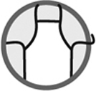
Procedure
1. Label the 400-mL beakers S (starch) and G (glucose) with the marker.
2. Fill each beaker three-quarters full with water.
3. Pour 200 mL of starch solution into one dialysis bag.
4. Place the dialysis bag into beaker S (Figure A).
5. Pour 200 mL of glucose solution into the second dialysis bag.
6. Place the dialysis bag into beaker G (Figure B).
Starch
7. Set aside for 15 minutes.
Fehling’s test
1. Boil 200 mL of water in the 600-mL beaker.
2. Label the test tubes 1 and 2.
3. Add 20 drops of distilled water to test tube 1.
4. Collect a sample from beaker G with a dropper.
5. Add 20 drops of the sample collected from beaker G to test tube 2.
6. Add 10 drops of Fehling’s reagent solution A to each test tube.
7. Add 10 drops of Fehling’s reagent solution B to each test tube.
8. Place the test tubes into boiling water for 5 minutes.
9. Observe the contents of the test tubes. Record your observations.

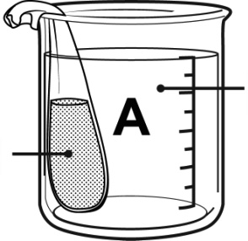
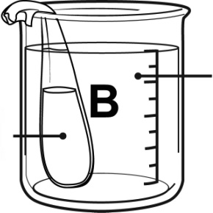
Water
Glucose
Water

Lugol’s test
1. Add 20 drops of distilled water to one well in the spot plate.
2. Collect a sample from beaker S with a dropper.
3. Add 20 drops of the sample collected from beaker S to a well in the spot plate.
4. Add 6 drops of Lugol’s solution to each well.
5. Observe the contents of the wells. Record your observations.
6. Clean up and put away materials.
Observations
Record your observations in the table below. Give the table a title.

Title:
Indicator | Test substance | Indicator reaction
Reflecting on your observations
1. During the procedure, what represented:
a) the wall of the digestive tract?
b) blood or lymph nodes?
c) substances contained in the digestive tract?
2. How did your observations show that starch cannot be absorbed by an organism?
3. Why can’t starch be absorbed?
4. How do your observations show that glucose can be absorbed by an organism?
5. Do your observations help you to better understand how an organism absorbs nutrients
during digestion?
6. How could you improve the protocol for this lab?

