Locating the focal
point of a lens
Goal
Apply a technique to locate the focal point of a converging lens.
Materials
• converging lens(es)
• optical bench
• ray box
• screen (white cardboard)
• 1-m ruler
Procedure
1. Secure the lens near one end
of the optical bench.
2. Place the ray box 1 m away from
the lens.
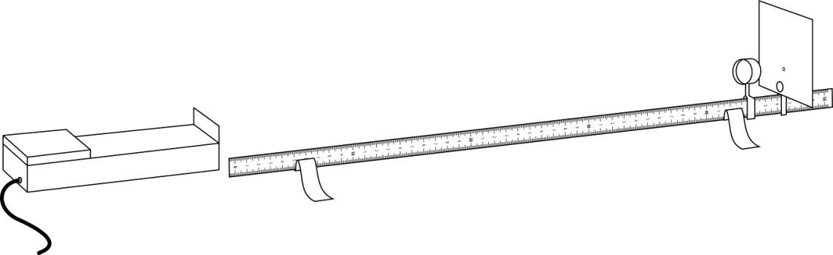
3. Place the screen behind the lens at
a distance where a point of light
is obtained.
4. Measure and record the distance between the centre of the lens and the screen.
5. Repeat steps 1 to 4 with other lenses, if applicable.
6. Put away materials.
Results
Record your results in the table below. Give the table a title.

Title:
Lens | Location of focal point

Reflecting on the lab technique
1. Are focal points of lenses the same distance?
2. What corresponds to the focal point of a converging lens?
3. What are the possible sources of error in this lab?

