liquid Pressure
LAB 26
EXPERIMENT
STUDENT BOOK | Chapter 3, page 73
toolbox | Page 22

Part I
Goal
Verify the relationship between pressure and volume mass of a liquid using a U-tube manometer.
1. What is the independent variable in this lab?
2. What is the dependent variable in this lab?
Hypothesis
I think that
because
Part II
Goal
Verify the relationship between pressure and volume depth of a liquid using a U-tube manometer.
1. What is the independent variable in this lab?
2. What is the dependent variable in this lab?
Hypothesis
I think that
because
Materials
• balance (accurate to 0.01 g)
• 50-mL graduated cylinder
• 3 containers each with more than 1 L of a different liquid: distilled water, methanol, glycol,
saline solution, etc.
• 2 30-cm rulers
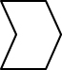
• 1000-mL graduated cylinder or container more than 40 cm in height
• U-tube manometer
• 30-cm glass stirring rod

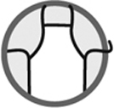
Procedure
1. Measure the volume mass of each liquid.
a) Weigh and record the mass of the empty 50-mL graduated cylinder.
b) Pour into the graduated cylinder 50 mL of one liquid.
c) Weigh and record the mass of the graduated cylinder and contents.
d) Calculate the volume mass of the liquid (g/mL).
e) Repeat steps a) to d) with each of the other two liquids.
2. Secure two rulers to the 1000-mL graduated cylinder to make
a measuring scale of 40 cm—0 mark at the top and 40 mark
at the bottom.
3. Pour into the 1000-mL graduated cylinder one liquid to
the 0 mark.
4. Measure the pressure outside the liquid using the U-tube
manometer—this reading corresponds to the 0 mark.
5. Place the funnel-shaped end of the manometer on the
surface of the liquid and submerge it with the glass
stirring rod.
6. Measure and record the pressure at every 10 cm of
depth—this reading corresponds to the difference
in height between the columns of liquid.
7. Empty, rinse and dry the graduated cylinder.
8. Repeat steps 3 to 7 for each other liquid.
9. Clean up and put away materials.
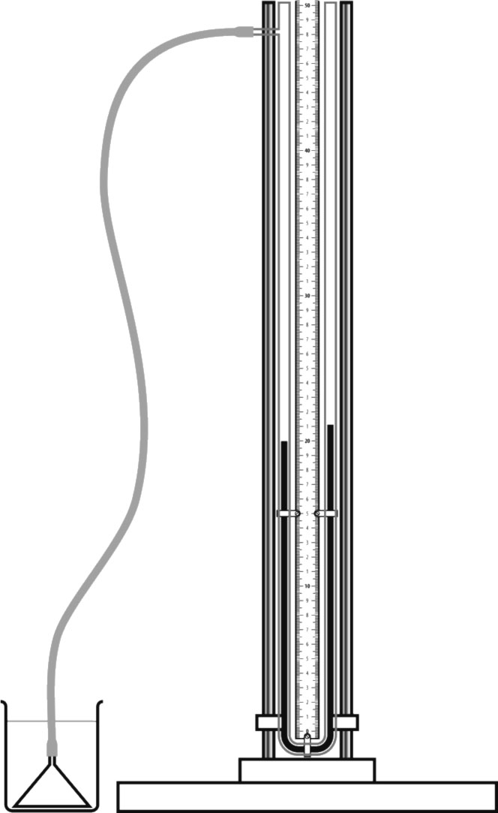
Results
Record your results in the tables below. Give each table a title.

Title:
Name of liquid | Mass  (g) | Volume  (mL) | Volume mass  (g/mL)
Title:
Depth of manometer  (cm) | Pressure of  liquid 1 (cm) | Pressure of  liquid 2 (cm) | Pressure of  liquid 3 (cm)
Graphs
Plot the pressure of each liquid according to  depth. (Plot one curve per liquid.) Give the  graph a title.  Title: |  | Plot the pressure of the liquids according to  volume mass. (Use the pressure reading at  the greatest depth.) Give the graph a title.  Title:
 |  | 
Analysis of the results
1. Describe the shape of the curve of the graph illustrating pressure according to volume mass.
2. How does pressure of a liquid vary according to volume mass?
3. Describe the shapes of the curves of the graphs illustrating pressure according to depth.

4. How does pressure of a liquid vary according to depth?
5. Does pressure according to depth vary in the same way for all three liquids?
6. How is pressure measured with a U-tube manometer?
7. What are the possible sources of error in this lab?
8. How could you improve the protocol for this lab?
Conclusion
1. Complete the following sentences:
a) | As volume mass increases, pressure of a liquid

b) | As depth increases, pressure of a liquid
2. Were your hypotheses confirmed or not? Explain your answer.
Application
Why do your ears feel blocked as you swim to the bottom of a pool?

