the Electrolysis of water
LAB 21
EXPERIMENT
STUDENT BOOK | Chapter 2, page 55
toolbox | Page 41

Goal
Determine the relationship between volumes of gases obtained during the electrolysis of water.
1. What is the independent variable in this lab?
2. What is the dependent variable in this lab?
Hypothesis
I think
because |  |  | .
Materials
• wash bottle of distilled water  • 600-mL beaker  • balance (accurate to 0.01 g)  • weighing pan  • spatula  • container of sodium carbonate (Na₂CO₃)  • glass stirring rod  • marker  • test-tube rack |  | • 2 test tubes (16 mm × 150 mm) and stoppers (No. 1)  • 2 electrolysis electrodes (platinum or stainless steel)  and stand  • 2 conductor wires and clamps  • source of electric current (battery or other)  • 30-cm ruler  • wood splints  • matches or lighter
 | 
Procedure
1. Measure into the beaker about 450 mL
of distilled water.
2. Add about 5 g of sodium carbonate to the beaker.
3. Mix with the glass stirring rod until dissolution
is complete.
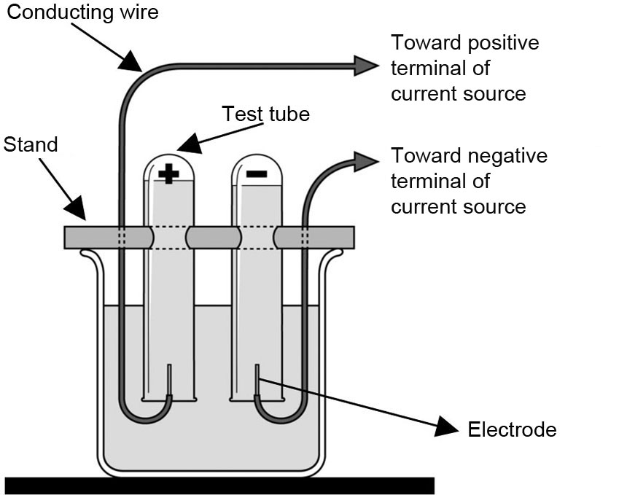
4. Write “+” on one test tube and “–” on the second
test tube with the marker.
5. Fill both test tubes with distilled water.
6. Upend both test tubes into the beaker without
letting in air bubbles.


7. Secure the test tubes to the electrolysis stand.
8. Connect the electrodes to the source of electric current.
9. Turn on the power and wait for a few minutes.
10. Record your observations.
11. Turn off the power when one test tube fills halfway with gas.
12. Measure the height of the gas column in each test tube. Record your results.
13. Turn on the power and continue until both test tubes fill with gas.
14. Quickly remove each test tube from the beaker and close it with the stopper.
15. Disconnect the source of electric current.
16. Conduct tests to identify the gas collected in each test tube.
17. Clean up and put away materials.
Results
Record your results in the table below. Give the table a title.

Title:
Characteristic tested | Test tube + | Test tube –
Analysis of the results
1. What gas is collected in test tube +? Explain your answer.
2. What gas is collected in test tube –? Explain your answer.
3. Is this a physical change or a chemical change? Explain your answer.
4. What is the relationship between the volumes of gases obtained?
5. What is the type of reaction observed?
6. What form of energy is involved in this change?
7. Is energy absorbed or released? Explain your answer.
8. Write the chemical equation for the change observed. Include the place of energy.
9. What are the possible sources of error in this lab?
10. How could you improve the protocol for this lab?
Conclusion
1. Complete the following sentences:
a) | In this experiment, |  | of water produces |  | and

b) | This change is called a

c) | This change involves |  | energy that is
2. Was your hypothesis confirmed or not? Explain your answer.
Application
What is the purpose of adding sodium carbonate to distilled water in this lab? Suggest a way to verify
your hypothesis.

