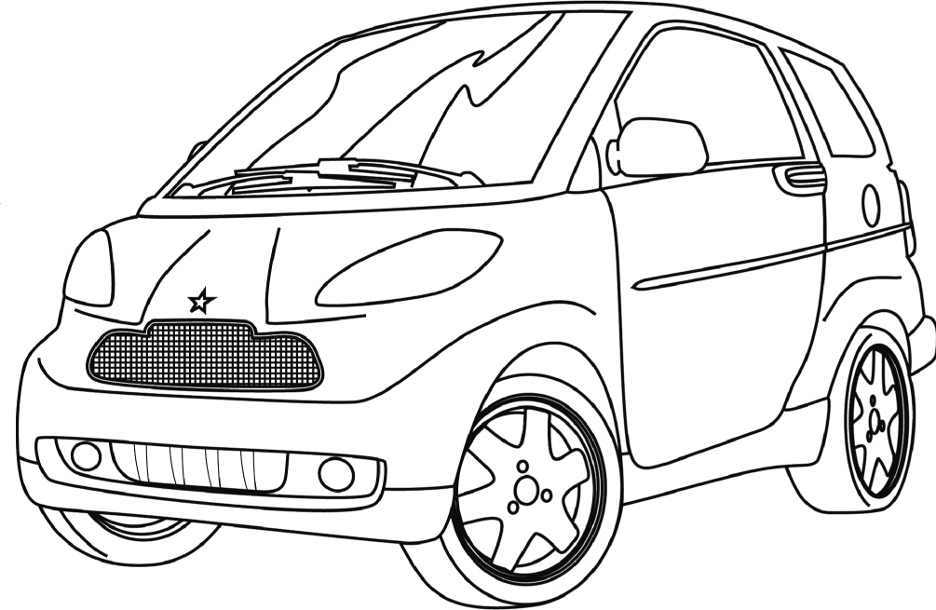


THE PROBLEM
Built
respectfully
for life
on the go
- Eco-friendly
- Safe
- Equipped
- Affordable
A safe eco-friendly car
Finally, a small eco-friendly car that’s safe and affordable.
Prorala introduces the new
Excellent safety ratings during front-end collision tests.
MEMORANDUM
TO: Research team
FROM: Louis Lesage, Director of Human Resources, Techno Logique
Maryse Lemieux, Vice-President, Government Affairs, Techno Logique
DATE: June 18, 2007
RE: Research project mandated by the Department of Transportation
The purpose of this memo is to remind you of the constraints to observe in completing the mandate issued by the Department of Transportation.
MANDATE OBJECTIVE
The Department has requested us to build a miniature prototype of an eco-friendly vehicle and to analyze the vehicle’s material constraints during front-end collision tests. This prototype must undergo three front-end collision tests. The resulting observations for improving the vehicle and the validity of the tests will help the Department to review safety evaluations of new small car models on the market.
GUIDELINES
When building the prototype of the eco-friendly car, you must respect the attached specifications. Use a polystyrene foam cup in lieu of a passenger to evaluate the prototype’s safety.
In this situation, you are a member of the research team.
the problem (continued)
SPECIFICATIONS OF THE ECO-FRIENDLY CAR
Overall function
- The vehicle to be built must be eco-friendly, light, resistant and safe enough to shield a polystyrene foam cup, which is standing in for a passenger. The cup must be intact following the collision tests.
Material constraints
- Maximum length of the vehicle, including trim, must be 25 cm.
- Maximum width of the vehicle, including trim, must be 20 cm.
- Vehicle must be as light as possible and must not exceed a weight of 750 g.
- Vehicle must be able to support a 2-kg load.
- Vehicle must have a polystyrene foam cup on board.
- Vehicle must have a restraint system for holding the cup in place.
- Vehicle must have a system for absorbing impacts during a collision.
- Vehicle must be built with at least three different materials, including wood and metal.
Human constraints
- Vehicle must roll as straight as possible so that it doesn’t fall off the test ramp.
- Vehicle must be as fast as possible.
- Vehicle must be able to withstand collisions.
- Polystyrene foam cup must remain intact after the collision tests.
- Vehicle must be easy to repair.
Aesthetic constraint
- Vehicle must have a polished appearance.
Safety constraint
- Vehicle’s edges must not be sharp or splintered.
Financial constraint
- Use of affordable materials should be prioritized.
Environmental constraint
- Use of recycled materials should be prioritized.
CREATING THE CONTEXT
I ask myself questions
1. What is a mechanical constraint?
2. Define the different types of constraints materials can be subjected to in the table below.
Constraint |  | Definition
3. What are the consequences of exposing materials to constraints of increasing intensity?
4. What is a mechanical property?

CREATING THE CONTEXT (continued)
5. Define the mechanical properties of materials in the table below.
Mechanical property |  | Definition

CREATING THE CONTEXT (continued)
6. Name the two principal types of wood used in most industries and specify whether they come from deciduous or coniferous trees. List three species of trees for each type of wood and give examples of how each species is used.
Type of wood |  | Variety |  | Species |  | Uses

CREATING THE CONTEXT (continued)
7. Name five types of modified wood available on the market. Describe their manufacturing process and give examples of their applications.
Type of modified wood |  | Manufacturing process |  | Applications
8. What is a metal? Give a few examples of metals.

CREATING THE CONTEXT (continued)
9. Name the two types of metal alloys sold on the market, and their principal constituent, in
the table below. Then give two examples of alloys for each type, and list their properties
and applications.
Type of alloy  and description |  | Example  of alloy |  | Properties |  | Applications

creating the context (continued)
I must
10. In your opinion, what is the goal of the problem to solve?
I think
11. In your opinion, which constraints will the following car parts be subjected to during a front-end collision? Check the most appropriate constraints for each part.

Car part | Constraints
Car part | Tension | Compression | Torsion | Bending | Shearing
Base
Passenger area
Bumpers
Axle
Wheels

CREATING THE CONTEXT (continued)
12. In your opinion, what is the most appropriate design solution for the car? Draw its design plan. Use symbols to show the constraints that its various parts will be subjected to during a front-end collision. Specify the movement of these parts.
Reflection Yes No
Do I understand the following concepts:
- constraints (tension, compression, torsion)?  
- mechanical properties?  
- types and properties of materials (ferrous alloys, nonferrous metals
and alloys, wood and modified wood)?  

PLANNING THE PROBLEM SOLVING
I plan
Draw the technical diagrams of the prototype of an eco-friendly vehicle. Remember to identify the following information on the diagrams:
- the names of the parts
- the materials to be used
- the linking components to be used

- the types of guides
- any other useful information for building the vehicle

- Draw the side view of the technical diagram.

PLANNING THE PROBLEM SOLVING (continued)
2. Draw the front view of your technical diagram.

PLANNING THE PROBLEM SOLVING (continued)
3. Use the table below to list the materials you need to make the various parts of your car. Justify your choices by specifying their desired properties for guaranteeing the safety of passengers.
Car part |  | Material |  | Justification

PLANNING THE PROBLEM SOLVING (continued)
4. List the linking components needed to make the vehicle. Specify the number of each component you intend to use.
Component |  | Quantity
5. List the equipment needed to build your car.
6. What safety rules should you follow when building your car prototype?
Reflection Yes No
Have I envisaged other possibilities for building my eco-friendly car?  

Teacher’s approval

INITIATING THE PROBLEM SOLVING
I design
1. Create a table for writing down the results from the front-end collision tests.

2. Build your car prototype according to your technical diagrams. If you modify your plan of action, indicate these changes on the technical diagrams as well as on the lists of materials and equipment. Be sure to record all modifications.
3. What safety rules did you follow when making your car prototype?
Reflection Yes No
Did I record and justify all the modifications I made to my plan of action?  

THE FINAL TEST
I verify
After writing down the results obtained by your car prototype during the front-end collision tests, answer the following questions:
1. Did the prototype meet the overall function of an eco-friendly vehicle? Explain your answer.
2. Did the prototype respect all the constraints in the specifications? If not, explain your answer.
3. Did you make any modifications to your plan of action? Explain your answer.
4. Did you encounter any difficulties when building your prototype? If yes, what were they?
5. What are your prototype’s strengths?
6. What are your prototype’s weaknesses?

The final test (continued)
7. Were the materials subjected to any constraints? Which ones?
8. What improvements would you make to the construction of your prototype?
9. What improvements would you make to the collision tests?

MY EVALUATION
Use the evaluation grid on the next page to do a self-evaluation. Write A, B, C, D or E
in the appropriate space.
SSC1 Seeks answers or solutions to scientific or
technological problems
Criteria* | Observable indicators | Me | Teacher | Comments
1 | Creating the context |  |   With help
 | Definition of the goal and production of a design plan |  |   With help
2 | Planning the problem solving |  |   With help
 | Suitability of elements in the plan  of action: materials, equipment and technical diagrams |  |   With help
3 | Initiating the problem solving |  |   With help
 | Respect for the technical diagrams and safety rules during vehicle construction |  |   With help
4 | The final test |  |   With help
 | Verification of vehicle operation and conducting of collision tests |  |   With help
* Evaluation criteria
1 Appropriate representation of the situation
2 Development of a suitable plan of action for the situation
3 Appropriate implementation of the plan of action
4 Development of relevant conclusions, explanations or solutions

evaluation grid
Seeks answers or solutions to scientific or technological problems | E | The work needs to be redone. |  | The work needs to be redone. |  | The work needs to be redone. |  | The work needs to be redone.
 | D | The goal is more or less clearly defined or  is not linked to the problem to solve  AND  the design plan contains major errors. |  | Most of the chosen materials and equipment are more  or less suitable  AND  the technical diagrams contain several errors. |  | The vehicle does  not comply with the technical diagrams  OR  the work is not done in a safe manner. |  | The vehicle does  not respect most of  the constraints in  its specifications.
 | C | The goal is more or less clearly defined or  is not linked to the problem to solve  OR  the design plan contains several errors. |  | The chosen materials and equipment are more or less suitable  OR  the technical diagrams contain several errors. |  | Several elements of the vehicle do not comply with the technical diagrams  AND  the work is done  in a safe manner. |  | The vehicle respects most of the constraints in its specifications, but the proposed improvements  are not very  appropriate.
 | B | The goal is clearly defined and linked  to the problem to solve. The design plan contains a  few minor errors. |  | The chosen materials and equipment are suitable. The technical diagrams contain a few  minor errors. |  | A few elements of the vehicle do not comply with the technical diagrams. The work is done in a safe manner. |  | The vehicle respects most of the constraints in its specifications. Most of the proposed improvements  are appropriate.
 | A | The goal is very clearly defined and linked to the problem to solve. The design plan is complete. |  | The chosen materials and equipment are suitable. The technical diagrams are complete. |  | The vehicle complies with the technical diagrams. The  work is done in a  safe manner. |  | The vehicle is operational and respects all the constraints in its specifications.  The proposed improvements  are appropriate.
 | Observable indicators | CREATING THE CONTEXT | Definition of the goal and  production of a design plan | PLANNING THE  PROBLEM SOLVING | Suitability of elements in the plan of action: materials, equipment, and technical diagrams | INITIATING THE  PROBLEM SOLVING | Respect for the technical diagrams and safety rules during vehicule construction |  | THE FINAL TEST | Verification of vehicle operation and conducting of collision tests
 |  | 1 |  | 2 |  | 3 |  |  | 4
* Evaluation criteria
1 Appropriate representation of the situation
2 Development of a suitable plan of action for the situation
3 Appropriate implementation of the plan of action
4 Development of relevant conclusions, explanations or solutions
INFORMATION DOCUMENT
Protocol for conducting the collision tests
1. Place the cup in the vehicle.
2. Secure the cup with the chosen restraint system.
3. Place the vehicle at the top of the test ramp.
4. Start the stopwatch as you let go of the vehicle.
5. Stop the stopwatch when the vehicle reaches the bottom of the ramp.
6. Observe the cup and the vehicle.
7. Repeat steps 1–6 with a 1-kg load in the space created for this purpose.
8. Repeat steps 1–6 with a 2-kg load.

