THE PROBLEM
Montreal, May 7, 2009

Mrs. Denise Lemieux
Vice-President, Human Resources
PLG Construction
140 Beaumont
Montréal (Québec) H2X 2W3
Dear Mrs. Lemieux,
Please be advised that we will be administering a new pre-employment test starting in June.
This highly original test will provide a better evaluation of a candidate's skills and team spirit.
Candidates will work in teams of eight to manufacture a coin sorting machine from thermoplastic in accordance with the specifications and drawings we supply. They will receive exploded view and detail drawings.
Each candidate tested will draw a design plan for the coin sorting machine. He or she will draw up a list of equipment and materials, as well as a manufacturing procedure for making the component parts according to the dimensions and tolerances on the drawings.
Candidates will work in teams to assemble the parts of the coin sorting machine, but will individually verify that the machine functions properly.
We will inform you of the test results for the 32 candidates in July.
Yours truly,
Louis Laberge
Account Manager,
Lebel Employment Agency

In this situation, you are to play the role of a candidate taking part in a pre-employment testing.
THE PROBLEM (continued)
Specifications for the coin sorting machine
Overall function
- The object must sort coins.
Material constraints
- The object must be made from the materials provided.
- Every part of the object must meet the dimensions and tolerances specified on the detail drawings.
- The object must be made of the exact number of parts shown on the exploded view drawing.
- The assembled object must function properly.
Human constraint
- The object must be made as quickly as possible.
Esthetic constraint
- The object must look good.
Safety constraint
- No parts may have any sharp edges.
Financial constraint
- The materials must be used as efficiently as possible so as to prevent waste.
Environmental constraint
- The materials must be recyclable after the test.
THE PROBLEM (continued)
Exploded view drawing of the coin sorting machine
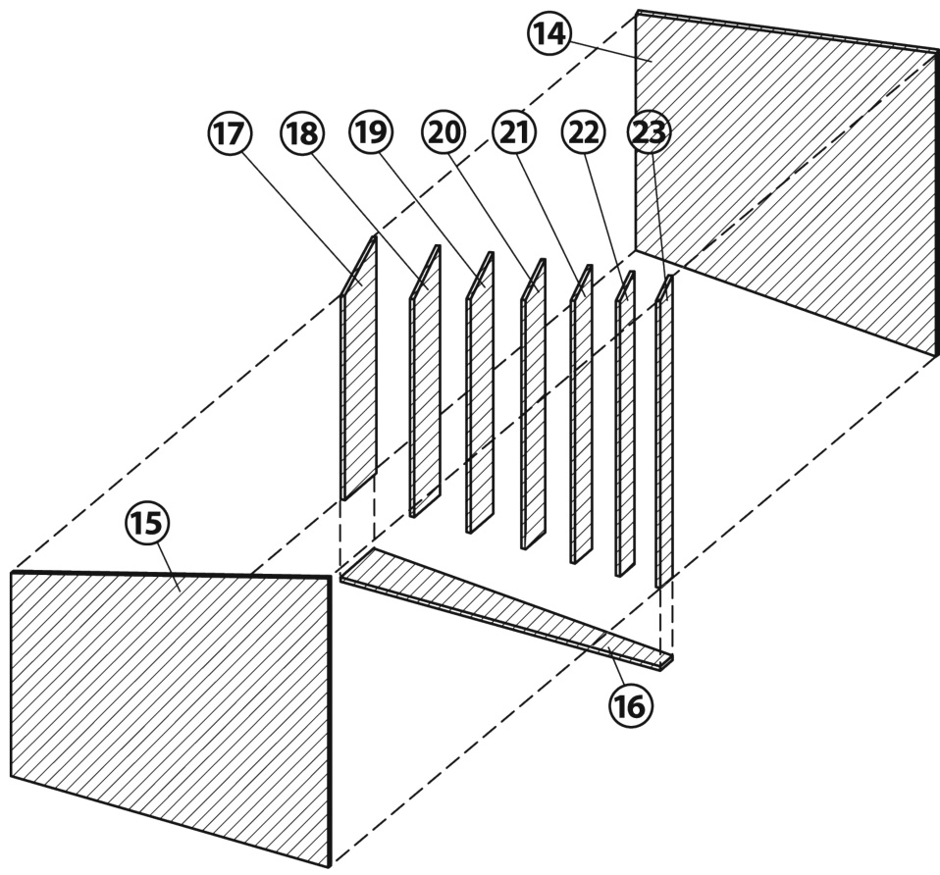
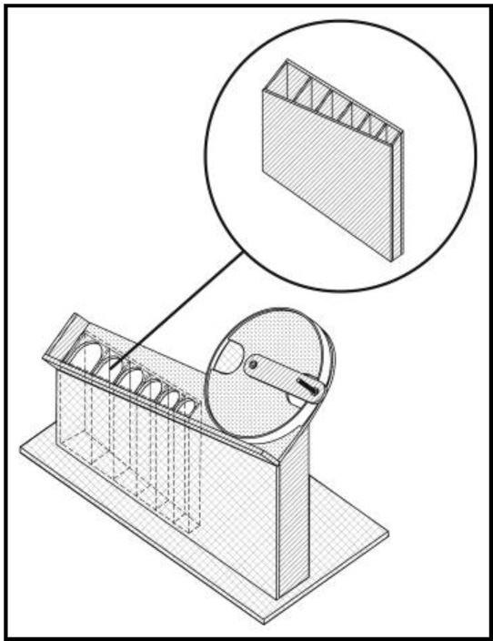
Parts nomenclature
1: Crank
2: Rotating disk
3: Fixed disk
4: Guard plate
5: Spacer
6: End plate
7: Sorter
8: End stop
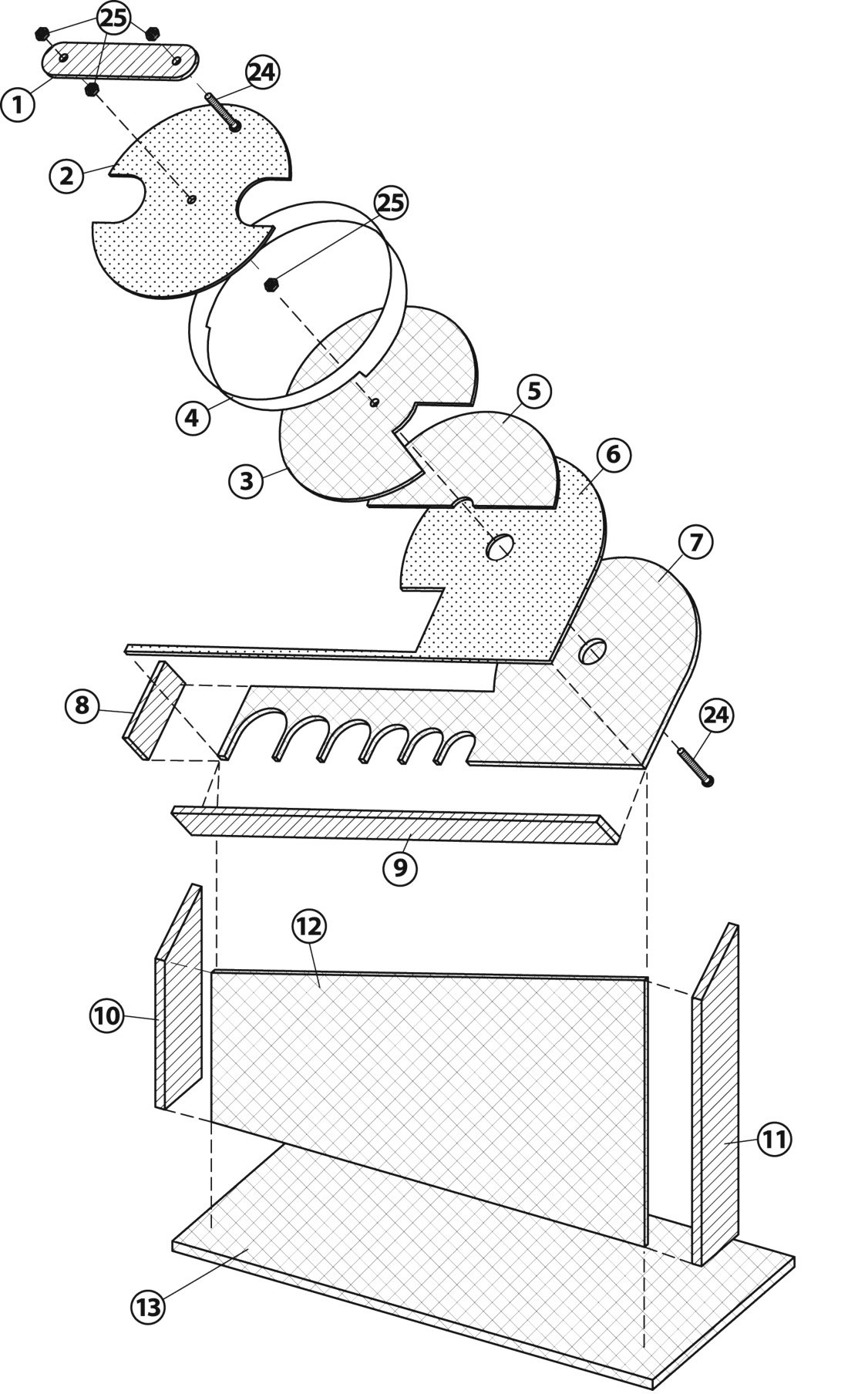
9: Rail
10: Left-side panel
11: Right-side panel
12: Sorter front panel
13: Sorter base
14: Collector back panel
15: Collector front panel
16: Collector base
17–23: 7 separators
24: 2 30-mm screws
25: 4 nuts

TITLE: Exploded view drawing  Coin sorting machine  5 | SCALE: 1:10

3 mm acrylic
Parts 1, 8, 9, 10, 11, 14, 15, 16, 17, 18, 19, 20, 21, 22, 23
1.5 mm acrylic
Parts 2 and 6
5 mm acrylic
Parts 3, 5, 7, 12, 13
Cardboard
Part 4
THE PROBLEM (continued)
Detail drawings for team member #1
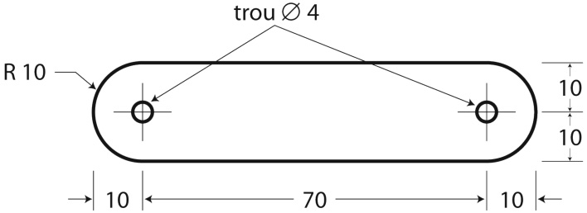
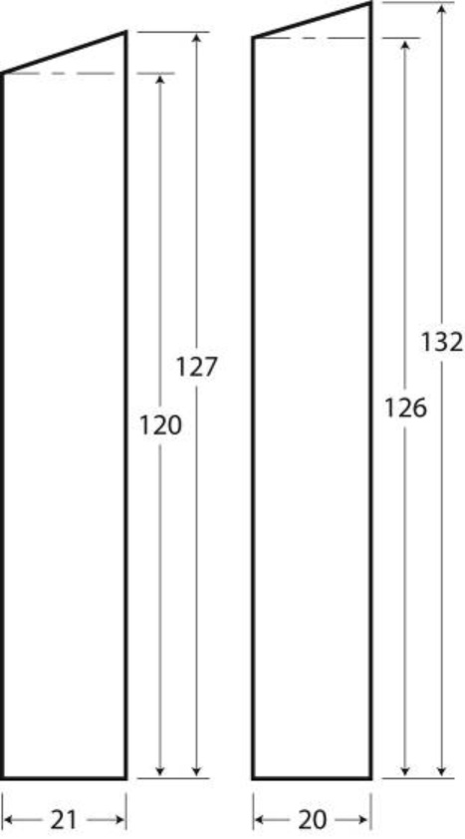
TITLE: Detail drawing, Parts 1, 22 and 23
Coin sorting machine
SCALE: 1:2 ± 2 mm
Pièce 1
Pièce 22
Pièce 23
hole
Part
Part
Part
THE PROBLEM (continued)
Detail drawings for team member #2
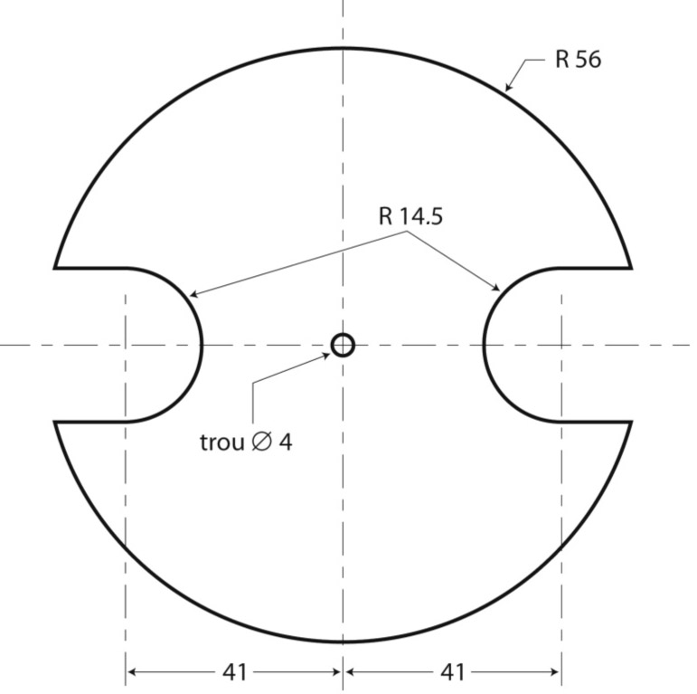
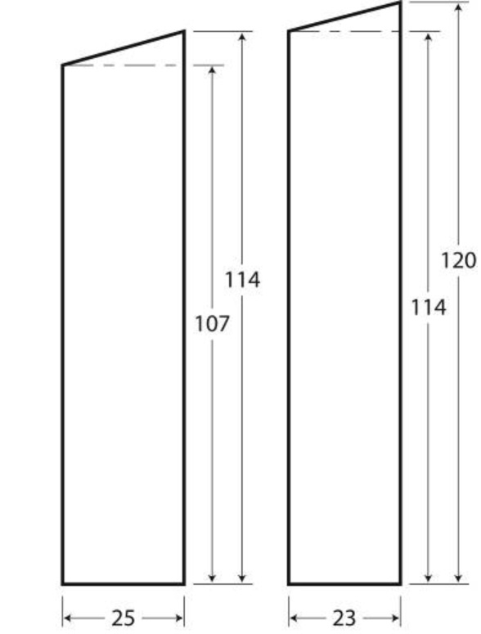
TITLE:Detail drawing, Parts 2, 20 and 21
Coin sorting machine
SCALE: 1:2 ± 2 mm
Part 2
Pièce 20
Pièce 21
Part
Part
hole
THE PROBLEM (continued)
Detail drawings for team member #3
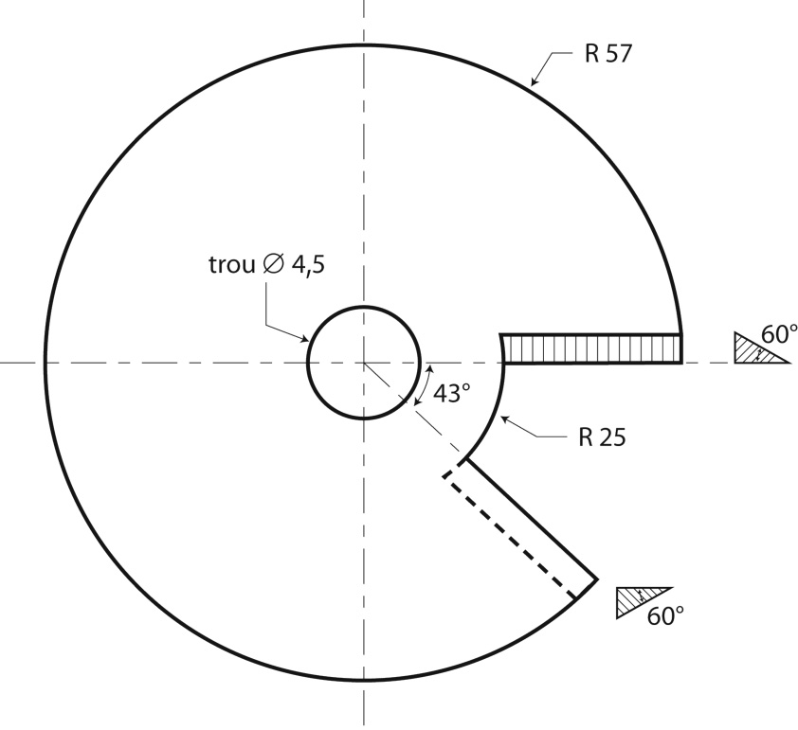
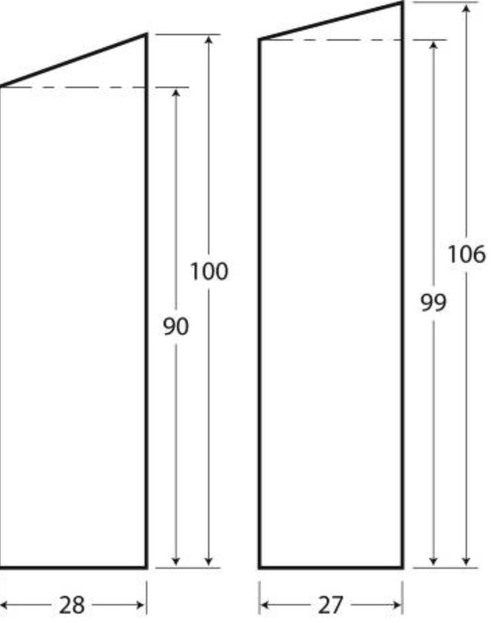
TITLE: Detail drawing, Parts 3, 18 and 19
Coin sorting machine
SCALE: 1:2 ± 2 mm
Part 3
Part
18
Part
19
hole
THE PROBLEM (continued)
Detail drawings for team member #4
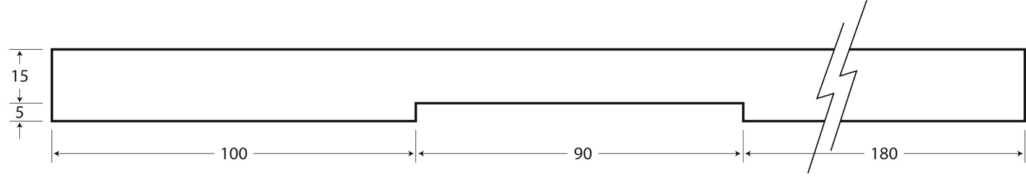
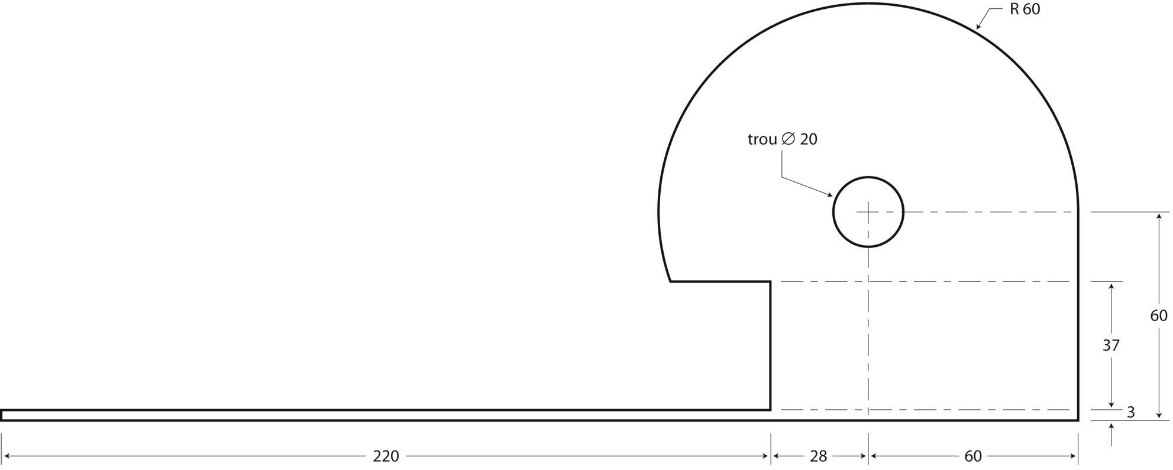
TITLE:Detail drawing, Parts 4 and 6
Coin sorting machine
SCALE: 1:2 ± 2 mm
Part 4
Part 6
hole
THE PROBLEM (continued)
Detail drawings for team member #5
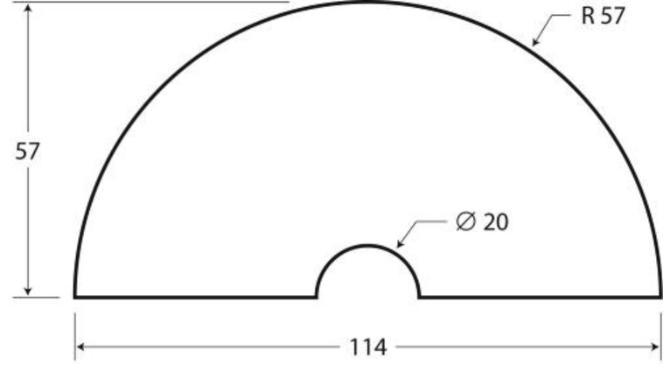
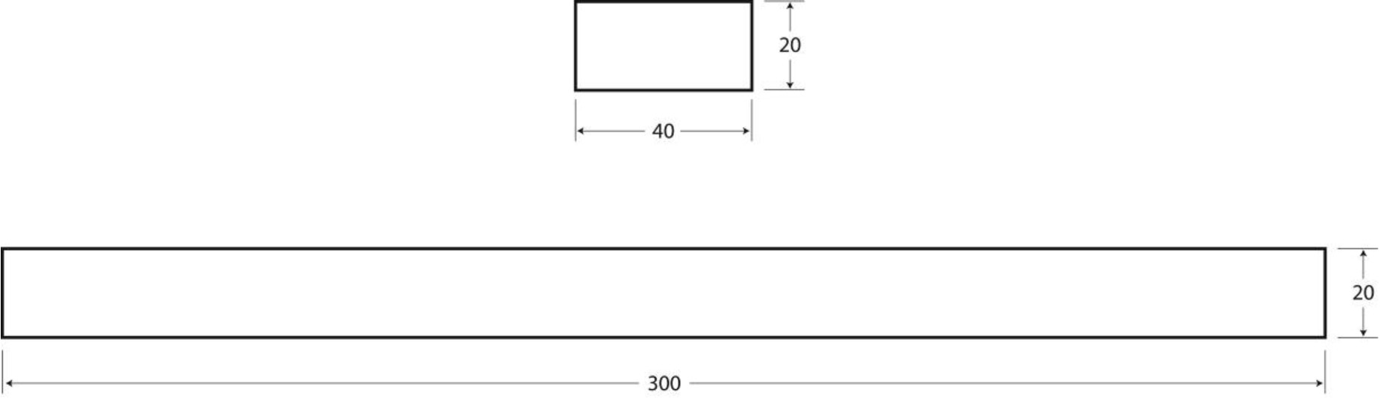
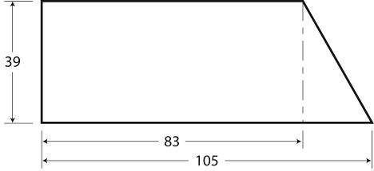
TITLE:Detail drawing, Parts 5, 8, 9 and 10
Coin sorting machine
SCALE: 1:2 ± 2 mm
Part 8
Part 5
Part 9
Part 10
THE PROBLEM (continued)
Detail drawings for team member #6
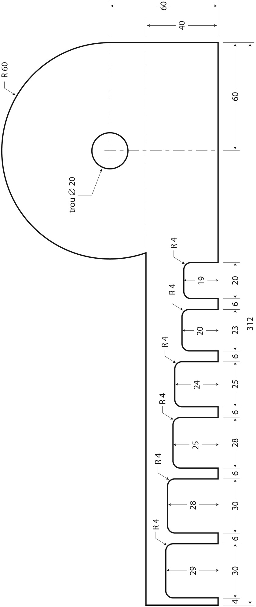
TITLE:Detail drawing, Part 7
Coin sorting machine
SCALE : 1:2 ± 2 mm
Pièce 7
Part
hole Ø20
THE PROBLEM (continued)
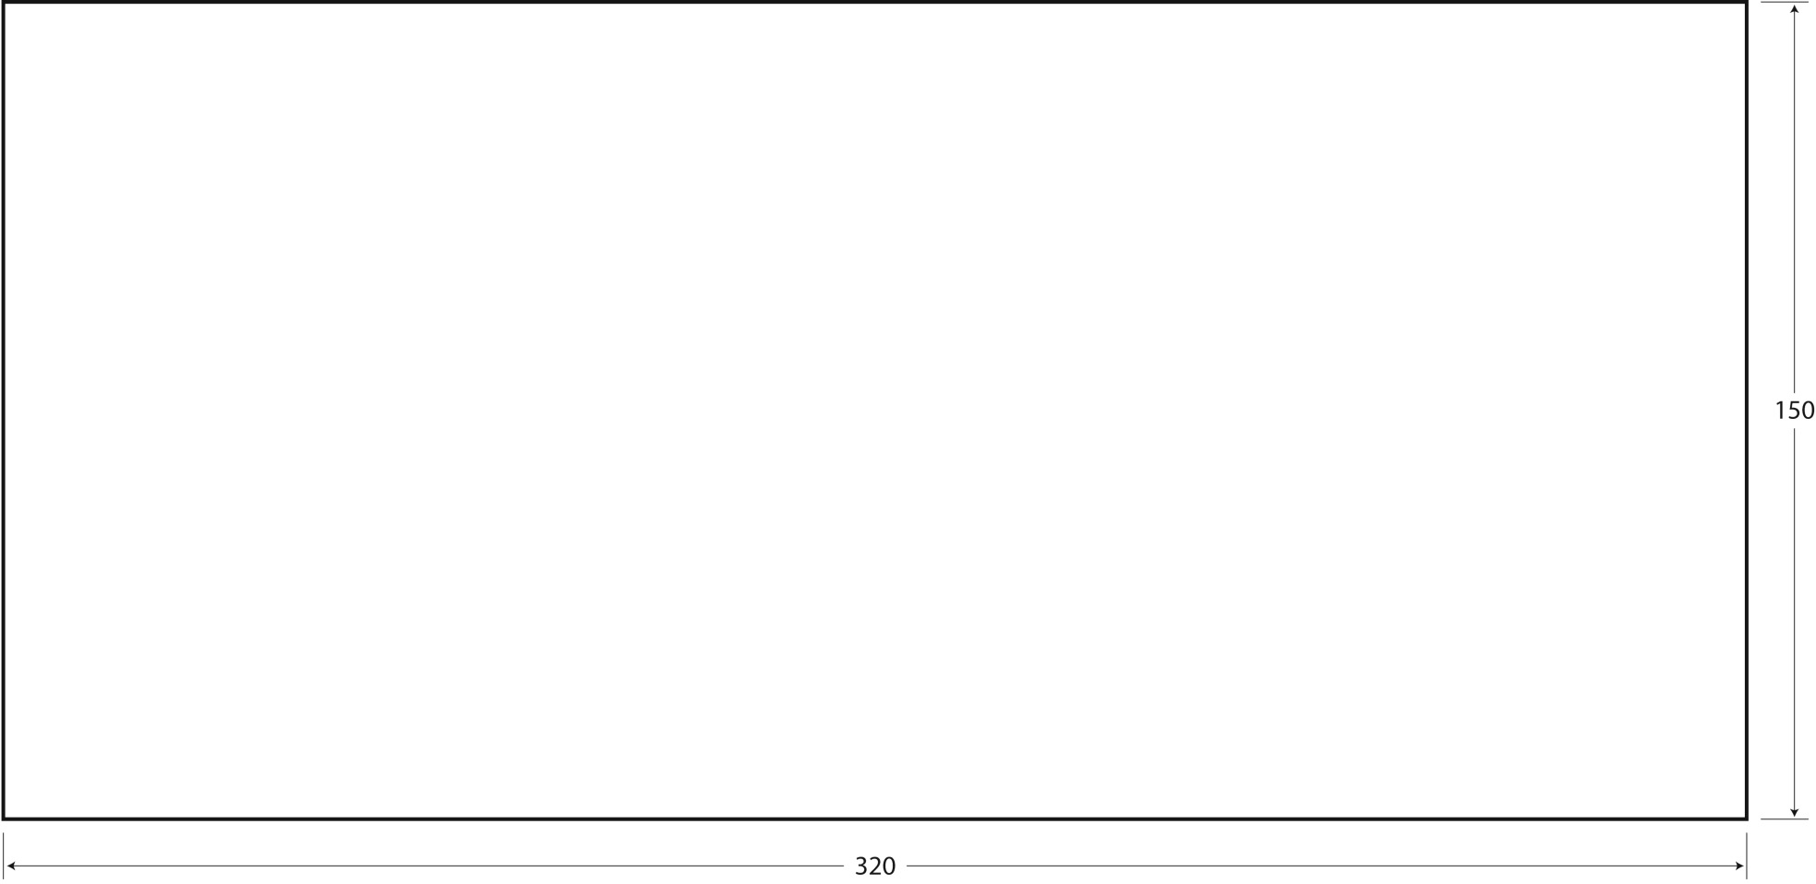
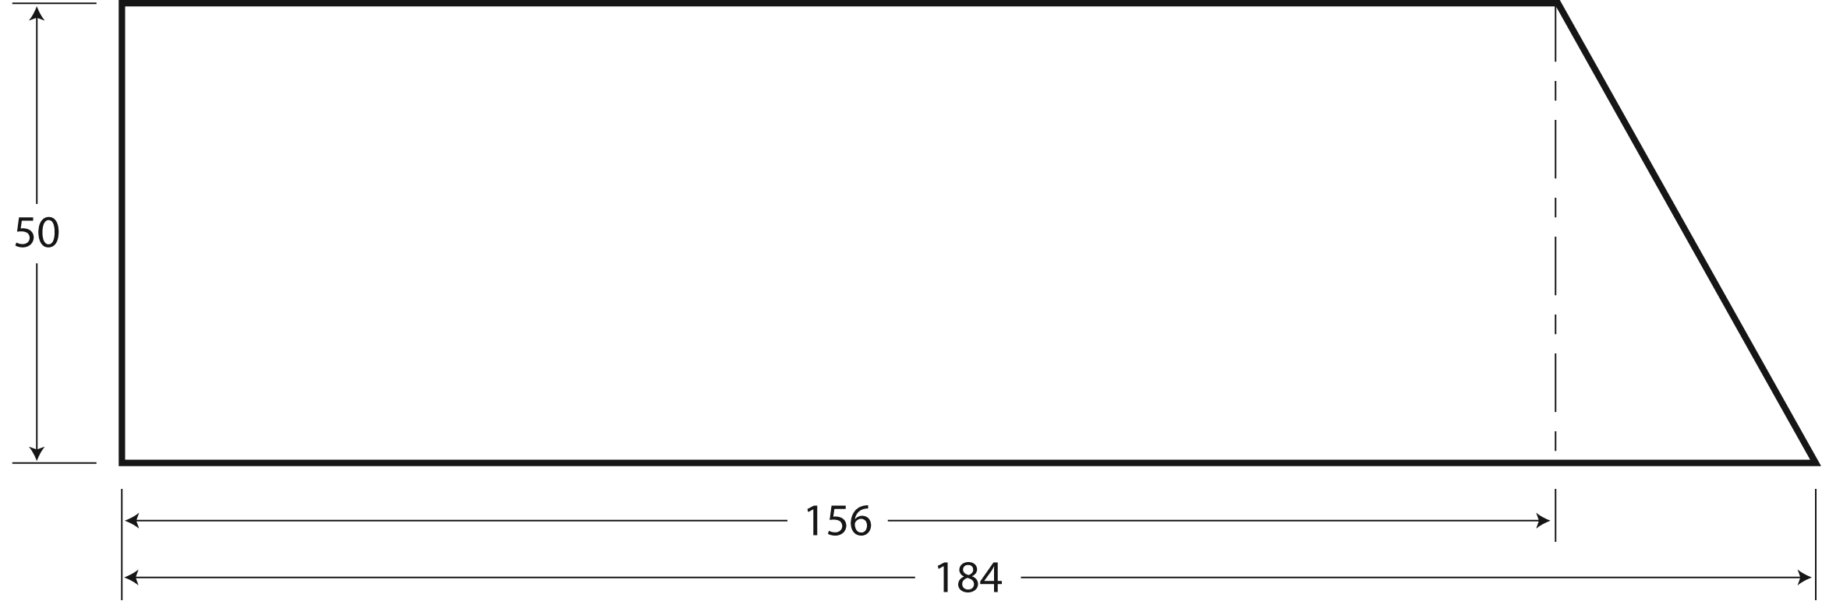
Detail drawings for team member #7
TITLE:Detail drawing, Parts 11 and 13
Coin sorting machine
SCALE: 1:2 ± 2 mm
Part 11
Part 13
THE PROBLEM (continued)
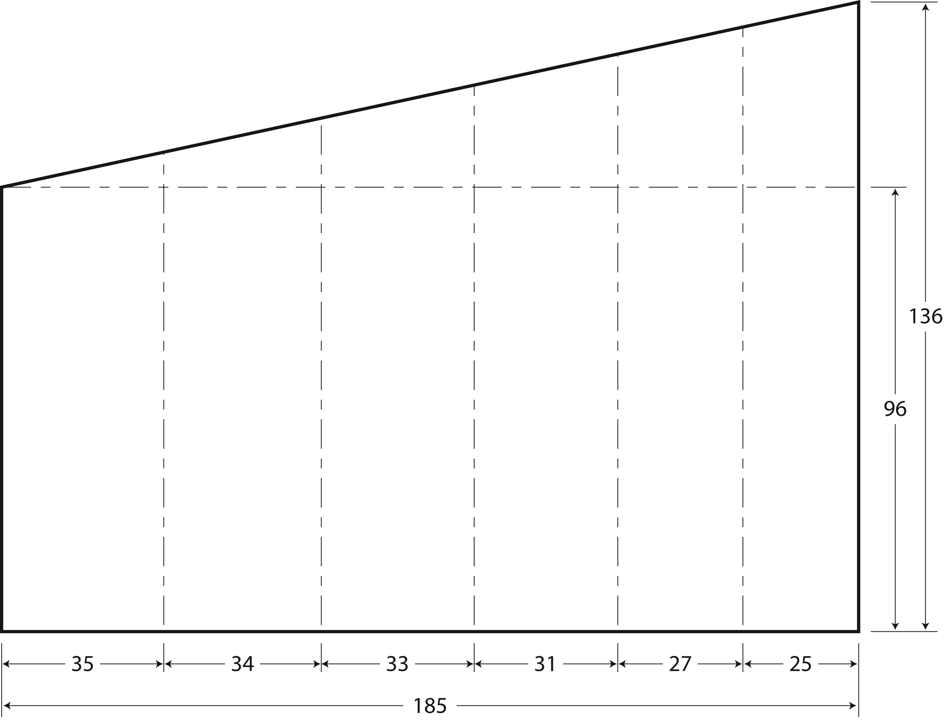
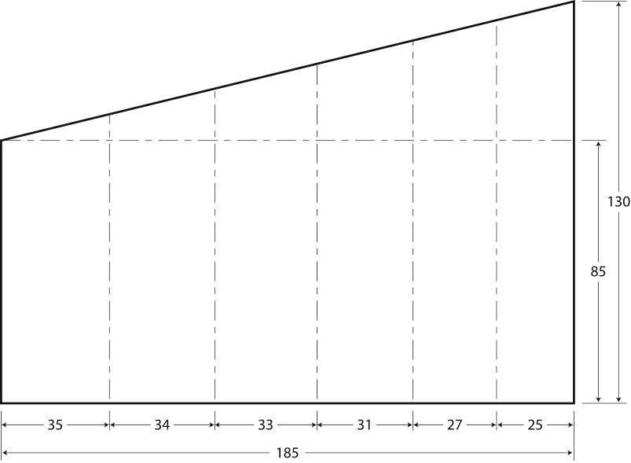
Detail drawings for team member #7 (continued)
TITLE:Detail drawing, Parts 14 and 15
Coin sorting machine
SCALE: 1:2 ± 2 mm
Part 14
Part 15
THE PROBLEM (continued)
Detail drawings for team member #8
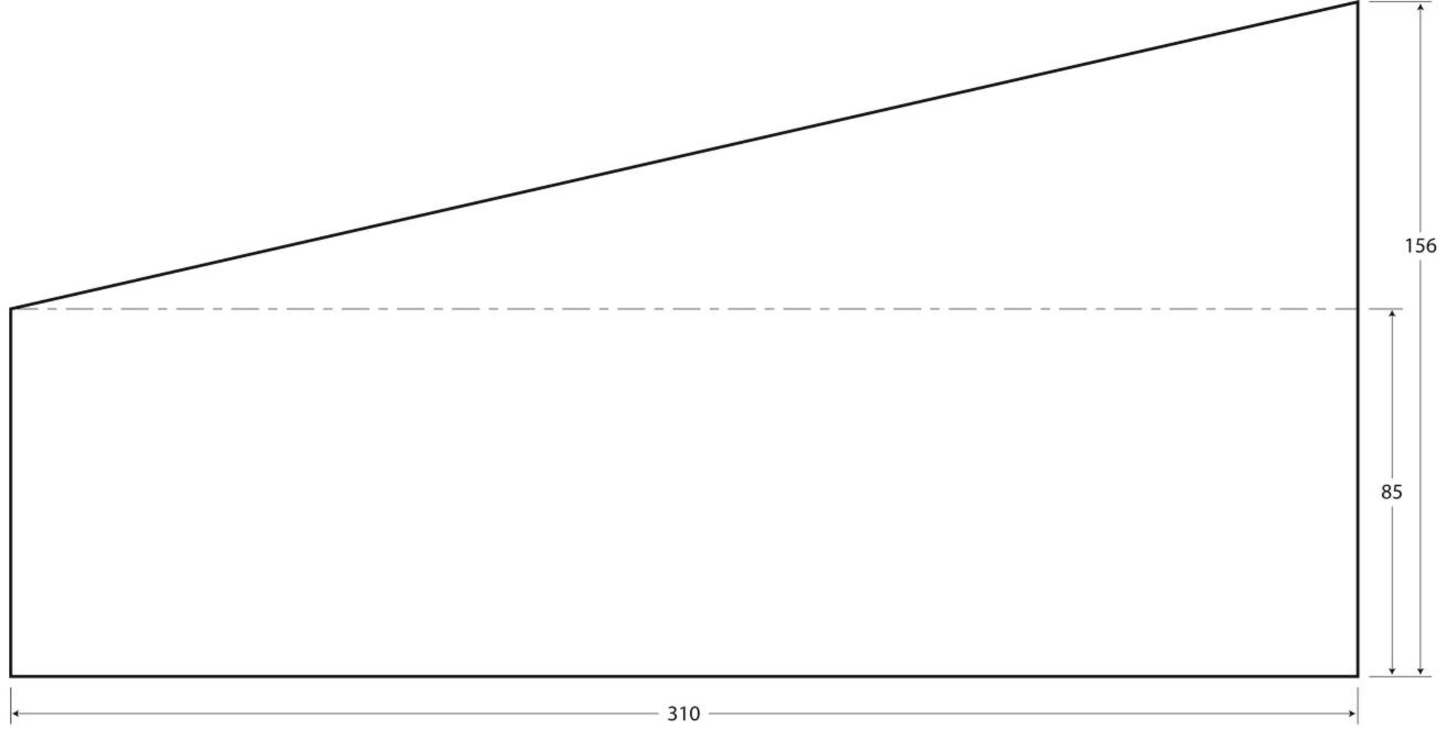
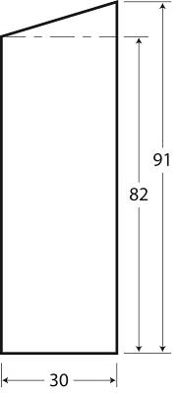
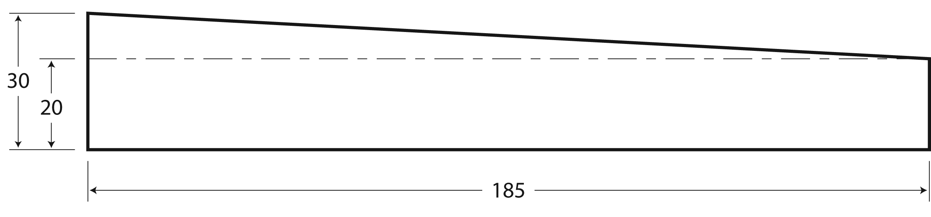
TITLE: Detail drawing, Parts 12, 16 and 17
Coin sorting machine
SCALE : 1:2 ± 2 mm
Part 12
Part 16
Part 17
CREATING THE CONTEXT
I ask myself questions
1. What is a general drawing?
2. What is an exploded view drawing?
3. Which projection is normally used to produce an exploded view drawing?
4. What is a detail drawing?
5. What is dimensioning?
6. What is tolerance?
7. What are thermoplastics?
8. What are the advantages of using thermoplastics?
CREATING THE CONTEXT (continued)
I must
9. In your opinion, what is the goal of the problem you have to solve?
I think
10. Draw the design plan of the coin sorting machine from the exploded view drawing. Use symbols to mark the force applied to the object and the movement of its parts.

Reflection Yes No
Have I clearly understood the following:
• axonometric projection: exploded view (reading)?  
• dimensioning and tolerances?  
• plastics (thermoplastics)?  
planning the problem solving
I plan
1. Draw up a list of the equipment and materials required to manufacture the parts.
2. Write the procedure you must use to make each part.
planning the problem solving (continued)
2. Procedure (continued)
3. What are the safety requirements for manufacturing your parts?
Reflection Yes No
Have I considered various possibilities for making the parts?  
Approved by the teacher
INITIATING THE PROBLEM SOLVING
I design
1. Make the parts according to the dimensions and tolerances shown on the detail drawings. If you change your plan of action, include those changes on the drawings, the list of equipment and materials and in the manufacturing procedure.
2. What safety rules did you follow in making the different parts?
3. Together with your teammates, assemble the parts of the coin sorting machine. Make sure you record all changes made in your plan of action.
Reflection Yes No
Have I recorded and justified each change I made in the plan of action?  
the FINAL TEST
I check
After assembling the parts and verifying that the coin sorting machine functions properly, answer the following questions.
1. Does the coin sorting machine fulfil its overall function? Explain your answer.
2. Does the coin sorting machine meet all the constraints mentioned in the specifications?
If not, explain your answer.
3. Are the dimensions and tolerances of the coin sorting machine right? Justify your answer.
4. Did you make changes in the plan of action? Why? Justify those changes.
5. Did you have any trouble making your parts? If so, explain your answer.
6. Did you have problems working as part of a team? If so, describe them.
7. Did you have problems assembling the parts? If so, describe them.
8. How would you improve the design of the coin sorting machine?

MY Evaluation
Use the evaluation grid on the next page for your self-evaluation. Write A, B, C, D or E
in the appropriate space in this table.
SSC1 Seeks answers or solutions to scientific or technological problems
Criteria* | Observable indicators | Me | Teacher | Comments
1 | Creating the context |  | ◻  With help
 | Definition of the goal and formulation of the design plan |  | ◻  With help
2 | Planning the problem solving |  | ◻  With help
 | Relevance of the elements in the plan of action: list of equipment and materials, and manufacturing procedure |  | ◻  With help
3 | Initiating the problem solving |  | ◻  With help
 | Respect for the dimensions, tolerances and safety rules when manufacturing parts |  | ◻  With help
4 | The final test |  | ◻  With help
 | Analysis of the operation of the coin sorting machine and suggested improvements |  | ◻  With help
* Evaluation criteria
1 Appropriate representation of the situation
2 Development of a suitable plan of action for the situation
3 Appropriate implementation of the plan of action
4 Development of relevant conclusions, explanations or solutions

Evaluation grid
* Evaluation criteria
1 Appropriate representation of the situation3 Appropriate implementation of the plan of action
2 Development of a suitable plan of action for the situation4 Development of relevant conclusions, explanations or solutions.
Seeks answers or solutions to scientific or technological problems | E | The work needs to be redone. |  | The work needs to be redone. |  | The work needs to be redone. |  | The work needs to be redone.
 | D | The goal is defined more or less clearly or does not relate to the problem to be solved  AND  the design plan contains major errors. |  | The choice of equipment and materials is more or less appropriate  AND  the manufacturing procedure contains many errors. |  | The parts do not meet the dimensions and tolerances on the detail drawings  OR  the work is not performed safely. |  | The coin sorting machine does not meet most of the specified constraints.
 | C | The goal is defined more or less clearly or does not relate to the problem to be solved  OR  the design plan contains many errors. |  | The choice of equipment and materials is more or less appropriate  OR  the manufacturing procedure contains many errors. |  | The parts include many elements that do not meet the dimensions and tolerances on the detail drawings  AND  the work is performed safely. |  | The coin sorting machine meets most of the specified constraints, but the suggested improvements are only more or less relevant.
 | B | The goal is clearly defined and relates to the problem to be solved  AND  the design plan contains a few minor errors. |  | The choice of equipment and materials is appropriate  AND  the manufacturing procedure contains a few minor errors. |  | The parts include a few elements that do not meet the dimensions and tolerances on the detail drawings  AND  the work is performed safely. |  | The coin sorting machine meets most of the specified constraints. Most of the suggested improvements are relevant.
 | A | The goal is very clearly defined and relates to the problem to be solved  AND  the design plan is complete. |  | The choice of equipment and materials is appropriate  AND  the manufacturing procedure is relevant and complete. |  | The parts meet the dimensions and tolerances on the detail drawings  AND  the work is performed safely. |  | The coin sorting machine functions properly and meets all specified constraints. The suggested improvements are relevant.
 | Observable indicators | CREATING THE CONTEXT | Definition of the goal and formulation of the design plan | Planning the problem solving | Relevance of the elements in the plan of action: list of equipment, materials and manufacturing procedure | Initiating the problem solving | Respect for the dimensions, tolerances and safety rules when manufacturing parts | the final test | Analysis of the operation of the coin sorting machine and suggested improvements
 |  | 1 |  | 2 |  | 3 |  | 4


