the CASE STUDY

WORK ORDER
Good Measure Designs, Inc.
TO: All designers
DATE: April 12, 2018
SUBJECT: Signing of a contract with the municipal library
We are proud to announce that we have just signed an important contract with the municipal library. To ensure the comfort and well-being of its patrons, the library has ordered ergonomic reading chairs adapted to its clientele. They have chosen to target four separate groups: young children, children, small adults and tall adults. We are asking our designers to submit multiview projections for each of the target clientele, keeping in mind technical and ergonomic norms. Later, the designers will undertake to create the chair’s style and maximize its potential for comfort.
Thank you for your collaboration.

Jim Gray
President

Ergonomic
Anyone who works sitting down knows what it’s like to have back pain. Thanks to ergonomics, it is now possible to have chairs that are designed to help prevent such discomfort. The field of ergonomics studies working conditions and the relationship between people and objects. The designer, by adapting the object to its user, increases the user’s well-being and productivity. More and more companies are integrating ergonomic norms into their workplace design. The municipal library recently received complaints from users who have experienced back pain sitting in its chairs. In an effort to maintain its patronage, the library has decided to purchase some ergonomic reading chairs.

In this learning and evaluation situation, you will play the role of a designer. To complete the task, you will need to:
• Calculate the measurements for each part of the chair;
• Make multiview projections of the chair at a scale of 1:10;
• Provide dimensions for each of the following chair parts:
– height of the chair-back supports, – length of the armrests,
– total height of the chair back, – depth of the chair seat,
– height of the armrest supports, – width of the chair seat,
– height of the armrests, – height of the chair legs.
the CASE STUDY (continued)
Technical and
ergonomic norms
established by
Good Measure
Designs, Inc.
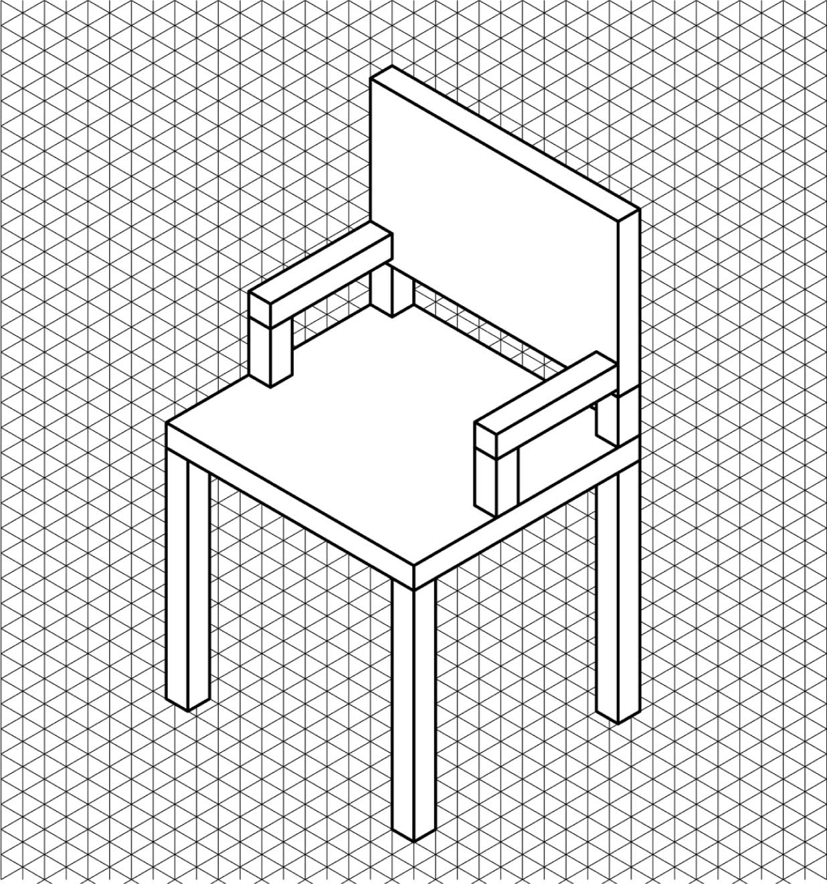
Technical norms
1.1 The chair-back supports, armrest supports, armrests and chair legs are made of square wooden balusters (posts), measuring 5 cm x 5 cm.
1.2 The chair seat and the chair back are 5 cm thick.
Ergonomic norms
Chair legs
2.1 Height
The highest part of the chair seat should be at knee height. In this way, the user, when seated, can rest his/her feet comfortably on the floor.
Seat
2.2 Depth
When seated, the user should be able to rest his/her back against the chair back without there being any pressure on the back of the knees from the seat; there should be 5 cm of space between the back of the user’s knees and the edge of the seat.
2.3 Width
The seat should be wide enough so that there is no pressure placed on either side of the user’s thighs and pelvis, so leave 2.5 cm of space on either side of the pelvis when the legs are slightly apart. In addition, the designer must leave 10 cm for space to secure the armrests.

the CASE STUDY (continued)
The chair back
2.4 Total height
The height of the chair back should correspond to the height of the user’s shoulders when he/she is seated. The user should be able to rest his/her neck on the top of the chair back when stretching.
2.5 Width
For maximum comfort, the chair back should be the same width as the seat.
The chair-back supports
2.6 Height
The chair-back supports should be 10 cm high. They should be positioned on the right and left sides of the chair back and at the two back corners of the seat.
Note: The space that this creates will allow the natural curve in the user’s lower spine to occupy the 5-cm space below the chair back.
The armrests
2.7 Length
The armrests should provide enough room for the user’s entire forearms—from elbow to wrist—to rest comfortably.
The armrest supports
2.8 Height
The user should be able to rest his/her elbows on the armrests, with arms vertical and shoulders relaxed. The armrests must not hamper natural movement.

the CASE STUDY (continued)
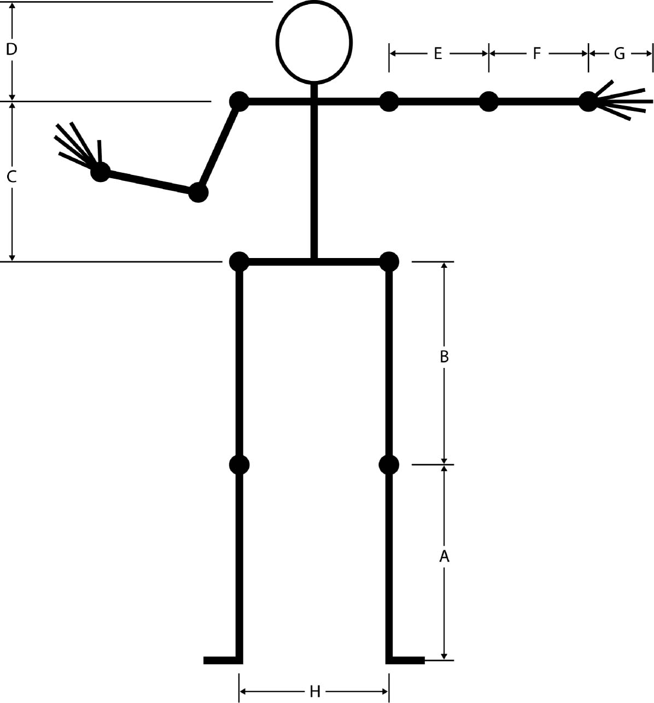
Measurements for the target groups
Unit of measurement: cm
Young child
A. Length floor–knee: 30
B. Length knee–hip: 30
C. Length hip–top of shoulder: 35
D. Length top of shoulder–top
of head: 22
E. Length shoulder–elbow: 15
F. Length elbow–beginning of wrist: 12
G. Length wrist–tips of fingers: 14
H. Width of pelvis, legs slightly apart: 24
Child
A. Length floor–knee: 40
B. Length knee–hip: 40
C. Length hip–top of shoulder: 38
D. Length top of shoulder–top of head: 24
E. Length shoulder–elbow: 22
F. Length elbow–beginning of wrist: 20
G. Length wrist–tips of fingers: 16
H. Width of pelvis, legs slightly apart: 26
Small adult
A. Length floor–knee: 42
B. Length knee–hip: 46
C. Length hip–top of shoulder: 42
D. Length top of shoulder–top of head: 24
E. Length shoulder–elbow: 26
F. Length elbow–beginning of wrist: 22
G. Length wrist–tips of fingers: 17
H. Width of pelvis, legs slightly apart: 37
Tall adult
A. Length floor–knee: 55
B. Length knee–hip: 57
C. Length hip–top of shoulder: 45
D. Length top of shoulder–top of head: 28
E. Length shoulder–elbow: 28
F. Length elbow–beginning of wrist: 28
G. Length wrist–tips of fingers: 18
H. Width of pelvis, legs slightly apart: 42

CREATING THE CONTEXT
Who is your target clientele?
I ask myself questions
1. What is ergonomics?
2. Who are the actors in this case study?
3. Formulate the questions that you will have to answer as you make a technical drawing of your chair.
I must
4. Reformulate the case study goal.

CREATING THE CONTEXT (continued)
I think
5. Which views do you think should appear on the drawing (e.g. front view, top view, bottom view, right-side view, left-side view, rear view)? Use arrows to indicate your choices on the drawing below, and justify your answers.
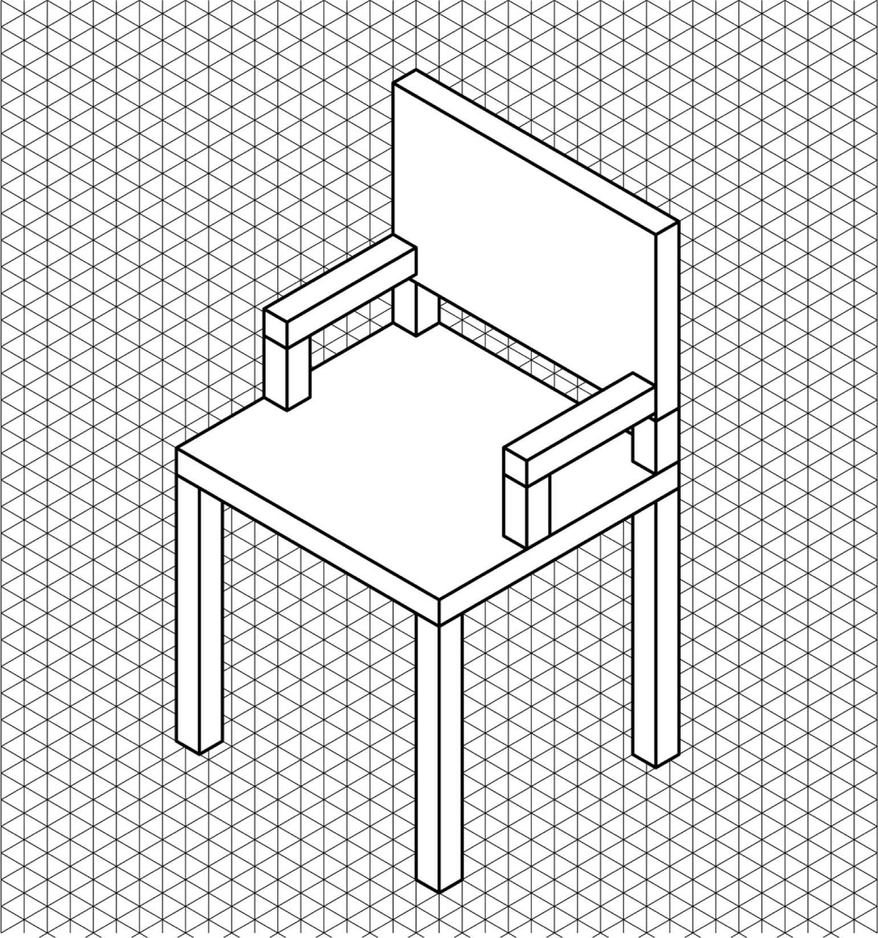
Justification:

CREATING THE CONTEXT (continued)
What I know and what I must find out
6. Write down the information you have, and what you need to find out.
What I know . . . |  | What I need to find out . . .
I prepare my work
7. Where can you find the information you need to produce your technical drawing?
8. In chronological order, list the principal steps of your work.
Reflection Yes No
Do I have a good understanding of the work to be done?  

GATHERING INFORMATION
I prepare my work
1. To make a technical drawing of a custom-made chair, you need to use certain basic lines. In the table below, name the lines and explain their use.
 | Name of  the basic line |  |  | Line |  |  | Use
 |  |  |  | 2.75
2. What calculation should be used to convert a real measurement to a scale reduction of 1:10?

GATHERING INFORMATION (continued)
3. Here is the chair that you will need to draw. On the drawing, label each of the parts using dimension lines.

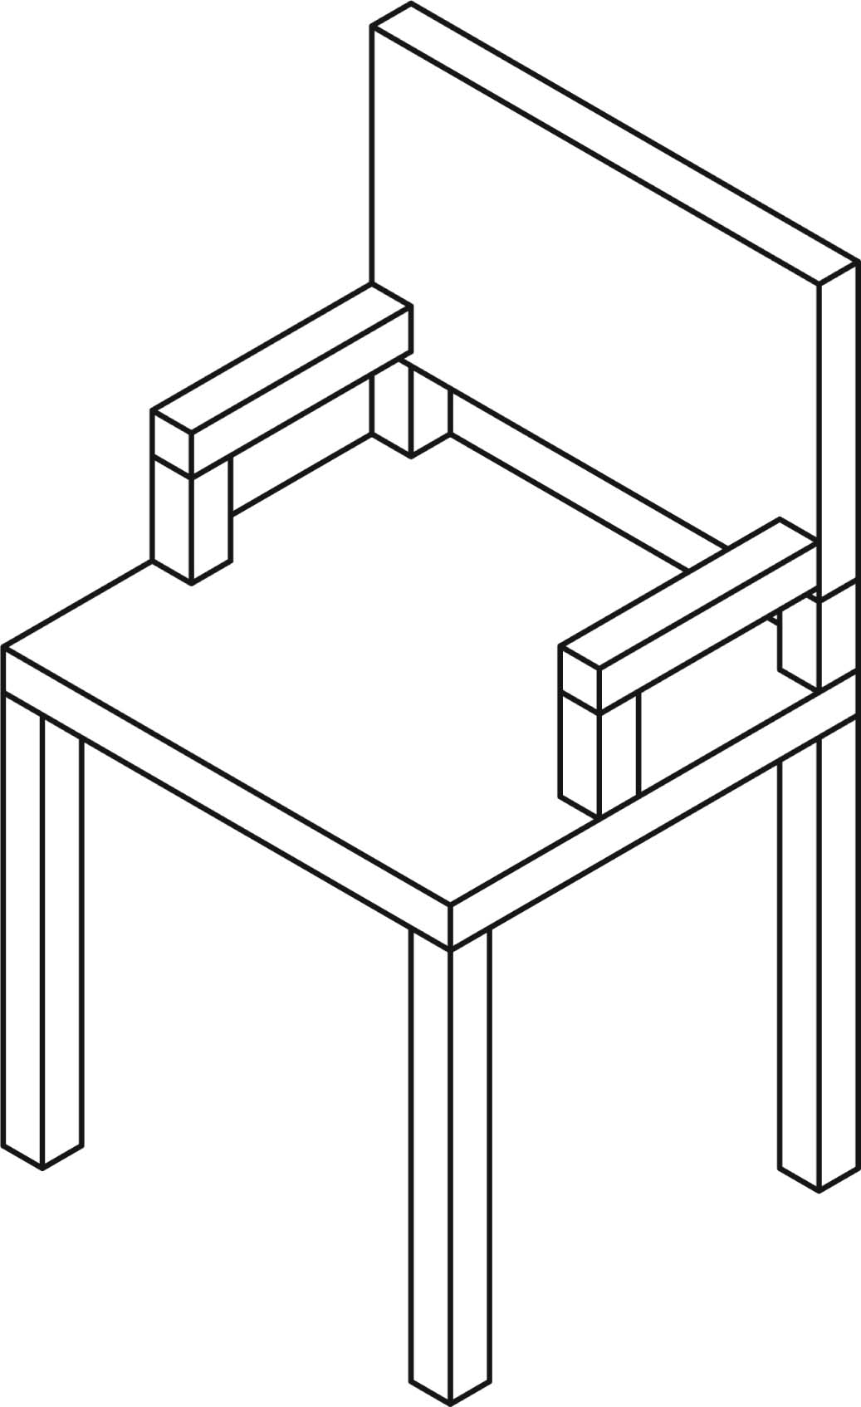 | Chair parts
 | Nos. | Characteristics
 | 1 | Thickness of chair seat
 | 2 | Depth of chair seat
 | 3 | Width of chair seat
 | 4 | Dimensions (length, width)  of chair legs
 | 5 | Height of chair legs
 | 6 | Thickness of chair back
 | 7 | Dimensions (length, width)  of chair-back supports
 | 8 | Height of chair-back supports
 | 9 | Width of chair back
 | 10 | Height of chair back
 | 11 | Total height of chair back
 | 12 | Dimensions (length, width) of armrests and their supports
 | 13 | Length of armrests
 | 14 | Height of armrest supports
 | 15 | Total height of armrests

GATHERING INFORMATION (continued)

4. What is the formula that you will use to determine the measurements for each of the parts of your chair? Your formula will include the measurements for your target group, and where necessary, the extra space for ease as defined by the norms of the firm.
Example:
Depth of chair seat = length knee-hip – 5 cm
Seat width =
Height of chair leg =
Width of chair back =
Height of chair back =
Total height of chair back =
Armrest length =
Height of armrest supports =
Total height of armrests =

GATHERING INFORMATION (continued)

I apply my research results
5. Using the data gathered in No. 4, find the measurements of the chair parts and record them in the column “True value” in the table below. Next, record the value to scale in the adjacent column.
Chair parts |  | Measurement of part
Nos. | Aspect | True value (mm) | Value  to a scale  of 1:10 (mm)
1 | Thickness of seat
2 | Depth of seat
3 | Width of seat
4 | Dimensions (length, width) of chair legs
5 | Height of chair legs
6 | Thickness of chair back
7 | Dimensions (length, width) of chair back supports
8 | Height of chair back supports
9 | Width of chair back
10 | Height of chair back
11 | Total height of chair back
12 | Dimensions (length, width) of armrests and their supports
13 | Length of armrests
14 | Height of armrest supports
15 | Total height of armrests

GATHERING INFORMATION (continued)
6. Make sketches of the front view, the right-side view and the top view of the chair illustrated here.
• Lay out the three
views in an
L-shape.
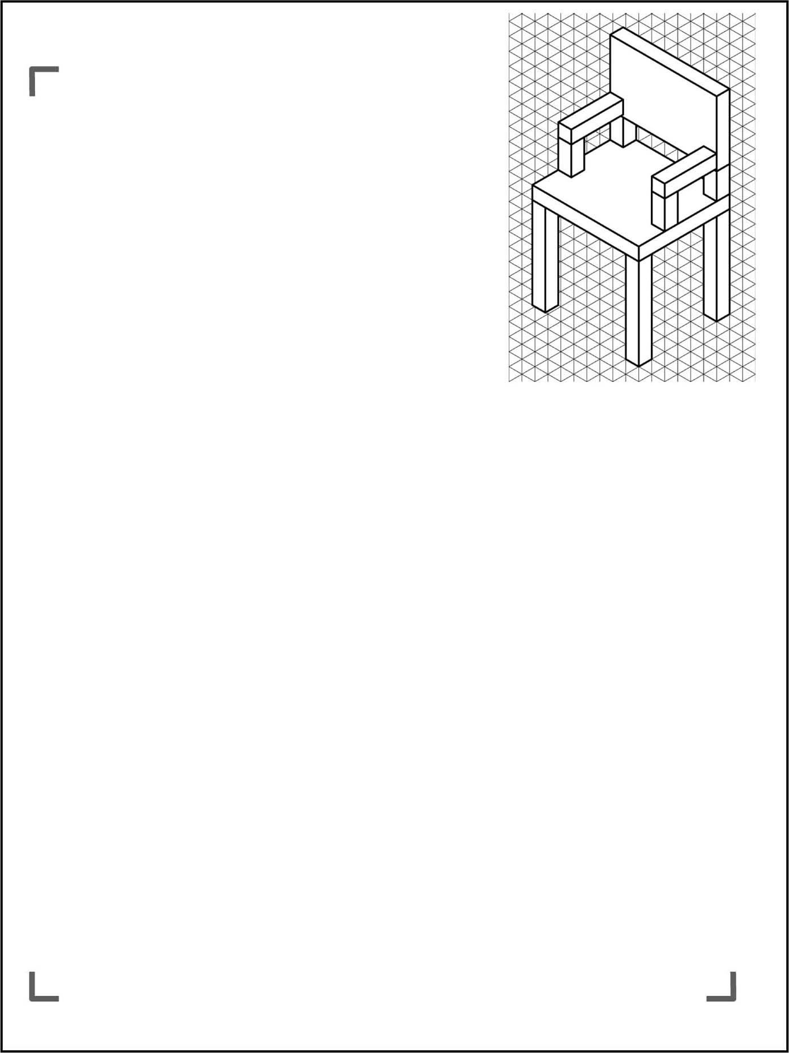
• You don’t have
to make a drawing
to scale just yet.
Reflection
Do I have a good understanding of: Yes No
• geometric lines?  
• forms of representation (such as sketch, perspective
drawing, oblique projection)?  
• basic lines?  
• orthogonal projections (multiview, isometric)?  
• dimensioning?  
• scales?  

COMPLETING THE CASE STUDY

I make suggestions
1. On the next page, complete your drawings of the front, right-side and top views of the chair that is adapted to your target group.
• Make your technical drawing to a scale of 1:10.
• Use dimensioning to indicate:
height of the chair-back supports;
total height of the chair back;
height of the armrest supports;
height of the armrests;
length of the armrests;
depth of the chair seat;
width of the chair seat;
height of the chair legs.
Reflection Yes No
Have I explored different ways of using drafting instruments?  

COMPLETING THE CASE STUDY (continued)


NAME: | DATE:
TITLE: | SCALE:

VALIDATING THE CASE STUDY
I justify my approach
1. On the next two pages, you will find silhouettes of the users from the four target clienteles, drawn according to the data provided and at a scale of 1:10.
a) Copy the right-side view of the chair as if the user were sitting in it.
b) Does your drawing of a chair respect the ergonomic norms as established by the firm? Include at least four justifications (numbered) on your drawing.

My reflection
Identify the design-related aspects of creating the model.

VALIDATING THE CASE STUDY (continued)
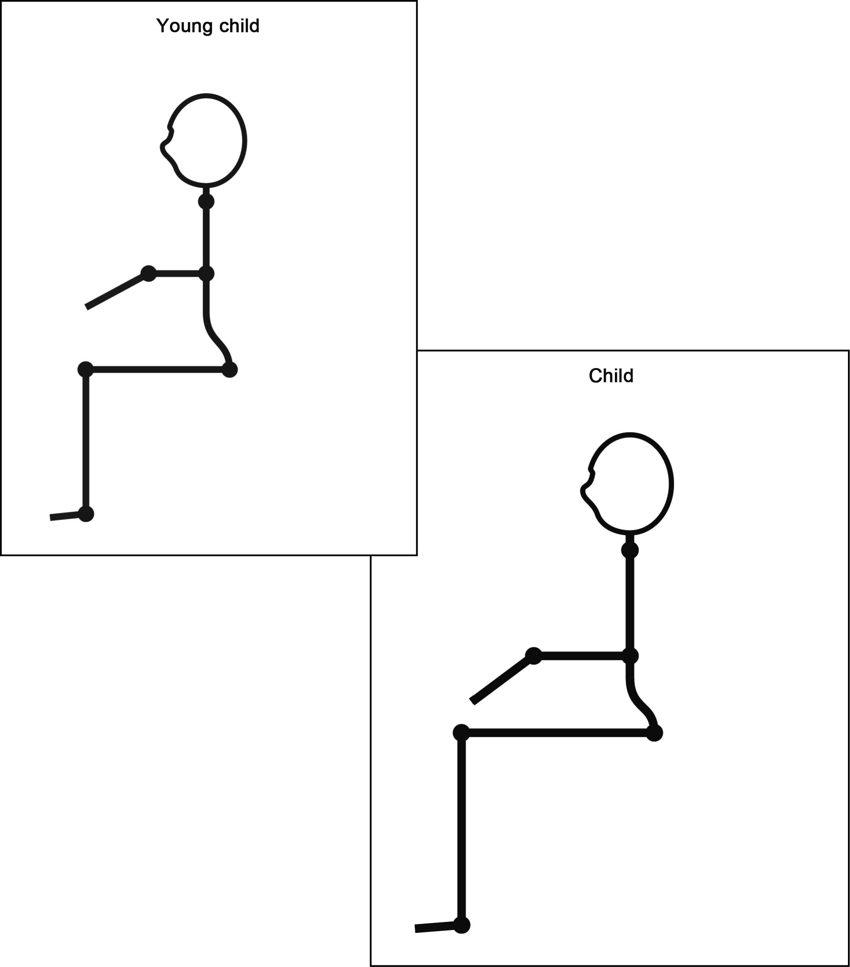

VALIDATING THE CASE STUDY (continued)
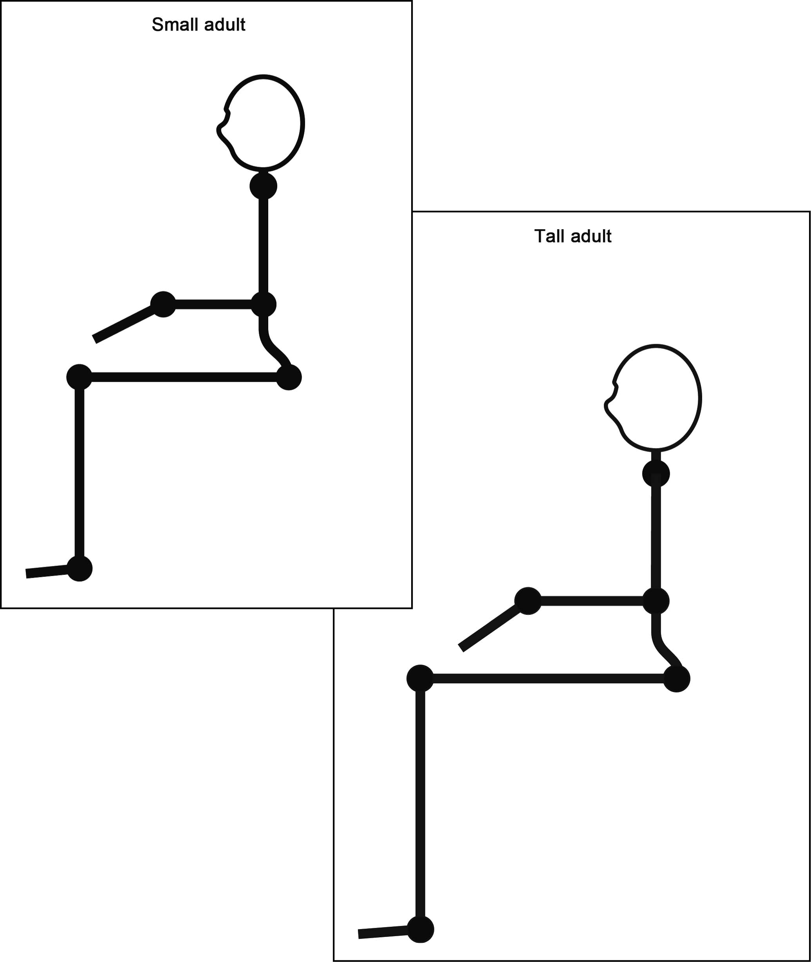

My evaluation
Use the evaluation grid on the next page to do a self-evaluation. Write A, B, C, D or E
in the appropriate place in the table.

SSC2 Makes the most of his/her knowledge of science
and technology
Criteria* | Observable indicators | Me | Teacher | Comments
1 | Creating the context |  |   With help
 | Statement of the case study goal and formulation of questions for information gathering. |  |   With help
2 | Gathering information |  |   With help
 | Respect for the norms when calculating the dimensions for the chair |  |   With help
3 | Completing the case study |  |   With help
 | Production and dimensioning of multiview projections |  |   With help
4 | Validating the case study |  |   With help
 | Justification of the respect for ergonomic norms |  |   With help
* Evaluation criteria
1 Formulation of appropriate questions
2 Appropriate use of scientific and technological concepts, laws, models and theories
3 Relevant explanations, solutions or actions
4 Suitable justification of explanations, solutions or actions

evaluation grid
* Evaluation criteria
1 Formulation of appropriate questions3 Relevant explanations, solutions or actions
2 Appropriate use of scientific and technological concepts, laws, models and theories4 Suitable justification of explanations, solutions or actions
 Makes the most of his/her knowledge of science and technology | E | The work needs to be redone. |  | The work needs to be redone. |  | The work needs to be redone. |  | The work needs to be redone.
 | D | The questions directing the information gathering are more or less relevant and the case study goal is more  or less clear. |  | Some of the measurements for  the chair parts are precise and respect the norms. |  | The multiview projections are more or less precise and more or less respect the norms for technical drawing. |  | The explanations are more or less relevant and are poorly indicated on the drawings.
 | C | The questions directing the information gathering are more or less relevant or the goal  is more or less clear. |  | Many of the measurements for  the chair parts are precise and respect the norms. |  | The multiview projections are more or less precise or more or less respect the norms for technical drawing. |  | The explanations are more or less relevant or are poorly indicated on the drawings.
 | B | The questions directing the information gathering are relevant and the case study goal is clear. |  | Most of the measurements for  the chair parts are precise and respect the norms. |  | The multiview projections are precise and respect the norms for technical drawing, but the drawings contain a few minor errors. |  | Most of the explanations are relevant and clearly indicated on the drawings.
 | A | The questions directing the information gathering are relevant and the case study goal is very clear. |  | All of the measurements for  the chair parts are precise and respect the norms. |  | The multiview projections are precise and respect the norms for technical drawing. |  | All of the explanations are relevant and clearly indicated on the drawings.
 | Observable indicators | CREATING THE CONTEXT | Statement of the case study goal and formulation of questions for information gathering | GATHERING INFORMATION | Respect for the norms when calculating the dimensions for the chair | COMPLETING THE  case study | Production and dimensioning multiview projections | VALIDATING THE  case study | Justification of the respect for ergonomic norms
 |  | 1 |  | 2 |  | 3 |  | 4

