THE PROBLEM
PRESS RELEASE
Shawinigan – September 7, 2009
Getting students involved!
Last night a series of mysterious thefts occurred in a number of the town’s businesses. A variety of objects, often of very little value, were stolen. This morning municipal authorities asked a group of tech-lab students if they would be interested in participating in the investigation. The students were happy to be able to have a hand in solving the crime and responded enthusiastically. The authorities gave them the following mission: to identify the samples collected by investigators on-site in the different stores and thus find the guilty party.
Among the tasks set out for them, students are to identify the following four substances by means of experiments and tests:
• a dense solid (e.g. one that is not soluble in water)
• a solid in the form of a powder
• a liquid
• a gas

In this learning situation, you will play the role of one of the students working in the tech lab.
Notes

CREATING THE CONTEXT

I ask myself questions
1. What is a characteristic property?
2. Name some characteristic properties.
3. How can we identify a substance?

4. What do we need to do to identify the substances of the samples collected by the investigators? Do we have to proceed in the same manner for all types of substances?
I must

5. What is the goal of the legal investigation?

CREATING THE CONTEXT (continued)

I think

6. Which characteristic properties can you find for the following substances?
a) a dense solid not soluble in water?
b) a powdered solid?
c) a liquid?
d) a gas?
Reflection Yes No
Do I have a good understanding of:
• characteristic physical properties?  
• characteristic chemical properties?  
• pure substances?  

PLANNING THE PROBLEM solving

I plan

1. Plan each test that you will do on the substances given to you.
a) Specify the goal for each test.
b) List the materials needed for each test. If necessary, consult the appropriate section
in the Toolbox.
c) Give the steps for each test.
d) For each test, create a table in which you will write down your results.

2. What safety rules must be followed for each test?
Reflection Yes No
Can I think of any other possibilities?  

initiating THE PROBLEM SOLVING

I experiment
1. Perform the tests on the substances. Be sure to follow the steps you listed earlier.
2. If necessary, modify your plan of action. Be sure to record and explain your changes, and have them approved by the person in charge.
3. Record your observations and the results of your tests. If necessary, include your calculations.
4. Did you perform the tests safely? Explain your answer giving two examples.
Reflection Yes No
Did I write down and explain all the changes I made to my plan of action?  

ANALYZING RESULTS AND
DRAWING CONCLUSIONS
1. Relate the tests you performed with the results you obtained in order to identify the substances.

Dense solid | Code: |  |  | Name of substance:

Tests performed |  | Final results

Powdered solid | Code: |  |  | Name of substance:

Tests performed |  | Final results

Liquid | Code: |  |  | Name of substance:

Tests performed |  | Final results

Gas | Code: |  |  | Name of substance:

Tests performed |  | Final results
2. Are your results similar to the data in the tables of properties? If so, explain your answer.
3. Who committed the thefts?
LIST OF SUSPECTS
SUSPECT No. 1  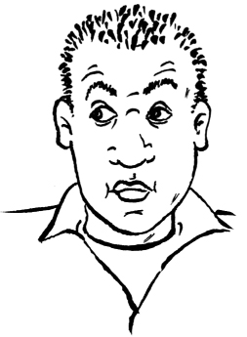 | SUSPECT No. 2  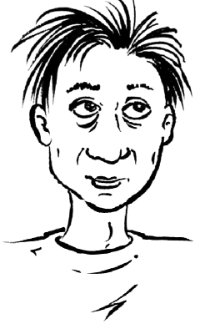 | SUSPECT No. 3  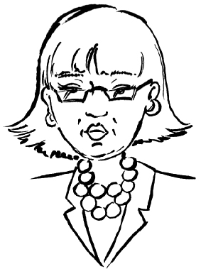
Age: 42  Height: 1.72 m  Weight: 85 kg  This man manufac-  tures zinc eavestroughs.  He loves the colour green,  but he hates fire and is always on the lookout for one that needs to be extinguished. He routinely chews antacids to soothe his heartburn. | Age: 34  Height: 1.50 m  Weight: 56 kg  This man devours  alcohol-filled candies.  He collects potassium-  based explosives and stores  them in aluminum boxes. His  mother is seriously ill and is hooked up to a respirator. | Age: 51  Height: 1.57 m  Weight: 51 kg  Always on the prowl  for quality wine, this  connoisseur needs to  take a potassium supple-  ment. She is always decked out in cheap jewellery and often takes trips in hot-air balloons.
SUSPECT No. 4 | SUSPECT No. 5 | SUSPECT No. 6
Age: 35  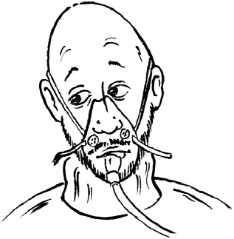  Height: 1.80 m  Weight: 95 kg  This man is clinically  depressed and  asthmatic. He takes  lithium and is hooked up to an oxygen tank. In his spare time, he cleans iron with acid. | Age: 48  Height: 168 m  Weight: 72 kg  This woman is very  concerned about  global warming.  She makes explosives  using carbon, potassium salts  and sometimes nitroglycerine. | Age: 29  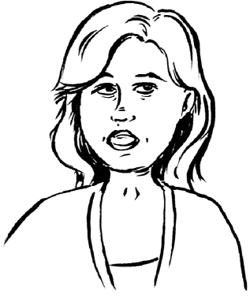    Height: 1.82 m  Weight: 100 kg  This man craves salty  food, and is always  thirsty. He uses copper  salt explosives with hydrogen detonators. He writes his ideas on pieces of paper with a lead pencil.
SUSPECT No. 7 | SUSPECT No. 8 | SUSPECT No. 9
Age: 49  Height: 1.75 m  Weight: 80 kg  This woman’s favourite  food treat is salty  french fries. She  hates fire and she often  gargles with glycerine to stop her coughing. She installs aluminum siding. | Age: 28  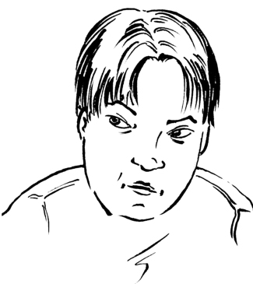  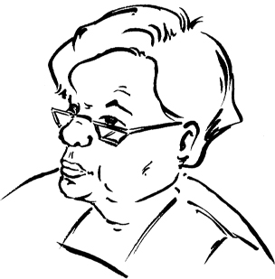  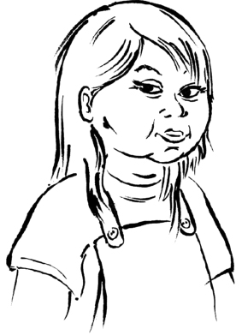  Height: 1.80 m  Weight: 89 kg  This loner is  obsessed with  zeppelins. His hands are permanently stained blue from copper salts. He hunts small animals with a lead pellet rifle.  Afterwards, he cleans his gun in a frenzy. | Age: 61  Height: 1.60 m  Weight: 80 kg  This woman is  always eating food  and drinking water. Her every breath is filled with the odour of sulphur. Her shoes are often wet and stained with calcium salts.

MY EVALUATION
Use the evaluation grid on the following page to do a self-evaluation. Write A, B, C, D or E
in the appropriate box in the table below.
SSC1 Seeks answers or solutions to scientific or technological problems
Criteria* | Observable indicators | Me | Teacher | Comments
1 | Creating the context |  |   With help
 | Definition of the goal and formulation of the test proposal for the substances to be identified |  |   With help
2 | Planning the problem solving |  |   With help
 | Relevance of the elements of the plan of action: materials and procedures |  |   With help
3 | Initiating the problem solving |  |   With help
 | Accuracy of the results and calculations |  |   With help
4 | Analyzing results and drawing conclusions |  |   With help
 | Identification of substances and the  guilty party |  |   With help
* Evaluation criteria
1 Appropriate representation of the situation
2 Development of a suitable plan of action for the situation
3 Appropriate implementation of the plan of action
4 Development of relevant conclusions, explanations or solutions


evaluation grid
* Evaluation criteria
1 Appropriate representation of the situation 3 Appropriate implementation of the plan of action
2 Development of a suitable plan of action for the situation4 Development of relevant conclusions, explanations or solutions
Seeks answers or solutions to scientific or technological problems | E | The work needs to be redone. |  |  | The work needs to be redone. |  | The work needs to be redone. |  | The work needs to be redone.
 | D | Goal is not defined clearly and not related to problem  AND  tests proposed for substances are not relevant. |  |  | List of materials is missing elements  AND  procedures are formulated poorly and not relevant. |  | Calculations contain major errors. |  | One or no substance is identified correctly.
 | C | Goal is not defined clearly or not related to problem  OR  tests proposed for substances are more or less relevant. |  |  | List of materials is missing elements  OR  procedures are formulated more or less clearly and relevant. |  | Some results are noted and relevant. Some calculations contain minor errors. |  | Two or three substances are identified correctly.
 | B | Goal is defined clearly and related to problem. Tests proposed for all substances are relevant. |  |  | List of materials is complete. Procedures are formulated clearly and relevant. |  | All results are noted and relevant. Some calculations contain minor errors. |  | All four substances are identified correctly.
 | A | Goal is defined very clearly and related to problem. Tests proposed for all substances are relevant. |  |  | List of materials is complete. Procedures are formulated very clearly and relevant. |  | All results are noted and relevant. All calculations are done correctly. |  | All four substances and the guilty party are identified correctly.
 | Observable indicators | CREATING THE CONTEXT | Definition of the goal and formulation of the test proposal for the substances to be identified |  | PLANNING THE PROBLEM SOLVING | Relevance of the elements in the plan of action: materials and procedures | INITIATING THE PROBLEM SOLVING | Accuracy of the results and calculations | ANALYZING RESULTS AND DRAWING CONCLUSIONS | Identification of substances and the guilty party
 |  | 1 |  | 2 |  |  | 3 |  | 4

